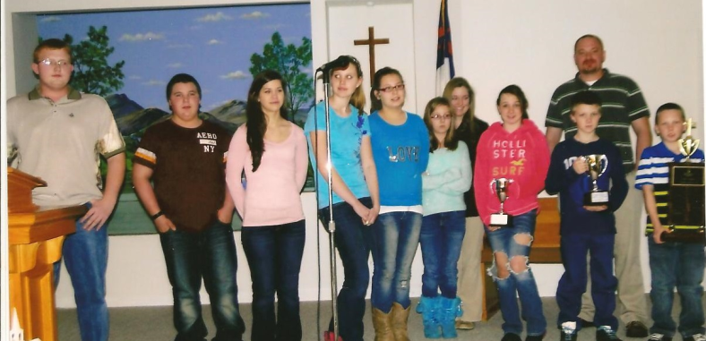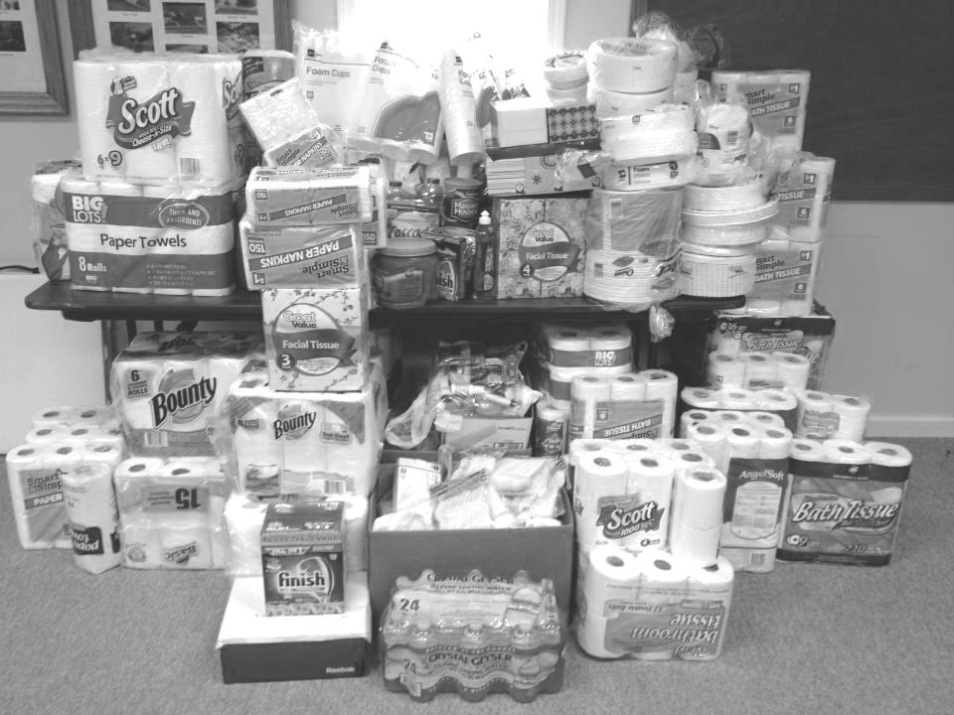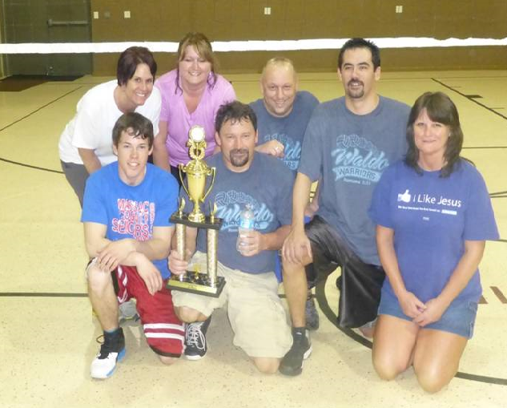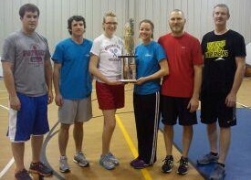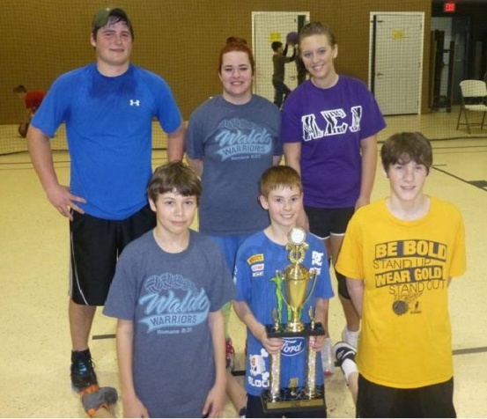

**Women’s Missions Celebration**

**April 25-27, Machesney Park**

Registration and hotel information are online at IBSA.org.

Contact Emma Hicks at 270-933-6187 if you would like to go. Transportation is available.

**YOUTH ON MISSION:** On February 10, Adam Koop, who is the Latreia Coordinator for Baptist Children’s Home and Family Services in Carmi, congratulated Dixon Springs Baptist Latreia youth. They are the winners of the First Place Trophy in the state of Illinois! These teens have chosen to worship God through service to the children and families served by BCHFS. They are looking forward to competing with more local church Youth Latreia groups in 2013. To find out more about this program, and how your youth group can serve, visit bchfs.com/Latreia/index.html

**Some members of Dixon Springs Baptist Latreia Youth**

**RESULTS OF THE FEBRUARY MISSION PROJECT!**

**Linda Mathis would like to thank everyone who gave products to the Hope Lodge Project in March. She was able to take a van load of items to them and they were so appreciative of what they received.**

**Hope Lodge in Nashville, TN is a free place for cancer patients, who are taking daily treatments, to stay at. Linda’s mother stayed there during her treatments. More pictures are available on our facebook page.**

**UBA MARCH MISSION PROJECTS:**

**One Day Mission Trip-Love Packages at Eagles Nest**

If you would like to go to Butler, IL to sort literature, please reserve a seat on the bus**. The trip will be on Thursday, April 11th. We will leave the UBA Office at 6:00 a.m. and return around 9:00 p.m.** You can reserve your seat by calling 524-9738 or 270-559-3717.

**UBA APRIL MISSION PROJECT:**

**Shawnee Community College Witnessing Bags-** These bags are given to the students at exam time. Please stuff bags (paper lunch bags or your own decorated) with the following: pack of gum, mechanical pencils with erasers, small candy bar, small bottle of water, pack of mints, individually wrapped snacks and a card stating “Provided by Women of Union Baptist Association”. It’s important to also insert a tract. You can provide your own or pick some up in the college office.

**Please deliver bags to the Metro Center by May 3rd!** One hundred bags are needed, so we need each church to please donate up to 10 bags, if possible. A mail out with this information will be sent to WMU leaders and our churches soon!

**Team Leader: Terry Mathis**

Christian Activity Center Banquet

We are excited to inform you that $5,800 was donated to CAC during the banquet in March! Special thanks to those who worked hard to make this event a success!

Worship Leaders Retreat

Where: IBSA Building, Springfield

When: April 5-6

Time: 1:00pm Friday-noon Saturday

Cost: $50/church (no matter how many you bring)

For more information or to register, visit IBSA.org/worship

Please call the IBSA office at 217-391-3132 or Tim Henderson (UBA Music Dir.) at 618-638-5937if you have questions.

**VACATION BIBLE SCHOOL STATE CLINIC**

**Saturday, April 13, 2013**

**Immanuel, Benton, IL**

**Biblical Preaching Conference**

**Tuesday, April 30, 2013, 6:00 p.m.**

**Marion First Baptist**

Speaker: Danny Akin, President of the Southeastern Theological Seminary

**Association VBS Clinic**

**Tuesday, April 23rd, 6:30 p.m.**

**Simpson Baptist**

***Please order your VBS Materials the night of the clinic. The UBA gets a commission of the sales.***

**All workers are encouraged to attend!**

**Coming in August - Walk for Jesus**

If you would like to volunteer, please contact Nathan or Lanesha Board at 618-759-2563. Walk for Jesus is an annual 24 hour event that was created to praise God. It is an outreach for Him. Participants walk around the park and tell others about Jesus. There is free food, concerts, games, and more for all who come and also for the workers. Walk for Jesus is held at the Vienna Park.:)

**Update on the Beast Feast –**

This year our Association’s Evangelism Department, under the leadership of David Wright, held a Sportsmen’s Beast Feast. We encouraged hunters and fishermen from our churches to invite and bring their hunting and fishing friends who don’t attend a church. We had several sponsors who donated door prizes to give away and several men who volunteered to cook wild game which was brought to them. That night, on March 16, we had over 130 in attendance and the gospel was preached to all by Bro. Tim Burdon of Marion, KY. There were 6 prospects discovered and their names have been given out to the churches which are near the location where they live. We feel this was a great beginning for our Beast Feasts and is something we can build on in the future of having people reach out to their lost friends. Thanks to everyone who had a part in this event. We have posted a couple of pictures on our facebook page.

**Other Tournament Results:**

**2nd Place: Group A –Joppa 2**

**Group B - Brookport 1st**

**Group C - Simpson Youth**

**3rd Place: Group A – Joppa 1**

**Group B – Simpson**

**Group C – Joppa Youth**

The 2013 Association Volleyball Co-ed League has finished its season. This year, we had 18 teams representing 11 churches. A great time of fun and fellowship was had between the churches throughout the eight week season. A special thanks to Simpson Baptist, Waldo Baptist, and Joppa Missionary Baptist for the use of their gyms. Also, for all the fine refreshments that were served at each of the games. In this newsletter, are the winners of each group. Those who were involved were: Simpson (2 adult, 1 youth), County Line, Brookport 1st, Eastland, Joppa (2 adult, 1 youth), Waldo (1 adult, 1 youth), Seven Mile (1 adult, 1 youth), New Hope (2 adult), New Beginnings, Hillerman, and Metropolis 1st.

**2013 Volleyball Tournament**

**1st Place in Groups**

**Group A – Waldo Baptist**

**Group B – Metropolis 1st**

**Group C – Waldo Youth**

**Looking for a Mission Trip for your church, mission group, Sunday School class, etc.? Contact the UBA Office. We have connections with some 20 different mission projects in connection with the IBSA. These trips are within the state, national, as well as international. Contact us early in the new year as many of these mission projects have deadlines for reservations.**

***Please pray for our travelling missionaries:***

HAITI: March 23-30 – Jimmy Martin from Metropolis First will lead a team to do construction work.

HAITI: March 30-April 6 – Cliff Easter from Metropolis First will lead a team of youth to do Bible Clubs.

***Please let us know if you have an event that you would like to have promoted in our newsletter, on our website, or on our facebook page!***

**UPDATE FROM MEXICO:**