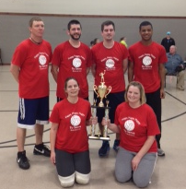

**APRIL MISSION ACTIONS:**

**Shawnee College Survival Kits (Witnessing Bags)**

**Deliver to Metro Center by May 5th**

**A detailed letter was sent to each WMU leader or your church.**

**Leadership: Dixon Springs**

**One Day Mission trip to Eagle’s Nest – April 17th**

**Leaving UBA at 6:00 a.m. and will be sorting material all day. We will return around 8:00 p.m. If you would like to go, please contact our office as van seating is limited.**

**Leadership: Terry Mathis**

**One Day Mission trip to Baptist Children’s Home to help stuff envelopes. Please get your volunteers lined up and we will give you the date ASAP.**

**Leadership: Dixon Springs**

**MAY MISSION ACTIONS:**

**Collection for Guardian Family Services. Needed items: toilet paper (most needed), laundry detergent, fabric softener sheets, garbage bags, aluminum foil, koolaid, tea bags, sugar, coffee.**

**Leadership: Alma Harris**

**Hope Unlimited Baby Bottles**

**Leadership: Pat Agee**

**GPS – God’s Plan for Sharing**

**Saturday, April 12th**

We encourage all of our churches to do something special on that date and to do intentional evangelism in their area.

**We would like to thank all of the churches that hosted games, along with all those who participated, in our volleyball season!**

**Listed below are the 1st, 2nd, & 3rd place winners for each of the 3 groups:**

**Group “A”: 1st Place – Joppa 2**

**2nd Place – Eastland 3**

**3rd Place – Joppa 3**

**Group “B”: 1st Place – Waldo Youth**

**2nd Place – Joppa Youth**

**3rd Place – Metropolis 1st**

**Group “C” 1st Place – New Hope Youth**

**2nd Place – Simpson**

**3rd Place – County Line**

**Other participating teams were: Life Church Eastland (2 teams), Brookport 1st, Joppa 1, Seven Mile, Waldo Adult, New Hope (2 Teams), Hillerman and St. Paul.**

**Volleyball Season Final Standings**

Family Ministry Matters

One of the most important aspects of the Christian family is to have family worship together. This can take many forms, but should at the very least include Bible reading and prayer. To that end, here are some Bible story book recommendations which keep the history of redemption in mind.

The Big Picture Story Bible by David Helm (ages 0-5)

The Jesus Storybook Bible: Every Story Whispers His Name by Sally Lloyd-Jones (ages 4-8)

The Gospel Story Bible: Discovering Jesus in the Old and New Testaments by Marty Machowski (ages 8 and up)

Finally, an excellent resource for helping your children and your whole family understand major theological concepts is Big Truths for Young Hearts by Bruce Ware.

Happy Reading!

**Please pray for the following:**

**Haiti Trip – June 10-17 – Metropolis 1st Youth trip**

**Mexico - July 26-August 1 - Life Church Eastland**

***A Message from Bro. Ben Hottel,***

***UBA Family Life Ministry Director:***

[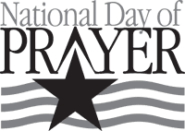](http://www.churchart.com/Subscriber/ViewImages.aspx?keywords=&entry_date=1/1/0001&image_type=,cl,ca,ph,ea,pp,bc&topic_id=427&image_source_id=&page=1#no)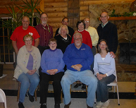[](https://www.google.com/url?sa=i&rct=j&q=&esrc=s&source=images&cd=&cad=rja&uact=8&docid=YkVOGJKtfE_DvM&tbnid=koPZGurSvQ4dRM:&ved=0CAYQjRw&url=https://play.google.com/store/apps/details?id=com.lifeway.agencydthree&ei=qVMwU6H6LIqqyAHVsYDQDg&bvm=bv.62922401,d.aWc&psig=AFQjCNHUkIyIqn92-y541V-O-j96dSL05A&ust=1395762451296106)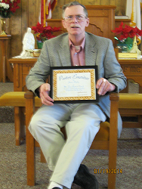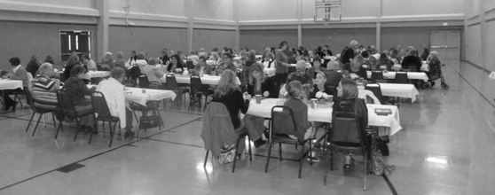

***Coming in May:***

***May 6 – Pastor’s Breakfast, Dolly’s in Vienna, 7:00am***

***May 10 – IBSA Worship Leaders Retreat***

***May 17 – UBA Golf Scramble***

***May 26 – Memorial Day, Office Closed***

**Pastor & Wife Retreat 2014**

**You will have the opportunity to look over materials and place your order at this time. Again, the commission from sales comes back to the UBA to use for Mission Projects.**

**VBS Directors, we will be looking forward to seeing you on April 22nd!**

**VBS Material Workshop**

**Tuesday, April 22**

**6:00-8:00 p.m.**

**Location: UBA Office**

**Women’s Conference**

**“Overcomers”**

**We had around 150 ladies in attendance at Metropolis 1st!**

**Womens Mission Celebration**

**May 1-3**

**1st Baptist Church in Marion, Illinois**

**Mt. Zion Baptist Church recognized their former pastor, James Shipley, with a “Pastor Emeritus” award on Sunday, January 19th. Pastor Shipley was pastor of Mt. Zion for 28 years and retired in July of 2013.**

**PRAY FOR OUR NATION!**

**Thursday, May 1, 2014**

**The Massac Ministerial Alliance has scheduled times for scripture reading and prayer in 15-30 minute intervals, at 2 locations:**

**Metropolis: Vacant corner across from First United Methodist Church 11:00 a.m.-Noon**

**Brookport: by the soldier statue on Hwy 45, 7:00-8:30 p.m.**

**If you would like to be scheduled to read or pray, or for more information, contact the UBA Office at 524-9738.**

**Group C Champions – New Hope**

**Group B Champions - Waldo**

**Group A Champions – Joppa 2**

**Construction Mission Project**

IBSA Lake Sallateeska Camp has weekend project needs. The dates are: April 25-26, May 2-3, May 9-10, May 16-17, May 30-31.

The cost is $25 per person which includes overnight stay at the camp as well as 3 meals.

If interested in participating, contact Barb Troeger at 217-391-3138.

**SHORT-TERM MEDICAL MISSION TRIP**

If you have medical experience in your background and are looking for a way to allow God to use your gift, please consider a trip to Bolivia. A team is forming to travel in June. This is a region where floods have hit the villages very hard.

Julie Dalechek, an RN, is the Team Leader. If interested in joining the group, contact the UBA Office for contact information.

**Please pray for the following churches as they search for a Pastor:**

**Dixon Springs Baptist**

**Simpson Baptist (has interim)**

**Seven Mile Baptist**

**Weaver Creek Baptist**