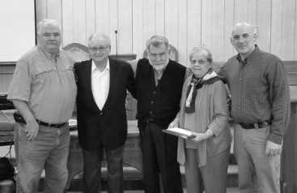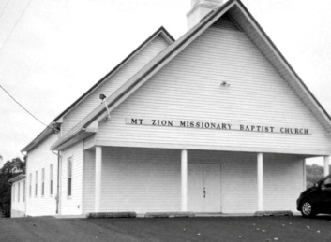

**Associational VBS Material Workshop!**

**PRIORITY IBSA Annual Women’s Conference**

**April 27-28, 2018 at the Decatur Conference Ctr. and Hotel**

***The deadline to register and go with the UBA group is April 6th!* For more information on the conference, please visit IBSA.org/Priority or call or email Barb Troeger at BarbTroeger@IBSA.org , 217-391-3138.**

**Come anytime between 6:00 & 8:00 to see a preview of the 2018 VBS materials. The UBA receives a commission on the orders, so please plan on ordering through our office!**

Bro. Charles Blair has been leading the Winter Bible Study at Joppa Baptist and Hillerman Baptist for the past 50 years and at Karnak 1st Baptist for the past 13 years! Pictured are Bro. David Wright, Bro. Dean West, Bro. Charles Blair, Alma Blair and Bro. Ben Hottel.

**UBA Church Leadership Training**

**Tuesday, April 24th, 6:00pm meal, 6:45pm Training**

**In order to help us plan the dinner, please RSVP by calling our office by Friday, April 20th**

**SUNDAY SCHOOL TRAINING**

**Saturday, April 14th, 10:00 a.m. – Noon**

**Theme “Think Big, Grow Big”**

This training will be held at the UBA Office and it is for all Sunday School Directors and Teachers. A light lunch will be served. To register, please call our office by April 12th.

Illinois Baptist Subscriptions are free! If you would like to subscribe, call 217-786-2600 to give them your mailing address. The paper is published every 3 weeks. You can also subscribe online by visiting ibsa.org

**Monday, May 7th**

**7:00 a.m.**

**Old Jumbo’s location in Vienna**

Mt. Zion Missionary Baptist Church, located one mile east of Buncombe, was organized in 1850. The present building was built in 1896-1897. In 1952, a basement was dug. In 1983, a new addition was added on to the front of the church and a church steeple was also added. Around the year 2002, they added a fellowship hall and Sunday School classrooms were added upstairs, behind the church.

Mt. Zion has always been a loving and caring congregation to its community, participating in several local events throughout the years. For example, in the year 2000, they gave “Jesus” videos to every household in the Buncombe community.

Mt. Zion has continuously been listed in the top 100, in per capita giving, to the Cooperative Program! They also have been very generous in their giving to the Union Baptist Association dating back to 1899!

Mt. Zion currently has a new pastor, Bro. John Yeo, Sr. We would like to thank Mt. Zion Missionary Baptist for being a shining light in your community, for Jesus and also for being faithful to the Lord’s direction. We are proud to have you as a part of the Union Baptist Association!

**PASTOR/WIFE/CHURCH STAFF BIRTHDAYS**

**April 4 – David “Buck” Siere, Brookport 1st**

**April 6 – Jake Ervin, Weaver Creek**

**April 13 – Mary Hill, New Salem**

**April 13 – Robin Anderson, Eastland Life**

**April 13 – Bill Gholson, retired UBA pastor**

**May 8 – Brian Anderson, Eastland Life**

**PASTOR & WIFE ANNIVERSARIES**

**April 2 – Terry & Linda Mathis, UBA**

**April 4 – Trad & Kamie York, Waldo Missionary**

**April 4 – Frank & Sara Forthman, New Hope**

**May 22 – Gary & Vickie O’Neal, Cypress First**

**May 23 – Joe & Grace Buchanan, Metropolis First**

**Pastor Church Anniversary**

**Brian Anderson - Eastland Life – April, 2005**

**Trad York - Waldo Missionary – April, 2011**

**Jake Ervin – Weaver Creek – April, 2014**

**Pastor John Yeo and his wife, Betty**

**This month’s featured church is:**

**Mt. Zion Missionay Baptist Church**

***Church Contributions for Budget***

***(rec’d & deposited in February, 2018)***

Brookport First $ 470.91

County Line $ 200.00

Cypress First $ 123.00

Dixon Springs $ 149.00

Eastland Life Church $ 200.00

Hillerman Missionary $ 367.52

Immanuel $ 210.27

Joppa Missionary $ 818.38

Karnak First $ 550.97

Metropolis First $ 1,693.42

Mt. Zion $ 245.28

New Beginnings $ 0.00

New Hope $ 0.00

New Salem $ 0.00

Oak Grove $ 59.22

Revelation Road $ 27.00

Seven Mile $ 0.00

Simpson $ 100.00

Vienna First $ 433.33

Waldo $ 466.67

Weaver Creek $ 0.00