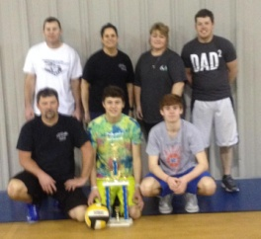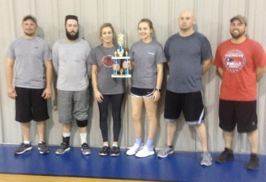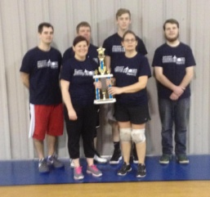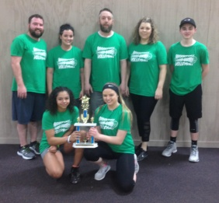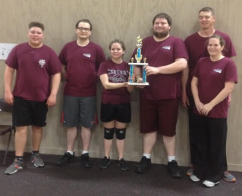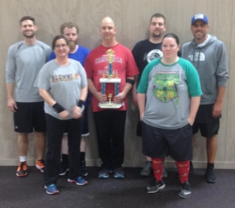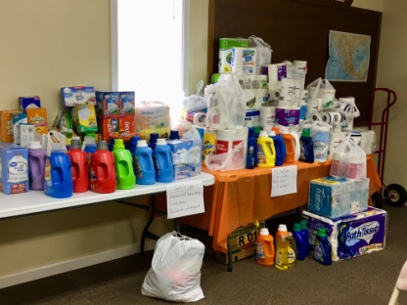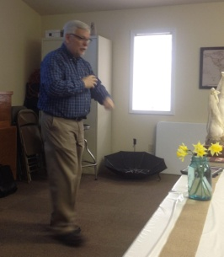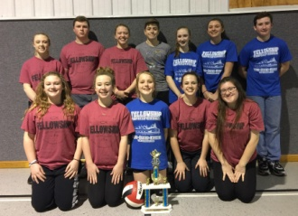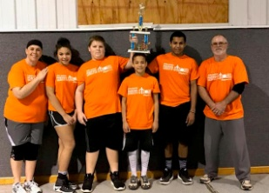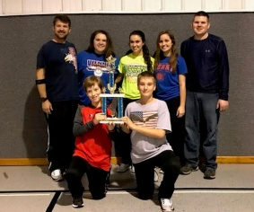******

2nd: Joppa Youth

***We won’t be mailing out a newsletter in April. The next one will be the June newsletter and it will be mailed the end of May.***

Our Volleyball Season had a good turnout this year with 13 teams competing! The 1st, 2nd and 3rd place winners of each group are pictured below.

**GROUP A**

3rd: Waldo 2

2nd: Joppa 1

1st: Waldo 1

**GROUP C**

**GROUP B**

1st: Eastland

2nd: Hillerman

3rd: Brookport First

**Our February mission project was collecting items for At the River Ministries and Salt and Light Ministries. Once again, our churches were very generous in their giving!**

**We had a great attendance at the WOM Spring Gathering in March! Donnie Gregory was the speaker and he shared about the mission trip to Italy that he and his wife, Patti, went on.**

1st: Simpson Youth

3rd: Fellowship Bapt. Youth

**The**

**UBA Connection**

**Union Baptist Association**

**P.O. Box 29**

**Metropolis, IL 62960**

***Return Service Requested***

**Volume 1, #76**

**UBA MONTHLY MISSION PROJECTS**

**APRIL** –3 projects **1.** Collection for Guardian Family Services – size 5 diapers, baby wipes, laundry detergent, bleach, trash bags. Please drop items off at the shelter (117 W. 10th, Metropolis) by May 4th. **2.** Shawnee Community College Witnessing Bags – you can use paper lunch bags or decorated bags. Please include: pack of gum, mechanical pencils with erasers, small candy bars, small bottle of water, pack of mints, individually wrapped snacks. Please include a card in the bag stating “provided by Women of the Union Baptist Association”. Each church is asked to donate up to 20 bags. Please drop them off at the Metro Center by May 4th. **3.** One-day mission trip (sorting literature) to Eagles Nest Ministries in Butler, IL. The date is April 9th and the group will leave the UBA at 6:00 a.m. Please call our office to reserve your seat on the van.

**MAY –** 2 projects. **1.** Mother’s Day Offering for the Baptist Children’s Home in Carmi. If your church would like to participate, but does not receive the promotional materials, please contact BCH and they will mail them to you. **2.** Hope Unlimited Baby Bottle Campaign runs from Mother’s Day through Father’s Day. If your church would like to participate, please contact Hope Unlimited and they will provide the bottles. Church members take them home on Mother’s Day, fill them with change or cash and return them to the church on Father’s Day.

**Union Baptist Association Terry Mathis, Director of Missions**

**P.O. Box 29 email:mathisterry2009@hotmail.com**

**Metropolis, IL 62960 Beverly Turner, Admin. Asst.**

**618-524-9738 bevturneruba@gmail.com**

**UBA theme for 2018: Assisting Churches - Advancing the Gospel**

**APRIL, 2018 NEWSLETTER**

**Non-Profit Organization**

**U.S. Postage Paid**

**Permit #137**