

**Please pray for the following:**

**Haiti – August 29-September 4 – An Evangelistic Team from Metropolis 1st will be sharing the gospel and informing people of the coming Medical Team Visit.**

**Haiti – September 4-7 – Medical Team, led by Dr. Oliver, will be ministering to those in need.**

**Association Executive Board Meeting**

**Monday, August 25, 7:00 p.m.**

**The meeting will be held at Mt. Zion**

**All Pastors and church elected association board members are encouraged to attend.**

Sunday School Training

For Directors and all Teachers

Leader: Aubert Rose, Jr.

Saturday, August 9, 10:00 a.m.-Noon

To be held at the UBA Office

Aubert Rose, Jr. was Sunday School Superintendent with Charles Stanley for several years and has a wealth of knowledge on how to grow a Sunday School Class.

Please call our office, by August 7th, to register.

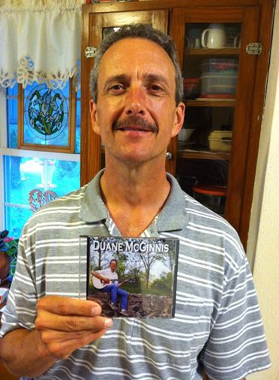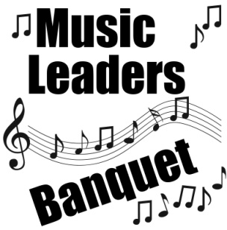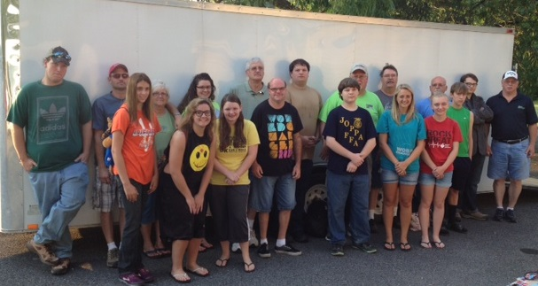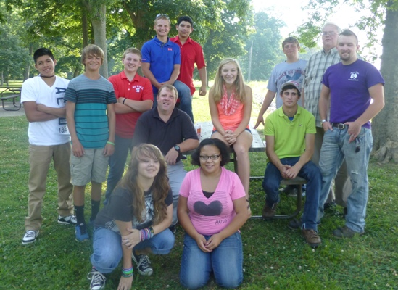

***A note from Duane McGinnis:***  Friends, first let me thank God for the opportunity to record this CD. It contains 13 original songs that God has blessed me with. Each one came from a specific happening or place in my life journey with The Lord.... (I would be happy to share details with you of any song, just ask) These are on sale for $10 each from me or $10 plus $2.50 shipping if need be. If you can't afford this let me know, these are God’s songs I have been allowed to share. I'll be glad to get you one. Please share this with your church families or anyone who might be interested. Any profit from this project will be used to further the Jamaica Mission work with the churches and schools there.

**AUGUST MISSION ACTION:**

**Local Crisis Intervention – Serve our police, firefighters, EMT’s, ministries, etc.**

**Each church chooses what their ministry will be.**

**SEPTEMBER MISSION ACTION:**

**Baptist Children’s Home Fall Festival – Silent Auction items.**

**Leadership: Mike & Georgia Casper**

**Saturday, Aug.16th,**

**6:00 p.m.**

**at the UBA Office**

**If you plan on attending, please call our office by August 12th.**

**This dinner is for all music directors, worship leaders, and instrumentalists who help with music during the worship service.**

**We would like to thank everyone who donated non-perishable food items for Camp Mac!**

**Some of our churches brought requested items to our office while others gave monetary gifts. This helped immensely with the food expenses. Also, thank the Lord for the anonymous person who donated a generous amount of money to put towards the food purchases. God is blessing and working in a great way through our churches and individuals, for these kids to have a great camp.**

**We had 177 kids registered for camp this year and, at the time of this printing, have had several to give their lives to the Lord! We will have more details in our next newsletter.**

**Please continue to pray for the following churches as they search for a pastor:**

**Dixon Springs (Interim, Matt Snell)**

**Seven Mile**

**Simpson (Interim, Ken Wilson)**

**Vacation Bible School is over and we would love to have your attendance numbers, along with any decisions that were made. Please turn in your VBS Reports to our office. If you don’t have a report to fill out, you can call our office with these numbers. We will include them in the September newsletter.**

**Coming in September:**

**September 1st: Labor Day – our office will be closed**

**September 8th: Pastor Breakfast, 7:00 a.m. in Metro.**

**September 13th: Associational Fish Fry**

**September 20th: BCHFS Fall Festival**

**September 24th: See You at the Pole**

**September 25th: IBSA Men’s Ministry Conference**

**September 26th: IBSA Youth Ministers’ Conference**

**September 27th: Pastor & Family Picnic, Ft. Massac Park**

August 8-9 at Lone Oak First Baptist

Speaker: James Merritt

The cost is $25 per person, which includes 2 meals and materials.

To register, call 270-554-1441 or visit online at loneoakfbc.org

**MEN’S CONFERENCE**

**World Changers**

**This year, our World Changers group traveled to Indianapolis where they worked on new homes for three families.**

**NC Mission Team**

**A mission team, from North Carolina, came to the area to help Brookport tornado victims. They roofed a house and built a ramp for another house. We appreciate their hard work and dedication to ministering to others.**

**Association Co-ed**

**Bowling League**

**Ed Hollis, Pastor of Vienna 1st, is beginning the process of organizing the fall and winter league. The organizational night is Friday, August 22nd at 7:00 p.m. at the newly renovated Super Bowl in Metropolis (formerly Bob’s Bowl). It has been completely remodeled and is more family friendly.**

**On the night of the organizational meeting, you will bowl to set up your scratch score for the league. We would love to have 10 to 15 teams or more! If interested, please contact Ed Hollis at 618-771-0442 before August 22nd.**