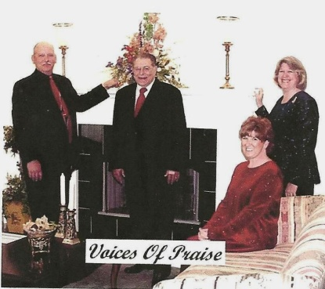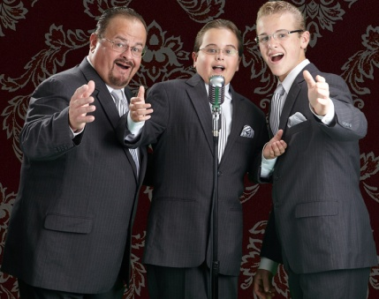****

**Pastor & Wife Birthdays**

**August 10 – Gary O’Neal, Cypress 1st**

**August 17 – David Wright, Joppa Missionary**

**August 18 – Marvin Ballard, Seven Mile**

**August 22 – Carol Siere, Brookport 1st**

**August 27 – Dustin Womack, Joppa Missionary**

**Wedding Anniversaries**

**August 6 – Dean & Donna West, Karnak 1st**

**August 24 – David & Karen Faulkner, County Line**

**Pastors’ Church Anniversaries**

**Gary O’Neal, Cypress 1st – 1998**

**Joe Buchanan, Metropolis 1st – 2007**

**Jim Wilson, Oak Grove – 2011**

**Stephen Williams, Simpson - 2014**

**Please pray for the following church that is currently without a pastor: New Beginnings**

Gospel Messengers

*We would like to extend our deepest sympathy to Pastor Marvin Ballard and family following the passing of his father, Marvin Ballard, Sr.*

*We would also like to extend our heartfelt sympathies to the family of Ms. Jane McGinnis. Please keep these two families in your prayers.*

**August 8th, 7:00 p.m.**

**Dixon Springs Baptist Church**

**Everyone is invited to bring family and friends to enjoy good gospel music and help support a very worthy ministry. Since 1918, the Baptist Children’s Home and Family Services has been a source of hope and healing, providing Christ-Centered services to children and families in crisis.**

**The musicians for the evening are the Gospel Messengers, from Mt. Vernon, IL. They are a trio consisting of father, Bart, and sons, Dennis and Daniel. The group sings traditional southern gospel music.**

**Also entertaining will be The Voices of Praise, from Harrisburg, IL. This quartet also sings southern gospel.**

**Secretary’s office hours: Monday-Thursday, 9:00 a.m. – 2:00 p.m.**

***Church Contributions for Budget***

***(rec’d & deposited in June)***

Brookport First $ 954.98

County Line $ 400.00

Cypress First $ 0.00

Dixon Springs $ 149.00

Hillerman Missionary $ 747.00

Immanuel $ 274.97

Joppa Missionary $ 1,073.52

Karnak First $ 702.70

Life Church Eastland $ 200.00

Metropolis First $ 0.00

Mt. Zion $ 356.75

New Beginnings $ 0.00

New Hope $ 0.00

New Salem $ 30.00

Oak Grove $ 34.23

Seven Mile $ 0.00

Simpson $ 208.00

Vienna First $ 433.34

Waldo $ 466.67

Weaver Creek $ 0.00

UBA theme for 2015: THE POWER OF ‘AND’ -

It’s you AND me working TOGETHER to bear witness to the POWER OF JESUS CHRIST in Jerusalem, AND in all Judea AND Samaria, AND to the ends of the Earth

***If you have information that you would like to have included in our monthly newsletter, please call or email the UBA office by the 20th of the month. We would be happy to promote any special events (revival, singing group, special programs/ministries, etc.)***

**CONTACT INFORMATION:**

**Phone: 524-9738**

**Email: Terry Mathis - mathisterry2009@hotmail.com, Beverly Turner - bevturneruba@gmail.com**

**Website – www.metrouba.com Facebook – UBA (Metro)**

**Volume 1, #50**

**Union Baptist Association**

**P.O. Box 29**

**Metropolis, IL 62960**

*Return Service Requested*

**AUGUST 2015 NEWSLETTER**

**Non-Profit Organization**

**U.S. Postage Paid**

**Permit #137**