

**MISSION TRIP!**

**Please remember this group in prayer.**

December 8-10- A group of ladies from our association will be traveling to Texas to help out in the Operation Christmas Child shoe box warehouse. Those going are: Kim & Grace Taylor, Cathe Glass, Betty Morris and Nelda Smothers.

**UBA Volleyball Co-ed League**

**January 10-March 7**

**Please form your teams and turn the information in to our office by Dec. 23rd. There can be 7-9 players per team (7th grade and up). Please call Terry Mathis at 270-559-3717 if you have questions.**

**Winter Bible Study 2015**

**UBA CONSTRUCTION VOLUNTEER WORKDAYS**

An association workday is scheduled for Saturday, December 6th at Weaver Creek Baptist. Instead of hanging sheetrock, we will be hanging interior doors and painting. Please call the UBA Office (524-9738) or Terry Mathis (270-559-3717) by December 4th if you can volunteer for this day. We will work at the church from 8:00 a.m. - 4:00 p.m.

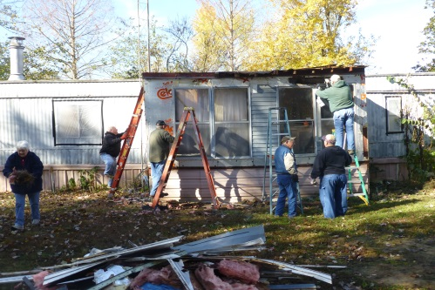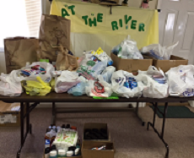

DATE: June 22-27,

LOCATION: West Memphis, Arkansas

If you have completed the 8th grade and are looking for a mission project for the summer, join us for World Changers. For more information, contact Terry Mathis at 270-559-3717 before January 15, 2015. The total cost is $315.00 (includes meals, travel costs, insurance, fees and materials) with a $50.00 commitment deposit due by January 15th.

**At the IBSA Convention this year, several from the UBA were elected to serve on various committees:**

Terry Mathis (UBA Director) – IBSA Committee on Order of Business

Terry Foster (layman, Metropolis 1st) – IBSA Credentials Committee

David Faulkner (Pastor, County Line) – IBSA Historical Committee

Cliff Easter (Youth & Family Minister, Metropolis 1st) – Board of Directors with Strategic Planning Comm.

Nelda Smothers ( Layperson, Metropolis 1st) – Baptist Foundation Board of Trustees

**Beast Feast Organizational Meeting**

**January 29th, 6:00 p.m.**

**Joppa Missionary Baptist**

The Beast Feast is a banquet for all members of our churches to invite their hunting and fishing friends to. It is an evening of Christian fellowship and worship. If you would like to be in on the planning of this great event, please plan on attending this meeting. The scheduled date for the Beast Feast is March 14th

**The Power of “And”:** On November 7-8, members from several churches in our association worked together at “Rebuild Brookport”. Those who participated were: David Siere, Scotty Vowell, Terry Mathis, Richard Goines, Joe Konemann, Loren Crockett, Nelda Smothers and Richard Smith.

**Please pray for the following church that is currently without a pastor:**

**New Beginnings**

**NOVEMBER MISSION ACTION: Gifts for children at the Christian Activity Center. Please try to have gifts brought to our office by Monday, December 1st.**

**DECEMBER MISSION ACTIONS:**

**Local Ministries – Meeting needs for Christmas.**

**Leadership: Each church has the choice of which ministry they would like to contribute to.**

**JANUARY MISSION ACTION:**

**Collecting for local food pantries. Please drop items off at the pantries.**

**Leadership: Joppa Missionary Baptist**

**FEBRUARY MISSION ACTION:**

**Collection for At the River Ministries**

**This project was moved from October to February for 2015. A list of needed items will be given later.**

**Leadership: Terry Mathis**

Please be in prayer for the group of ten from the UBA that will be attending the **Advance 2015 Midwest Leadership Summit** on January 20-22 at Springfield. Ten Baptist Conventions representing thirteen states will be attending, with a total of 1,300 people. Those attending from the UBA are:

Terry Mathis, Director of Missions

Jerry Jackson, Pastor of Mt. Zion

David Siere, Pastor of Brookport 1st and Assoc. Discipleship Director

Larry Fugate, Assoc. Sunday School Director

David Faulkner, Pastor of County Line and Assoc. Director of Pastoral Care

Karen Faulkner, Assoc. VBS Director

Dudley Kesler, Church Planter – Revelation Road Baptist

Charles Duckworth, Pastor and Church Planter – Revelation Road Baptist

Manuel Orozco, Pastor in Hispanic Ministry – Life Church Eastland

Stella Orozco, Hispanic Ministry – Life Church Eastland

**Church Technology Conference-**

**Saturday, January 31st, 9:00 a.m.-2:00 p.m.**

**IBSA Building in Springfield**

Cost is $10 per person and includes lunch. For more information and a list of the breakout conferences, visit ibsa.org or call Steve Hamrick at 217-391-3132.

**Association Executive Board Christmas Banquet**

**Monday, December 1st, 6:00 p.m. – meal**

**7:00 p.m. – business, 7:15 p.m. – Music by “Blend”**

Pastors, executive board members, council members and their spouses are invited. Also, this year we are inviting the worship leaders and their spouses to come as the outstanding group, “Blend”,will be performing. If you plan on attending, please RSVP by November 28th. Call the UBA Office or Terry Mathis at 270-559-3717.

**The Power and Purpose of Music**

**Winter Worship Conference**

**Saturday, December 13, 2014**

**Tabernacle Baptist Church in Decatur**

**9:00 a.m.-4:15 p.m. Worship Team Training**

**Concert at 7:00 p.m.**

**Youth bands are encouraged to attend.**

More information is available at ibsa.org or by contacting Debbie Mueller at 217-391-3126.

The New Beginnings Clothing Ministry is in need of casual men’s clothes (any size) and infant clothes (nb-24 mo.)

If you can help out, please leave donated items by the side door of the church. If it is raining you may leave them at the UBA office.

**Tuesday, January 13th**

**Jumbo’s in Vienna**

**7:00-8:30 a.m.**

**All pastors are invited to attend this time of fellowship.**

**Bro. Terry Mathis, our Director of Missions, has prepared four, one hour sessions on this study and has a few openings left. He has open dates in January, February and March. If your church would like to have him come and lead this study, please contact him at 270-559-3717.**

**As you can see from the picture below, our churches really came through on collecting items for At the River Ministries! Thanks to all who contributed!**

June 22-27, 2015

West Memphis, Arkansas