

**March 10, 2019**

If your church is interested in having a mission speaker during your morning, evening or both services on that Sunday, please let us know and we will set it up for you. We have a list of local missionaries who are anxious to tell of their experiences. We hope that every church in the association will have at least one speaker on that day. Please contact Bro. Terry at 270-559-3717 if you are interested.

**SPRING GATHERING 2019!**

**Thursday, March 7th at the UBA Office.**

**10:00 a.m. – Noon**

**More information will be sent to our churches!**

**This newsletter contains information for February, March and April! The next newsletter will be mailed out the end of April, 2019.**

**The**

**UBA Connection**

**Volume 1, #79**

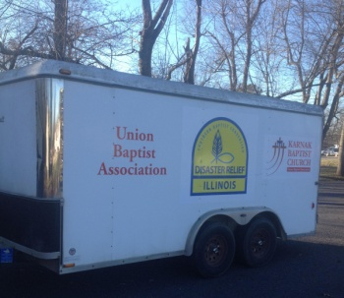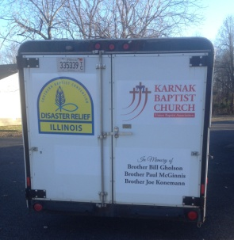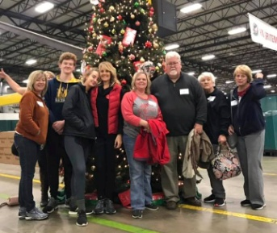

**The pictures above are of the UBA/Karnak 1st Baptist Disaster Relief Trailer. Charles Peck is our Association Disaster Relief Coordinator. We are so thankful for his hard work in organizing this effort.**

**American Heritage Girls – Alexia Land is collecting new or used Bibles as a Service Project for AHG. The Bibles will be donated to Eagle’s Nest in Butler, IL. The Bibles can be any version and they can be dropped off at the UBA office through the end of March.**

**Mission Trip: In December, a team from Metropolis First Baptist went to Atlanta Georgia to help out at the Operation Christmas Child Shoebox Warehouse.**

**In observance of President’s Day, our office will be closed on Monday, February 18th.**

**Union Baptist Association**

**P.O. Box 29**

**Metropolis, IL 62960**

***Return Service Requested***

**UBA MONTHLY MISSION PROJECTS**

**FEBRUARY–** Collection for At the River Ministries. In addition to providing a monthly hot meal for anyone who may have a need, ATR also hold a worship service and gives away gift bags which include items they may need. The following are the most needed items: shampoo, body wash, deodorant, hand soap, dishwashing liquid. *This year we are asking you to drop items off at Lange Chiropractic, which is located on E. 12th St., across from the UBA Office. The drop-off deadline is Tuesday, March 5th. Their office hours are: M,W,F 8:30-5:30; T,Th 8:30-noon.*

**MARCH**- Monetary donations for Migrant Health Kits. Please mail or drop off your church’s donation to the UBA Office.

**APRIL**- Witnessing bags for students at the Shawnee Community College Metro Center. The drop-off date will be in the next newsletter. Also in April, Bro. Terry will be taking a group to the Eagle’s Nest Ministry in Butler, IL. This will be a one-day mission trip. Date:TBA

**Union Baptist Association Terry Mathis, Director of Missions**

**P.O. Box 29 (716 E. 12th) email:mathisterry2009@hotmail.com**

**Metropolis, IL 62960 Beverly Turner, Admin. Asst.**

**618-524-9738 bevturneruba@gmail.com**

**UBA theme for 2019: Together, everyone achieves more – 1 Cor. 3:9**

**February, March & April, 2019 NEWSLETTER**

**Non-Profit Organization**

**U.S. Postage Paid**

**Permit #137**