

**The Power of “And”:** On December 6, 2014, members from several churches in our association worked together at the new Weaver Creek Baptist Church location. The group hung interior doors. Those who participated were:

Back row: David Goines, Lauren Crockett and Richard Goines.

Front row; Leroy Jones, Dan Haun, Marvin Barnhill and Michael Bowman.

Taking the photo: Terry Mathis

**UBA PASTORS & WIVES RETREAT**

**February 20-21st**

**Moors Landing at Kentucky Lake**

Same price ($70) and same great time!

This year Bro. Pat Pajak from IBSA will be the speaker. Bro. Pat is a great spiritual leader in our state office and is highly respected throughout the convention.

**Trip to Creation Museum! May 5-6, 2015**

Departing from 1540 Crescent Loop, Vienna at Noon on the 5th.

Cost: $130 (per person, based on double occupancy. Add $45 for single occupancy.)

$40 is due by April 1st. Balance is due May 1st.

Price Includes:

* Motor Coach Transportation
* One night lodging at Comfort Suites, Cincinnati Airport
* Entry into Creation Museum
* Motor Coach Driver Gratuity

**(Meals are NOT included with the exception of the Continental Breakfast on the 6th)**

May 5: Travel toward Cincinnati, Ohio with rest stops as needed. Enjoy an evening meal. Check into Comfort Suites.

May 6: Enjoy a Continental Breakfast. Depart for the Creation Museum. Enjoy your visit. Approximately 4:00 p.m., depart for home and have dinner on the way.

**For Information & Reservations Contact:**

**David Faulkner (618) 695-2461 & (618) 771-6532**

**or Karen Faulkner (618) 771-6531**

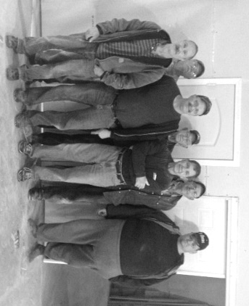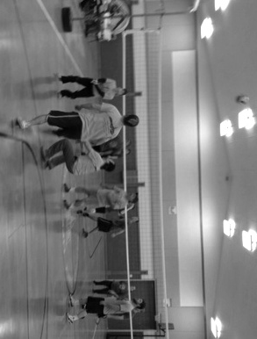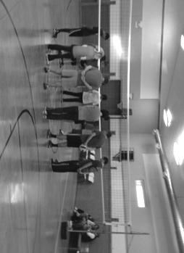

**Final Organizational Meeting for Beast Feast**

**Thursday, February 26th, 6:00 p.m.**

**Joppa Missionary Baptist Church**

The Beast Feast Event takes place on Saturday, March 14, 5:00 p.m., at Joppa Missionary Baptist.

**Vienna 1st Baptist: March 1-4**

Speaker: Pat Pajak, IBSA

**Mt. Zion Missionary: March 15-18**

Speakers: Sunday a.m.&p.m –Terry Mathis, UBA DOM

Monday p.m. – David “Buck” Siere

Pastor of Brookport 1st

Tuesday p.m. – Frank Forthman, Jr.

Pastor of New Hope

Wednesday p.m. – David Faulkner

Pastor of County Line

***Coming IBSA Events***

**Student Resource Conference**

For paid or volunteer student ministry leaders

February 20-21st at IBSA in Springfield

Register by emailing cathywaters@ibsa.org

**State VBS Clinic**

March 7th at Mt. Vernon

**UBA Council and Executive Board Meetings**

**Monday, March 2nd at Karnak First**

**6:00 p.m. – Council Meeting**

**7:00 p.m. – Exceutive Board Meeting**

**ANOTHER MISSION OPPORTUNITY:**

Beth Larrison will be going on mission to Peru again in July. This will be a 10 day trip. The group will be working and holding a VBS. If you are interested in going, please give Beth a call at (618) 534-3181.

**FEBRUARY MISSION ACTION:**

Collection for At the River Ministries

This project was changed from being the October project to being the February project for 2015.

Please collect items and drop them off at the UBA Office by March 9th. Needed Items: toilet paper, paper towels, shampoo, body wash, baby wipes, laundry detergent, dishwashing liquid.

Leadership: Terry Mathis

**MARCH MISSION ACTION:**

Contributions for Health/Hygiene Kits for migrant workers. If you would like to help out with this project, please consider giving a monetary donation only. This will go toward the purchase of items for the kits. The reason for this is that all bags need to be the same size and contain similar items. Contributions can be brought by or mailed to the UBA Office.

Leadership: Kevin Miller & Nelda Smothers

**PASTOR LUNCHEON**

**Hosted by Metropolis First Baptist**

**March 15th at Noon**

Metropolis First is holding a Church Planters Conference that week and would like to invite all pastors to come for lunch and to hear church planters tell about their experiences. This will cast our vision for the “Catch the Vision Tour”. Please contact the UBA Office by March 12th if you plan on attending. We will have more detailed information in the March newsletter.

**UBA Co-ed Volleyball League 2015**

The association Co-ed Volleyball League is off to a great start! We have a record number of twenty-one teams participating this year! Some of the churches have more than one team, yet we still have ten churches involved.

The churches with teams are New Hope Baptist, Life Church Eastland, Joppa Missionary Baptist, Metropolis First Baptist, Seven Mile Baptist, Simpson Baptist, Hillerman Baptist, County Line Baptist, Brookport First Baptist and St. Paul Lutheran.

There are 5 churches whose gyms we are using for Saturday games. The game schedule begins at 10:00 a.m. and continues until 9:00 p.m. Each game lasts for an hour. This hour is a great time of fellowship for the two church teams that are playing. Also, several people come just to watch and 300-350 people come through the gym throughout the day.

The host churches have done an outstanding job in providing refreshments with many of them being homemade goodies.

Let me encourage everyone to come out on Saturdays during the month of February and watch some exciting volleyball games.

Below is the location schedule for the games in February.

February 7 – New Hope, February 14 – Simpson, February 21 – Joppa Missionary, February 28 - Waldo

**Please remember to pray for our missionaries.**

**Jamaica – Feb. 20th – March 6th: Duane McGinnis, (New Hope) and Kevin Miller (Joppa Missionary Baptist) will be working with churches and schools.**

**Peru – January 27th: Beth Larrison (Life Church Eastland) will be traveling with others from Mt. Vernon, to hold VBS at a children’s home.**