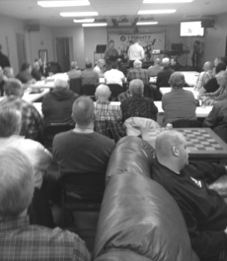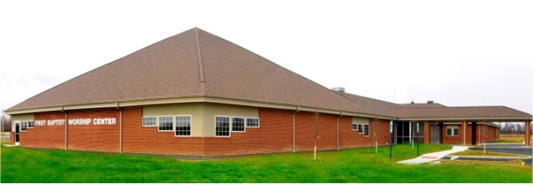

**IBSA Vacation Bible School Clinic**

**Saturday, March 3rd**

**Carterville, IL**

Please contact our Association VBS Director, Amy Land, for details and possible travel plans. She can be reached at landamy64@gmail.com

**The dates for Camp Mac 2018 are July 8-14**

We had a great turnout for the Church Security Seminar with about 60 present. Our association now has an individual who will come to meet with your church security committee and do a walk-through of your building to show you what you can do to protect your congregation. Contact the UBA Office for this information.

**PASTOR/WIFE/CHURCH STAFF BIRTHDAYS**

**February 7 – Ed Hollis, Vienna 1st**

**February 11 – Kim Coram, Immanuel**

**February 26 – Beverly Turner, UBA Office**

**PASTOR & WIFE ANNIVERSARIES**

**February 6 – Scott & Rosa Sparks, Vienna 1st**

**Metropolis First Baptist**

**Youth Ski Retreat & Conference**

**February 17-19 in Mitchell, IN**

Please contact Cliff Easter at Metropolis 1st if interested.

**Church Leadership Training –**

**Monday, February 26, 2018**

6:00pm meal, 6:45pm program

Topic: “5 Habits of Healthy Leadership”

Leader: Rich Cochran, IBSA Leadership Development Director

RSVP by calling the UBA no later than February 22nd.

**Men’s Ministry Meeting**

**February 15, 2018, 6:30 p.m.**

**Location to be announced**

**Pastor & Wife Retreat**

**February 9th & 10th at Moors Resort**

**$70.00 per couple (covers room & meals)**

**Deadline to register is February 6th**

**Pastor of Metropolis First Baptist: Joe Buchanan**

**Brian Anderson and his wife, Robin**

**This month’s featured church is:**

**Metropolis First Baptist Church**

Metropolis First Baptist Church began with 7 charter members on November 13, 1841. Bro. Willis White was its first pastor. Metropolis First was one of thirteen churches that helped organize the Union Baptist Association back in October of 1867.

The original location of 6th and Girard Streets in Metropolis has been there for over a century, beginning with an old stucco building. This building was replaced in 1952 with a new sanctuary and, in 1953, an educational building was added. The sanctuary was remodeled in 1965.

After years of growth in membership and also aging of the building, there became a need for relocation and a new church building. Today, the new church building is located on fifty-two acres of land on Massac Creek Road in Metropolis. The church continues to grow in membership. It is in the top twenty-five in giving to the cooperative program and also is a great supporter of the UBA.

The present pastor is Dr. Joe Buchanan and the ministry staff includes Cliff Easter, Youth and Family Minister, John Windings, Worship Minister, and Clarissa Fox, Children’s Leader.

We are proud to have Metropolis First Baptist as part of the Union Baptist Association.

***Church Contributions for Budget***

***(rec’d & deposited in November & December 2017)***

Brookport First $ 624.72 478.68

County Line $ 0.00 200.00

Cypress First $ 0.00 0.00

Dixon Springs $ 234.10 176.00

Eastland Life Church $ 200.00 200.00

Hillerman Missionary $ 671.66 591.53

Immanuel $ 0.00 228.51

Joppa Missionary $ 1,055.97 913.44

Karnak First $ 0.00 706.23

Metropolis First $ 2,555.47 1,931.62

Mt. Zion $ 403.62 280.67

New Beginnings $ 237.85 0.00

New Hope $ 0.00 0.00

New Salem $ 0.00 50.00

Oak Grove $ 38.57 32.90

Revelation Road $ 30.00 23.00

Seven Mile $ 0.00 0.00

Simpson $ 100.00 100.00

Vienna First $ 433.33 433.33

Waldo $ 466.67 466.67

Weaver Creek $ 0.00 75.00