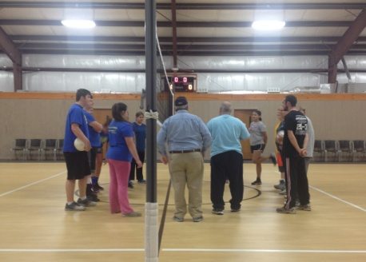

**March 11, 2018**

If your church is interested in having a mission speaker during your morning, evening or bother services on that Sunday, please let us know and we will set it up for you. We have a list of missionaries who are anxious to tell of their experiences. We hope that every church in the association will have at least one speaker on that day. Please contact the UBA Office or text Bro. Terry at 270-559-3717 if you are interested.

Brookport Youth and Joppa Youth Volleyball Teams having prayer together before beginning play. Volleyball games will continue through the month of February with Tournaments being held the first of March. Go out and support your church's team!

A Thank You from Braes Interfaith Ministries

“On behalf of Braes Interfaith Ministries, I would like to personally thank you for your generous donation of food and pantry items and also the check for $2,353.45 for Hurricane Harvey Relief. It is because of your generosity that we here at Braes are able to do what we do. The mission of Braes is to provide much needed help to our underprivileged neighbors in the Southwest area of Houston, and the support of people such as you, together with our coalition congregations, that makes it possible for us to carry out our work as we have for over 33 years.

Eloy E. Montez, LMSW

Executive Director of Braes Interfaith Ministries”

**SPRING GATHERING 2018!**

**Thursday, March 1st at the UBA Office.**

**10:00 a.m. – Noon**

**Potluck Soup and Salad Lunch**

**More details will be in the February newsletter.**

2018

**Union Baptist Association**

**P.O. Box 29**

**Metropolis, IL 62960**

***Return Service Requested***

**Volume 1, #74**

**The**

**UBA Connection**

**UBA MONTHLY MISSION PROJECTS**

**FEBRUARY -** Collection for At the River Ministries and Salt and Light House (New Beginnings)

Leadership: Terry Mathis

Items needed are: laundry detergent, wash scent boosters, 13-gallon trash bags, 4-packs of toilet tissue, paper towels

The UBA will also be providing funds for the ATR meal on February 26th out of the Annual Love Offering we receive from our churches.

Please bring donated items to the UBA Office by **Tuesday,February 27th.**

**MARCH** – Monetary donations for the purchase of items to make up health/hygiene kits for migrant workers. Please mail or drop off your donation to the UBA Office by April 12th.

**Union Baptist Association Terry Mathis, Director of Missions**

**P.O. Box 29 email:mathisterry2009@hotmail.com**

**Metropolis, IL 62960 Beverly Turner, Admin. Asst.**

**618-524-9738 bevturneruba@gmail.com**

**UBA theme for 2018: Assisting Churches - Advancing the Gospel**

**FEBRUARY, 2018 NEWSLETTER**

**Non-Profit Organization**

**U.S. Postage Paid**

**Permit #137**