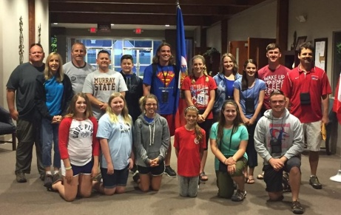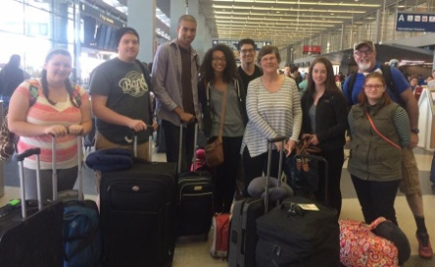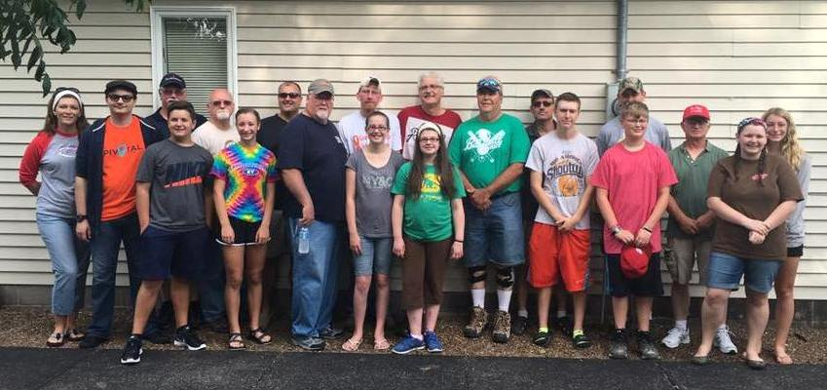

***We would like to welcome Clay Blankenbaker as the new pastor of New Beginnings Baptist Church. Clay and his wife, Holly, were members of Metropolis First Baptist.***

**Haiti Group**

**VBS in Haiti**

**UPCOMING MISSION TRIPS:**

Haiti – July 7-10 – Dr. Randy Oliver and team

Asia – June 13-July 21 – Chloe Quint

Mexico – July 23-30 – Life Church Eastland Group

Please keep our missionaries in your prayers.

**RECENT MISSION TRIPS**

**Italy Group**

**World Changers Group**

In 2015, a total of $3,760.00 was given toward helping 23 individuals, along with 4 groups, to work on mission trips and projects, both locally and internationally over the past year. You helped to reach people in the United States, El Salvador, Asia, Italy, Mexico, and Jamaica!

We are asking our churches to set aside **July 10, 2016**, or any Sunday in July, as “UBA Love Offering Sunday”. Envelopes and bulletin inserts have been sent to each church. Please let us know if your church did not receive them.

**Italy Group**

**Haiti Group**

**Volume 1, #59**

**MONTHLY MISSION PROJECTS**

**JULY:** Collection of School Supplies for the Christian Activity Center in E. St. Louis. Each church is being asked to collect the following items and **drop them off at the UBA Office by** **July 26th.** Items will be picked up on the 27th for deliver to CAC. Needed items: 1 subject notebooks, loose leaf paper, pencil sharpeners, copy paper, Science project boards (tri-fold boards) Leadership: Vienna 1st.

**AUGUST:** Local Crisis Intervention. Each church is asked to pick a crisis center in their community to serve in some way. This could be police, firefighters, EMT’s, abuse centers, etc.

**Union Baptist Association Terry Mathis, Director of Missions**

**P.O. Box 29 email:mathisterry2009@hotmail.com**

**Metropolis, IL 62960 Beverly Turner, Admin. Asst.**

**618-524-9738 bevturneruba@gmail.com**

**UBA theme for 2016: “Disciple- Be One/Make One”**

**JULY 2016 NEWSLETTER**

**Union Baptist Association**

**P.O. Box 29**

**Metropolis, IL 62960**

***Return Service Requested***

**Non-Profit Organization**

**U.S. Postage Paid**

**Permit #137**