

**“35 CHALLENGE” - UPDATE FROM THE D.O.M.**

Eight churches are participating in the 35 Challenge and, at this point, all are still in the praying stage of the event. Around the middle of March, they will begin to make personal contact with the residents of the homes that they have been praying for.

My Prayer is that everyone who receives this newsletter will pray for these churches as they begin to contact these residents. Please pray that God will open the doors of the homes and the hearts of the people to receiving the gospel.

Churches participating:

Metropolis 1st (6 Sunday School classes), Brookport 1st, Karnak 1st, Hillerman Missionary, Mt. Zion Missionary, Revelation Road, New Beginnings, Dixon Springs, Life Church Eastland (beginning in March)

Serving the Lord Together,

Terry Mathis, Director of Missions

**CONFERENCE**

**March 15-18**

**Metropolis 1st Baptist**

**Trip to Creation Museum! May 5-6, 2015**

Departing from 1540 Crescent Loop, Vienna at Noon on the 5th.

Cost: $130 (per person, based on double occupancy. Add $45 for single occupancy.)

$40 is due by April 1st. Balance is due May 1st.

Price Includes:

* Motor Coach Transportation
* One night lodging at Comfort Suites, Cincinnati Airport
* Entry into Creation Museum
* Motor Coach Driver Gratuity

**(Meals are NOT included with the exception of the Continental Breakfast on the 6th)**

**For Information & Reservations Contact:**

**David Faulkner (618) 695-2461 & (618) 771-6532**

**or Karen Faulkner (618) 771-6531**

#### The purpose of this conference is to link churches across southern Illinois together in reaching the estimated 8.2 million lost people in our state with the gospel and to facilitate the start of a multiplying church network among our churches. Many of you will not be able to attend our Sunday morning session because of the schedule at your church; however, we do hope you will plan to attend as many of the other sessions as possible. Working together we can reach people across the state of Illinois with the Gospel and plant multiplying churches in every region of our state. We hope that you will plan on attending this conference and bringing a few of your key church leaders with you.

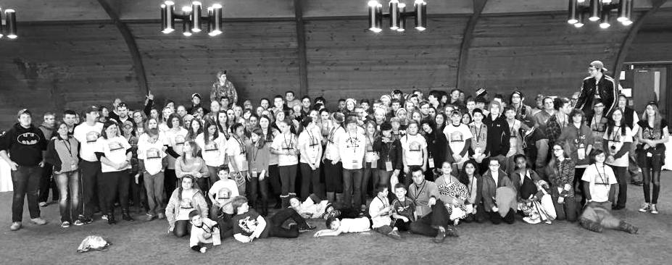

**Please pray for the following church that is currently without a pastor:**

**New Beginnings**

**Pastors’ Breakfast**

**Tuesday, March 10th, 7:00-8:30am**

**Yesterday’s in Metropolis**

All pastors, staff and retired pastors are invited for a time of fellowship together.

**UBA Co-ed Volleyball Tournament Dates**

“C” Group – Thursday, March 5th, Simpson

Games starting at 6:00 p.m.

“B” Group – Friday, March 6th, Metropolis 1st

Games starting at 6:00 p.m.

“A” Group – Saturday, March 7th, New Hope

Games starting at 9:00 a.m.

All Sunday School directors, teachers, as well as group leaders are invited.

Saturday, March 21st, 10:00 a.m. – Noon (Lunch provided)

The leader of the conference will be Tim Sadler from the I.B.S.A.

Please register by calling the UBA Office (618-524-9738) or Larry Fugate (618-564-2973).

Please register by March 18th so that we will know how many to plan for.

**UBA Council and Executive Board Meetings**

**Monday, March 2nd at Karnak First**

**6:00 p.m. – Association Council Meeting**

**7:00 p.m. – Executive Board Meeting**

**Conference Schedule:**

Sunday:

10:15 a.m. - Church Planter

Noon - Luncheon

1:00 p.m. – Multiplying Church Training for FBC Missions Team

6:00 p.m. – Sermon: Nate Adams, IBSA State Executive Director

Monday:

*Noon – Pastors Luncheon*

1:00 p.m. – Church Planters Testimony and Sharing

6:30 p.m. Sermon: Church Planter TBA

Tuesday:

Noon – Luncheon

1:00 p.m. – 1st Multiplying Church Cohort Meeting

6:30 p.m. – Sermon: Church Planter TBA

Wednesday:

Noon – Fasting and Prayer for Church Planting Movement

6:30 p.m. – Sermon: Van Kicklighter

**\*Pastor Luncheon\***

All pastors are invited to come and hear church planters share their stories and experiences. Please RSVP by calling the UBA Office, 524-9738, no later than March 12th.

You can register online at metrofbc.com/reach-illinois/

**Association**

**Sunday School/Group Leaders Training**

**Training**

**Students and leaders attending Ski Retreat 2015, headed up by Metropolis 1st**

**Vienna 1st Baptist: March 1-4, 6:00 p.m.**

Speaker: Pat Pajak, IBSA

**Mt. Zion Missionary: March 15-18**

Speakers: Sunday 11:00 a.m. & 6:00 p.m –Terry Mathis, UBA DOM

Monday, 6:00 p.m. – David “Buck” Siere

Pastor of Brookport 1st

Tuesday, 6:00 p.m. – Frank Forthman, Jr.

Pastor of New Hope

Wednesday, 6:00 p.m. – David Faulkner

Pastor of County Line

**STATE VBS CLINICS**

**March 6th at Marion 1st Baptist**

Registration – 6:00-6:30pm, Clinic – 6:30-9:00pm

**March 7th at Pleasant Hill Baptist in Mt. Vernon**

Registration – 10:00-10:30 a.m., Clinic – 10:30 a.m.-2:00 p.m. (Lunch will be served)

Come participate in a sample Worship Rally, experience a Bible Study or a Rotational Site curriculum overview, taste snack ideas, view decorating ideas and leave with inspiration about how your church can host a Vacation Bible School this year.

To register ahead of time, visit ibsa.org/kids

**Churches represented:**

**Metropolis 1st**

**Waldo Baptist**

**First United Methodist**

**Community Christian**

**ANOTHER MISSION OPPORTUNITY:**

Beth Larrison will be going on mission to Peru again in July. This will be a 10 day trip. The group will be working and holding a VBS. If you are interested in going, please give Beth a call at (618) 534-3181.

**MARCH MISSION ACTION:**

Contributions for Health/Hygiene Kits for migrant workers. If you would like to help out with this project, please consider giving a monetary donation only. This will go toward the purchase of items for the kits. The reason for this is that all bags need to be the same size and contain similar items. Contributions can be brought by or mailed to the UBA Office.

Leadership: Kevin Miller & Nelda Smothers

**APRIL MISSION ACTIONS:**

Shawnee College Survival Kits (Witnessing Bags)

A detailed letter will be sent to each WMU leader or to your church.

Leadership: Dixon Springs

Eagle’s Nest 1-Day Mission trip to sort literature. The date has not been determined yet.

Leadership: Terry Mathis

**Please remember to pray for our missionaries.**

**Jamaica – Feb. 20th – March 6th: Duane McGinnis, (New Hope) and Kevin Miller (Joppa Missionary Baptist) will be working with churches and schools.**