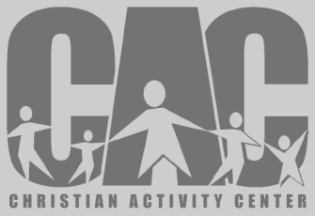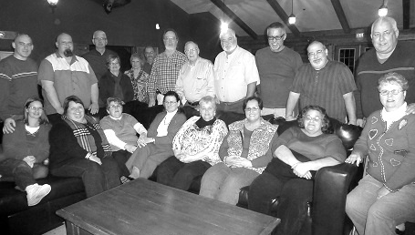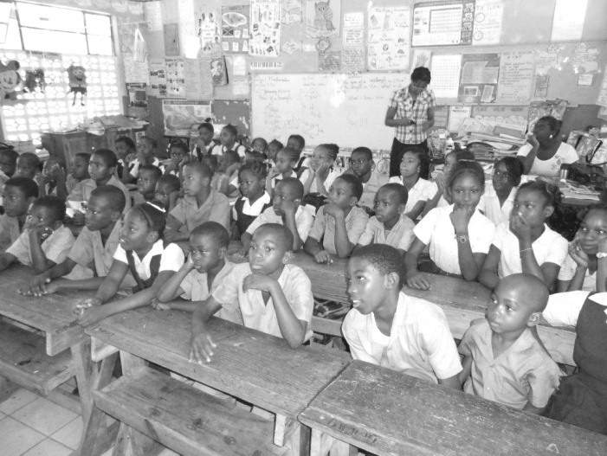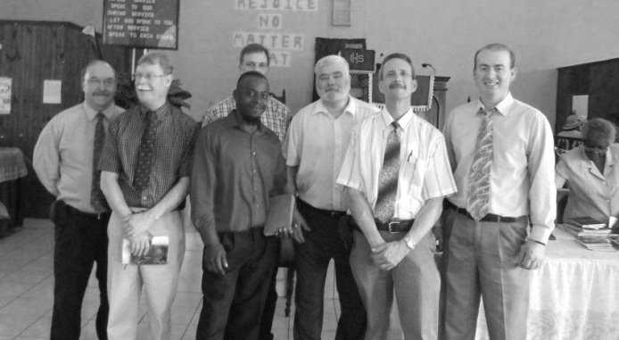

**Association Pastor Breakfast**

**Monday, March 11th, 7:00-8:30 a.m.**

**Yesterday’s in Metropolis**

Even if you don’t have breakfast, stop by and have a cup of coffee with us for fellowship.

**Southern Illinois Men’s Rally –1st Baptist in Herrin**

**Tuesday, March 26th, 5:00 p.m. Supper**

($5 per person at the door)

Emphasis: Reaching Our World for Christ

Main Speaker: Dr. Kevin Ezell, President, NAMB

Call 618-439-3742 or email fbamc@frontier.com to pre-register for supper.

Association VBS Clinic

Tuesday, April 23rd, 6:30 p.m.

Simpson Baptist

All workers are encouraged to attend!

**Baptist Children’s Home**

**Association Representatives Meeting**

**Monday, March 11th, 6:30 p.m.**

**County Line Baptist Church**

Christian Activity Center Banquet

Thursday, March 14th at 6:00 p.m.

Metropolis First Baptist

Special reservations need to be made for this as the seating is eight people per table.

**ADULTS ON MISSION AND**

**NORTH AMERICAN MISSION BOARD STUDY SALAD SUPPER**

**Brookport 1st**

**Thursday, March 7th at 6:00 p.m.**

**Bring your favorite salad dish to share.**

**Guest speakers!**

**CHILDREN’S MINISTRY DAY**

**Saturday, March 16, 2013**

**Park Ave. Church in Mt. Vernon**

This day is an amazing mission experience for girls and boys in grades 1-6. Children and leaders choose a hands-on ministry project that makes community missions come alive. The cost is $15/person. Online registration begins January 14 or you can contact Barb Troeger at 217-391-3138

**Mt. Zion Baptist**

**March 17-22**

**7:00 p.m. nightly**

**Speaker: Terry Mathis**

**UBA Director of Missions**

**The January mission project was collecting items for local food pantries. We received reports from 6 churches in our association with a combined total of 990 items plus $300 donated!**

**UBA MARCH MISSION PROJECTS:**

**Children’s Mission Day – March 10th**

**Team Leader: Linda Mathis**

**Migrant Health Kits**

**Team Leaders: Kevin Miller, Jane McGinnis, Nelda Smothers**

**One Day Mission Trip-Love Packages at Eagles Nest**

**If you would like to go to Butler, IL to sort literature, please reserve a seat on the bus. The trip will be on Thursday, April 11th. We will leave the UBA Office at 6:00 a.m. You can reserve your seat by calling 524-9738 or 270-559-3717.**

**Team Leader: Terry Mathis**

**Loads of Love**

NEW MINISTRY!

**Loads of Love** is a ministry that began at First Baptist in Brookport.  We have done ministry twice now in the Laundromat in Brookport and this ministry already been a blessing to us.  We have made contact with people that we may not normally be in contact with and have been visited by a family that we have ministered to.   On Saturday, February 2nd we went to minister from 10 am to 3 pm.  We were very busy during all those hours and have begun to make friendships that we pray will make an eternal significance in the lives of many people.  Our team has been blessed by what God has done so far and look forward to what He will allow us to do in the future.

**One Day Mission Conference**

**Sunday, March 24th**

If you would like to have a missionary from within our association come to your church to speak, please let us know. They will speak about their mission trip. You can have one speaker on Sunday Morning or Sunday Night, or you can have 2 different speakers for each service. Please contact our office by March 4th.

This year’s Pastor/Wife Retreat was held at Moor’s Resort. Those who attended were:

David & Karen Faulkner, Jerry & Angie Day--guest speakers, Terry & Linda Mathis, David & Anita Wright, Ben & Eren Hottel, David & Carol Siere, Justin & Jacinda Reynolds, Hal & Emma Hicks, Chris & Tina Sielbeck, Jim & Pennie Wilson, Gary & Pennie Cruse--visitors

**Looking for a Mission Trip for your church, mission group, Sunday School class, etc.? Contact the UBA Office. We have connections with some 20 different mission projects in connection with the IBSA. These trips are within the state, national, as well as international. Contact us early in the new year as many of these mission projects have deadlines for reservations.**

***Please pray for our travelling missionaries:***

HAITI: March 23-30 – Jimmy Martin from Metropolis First will lead a team to do construction work.

HAITI: March 30-April 6 – Cliff Easter from Metropolis First will lead a team of youth to do Bible Clubs.

INDIA: March 3-15 - Nelda Smothers will join a team in prayer walking and encouraging work in the World Craft Bible Studies and shops in the cities.

**The Beast Feast 2013**

**PLEASE NOTE THAT THIS IS BEGINNING AN HOUR EARLIER THAN ORIGINALLY PLANNED**

**For Outdoor Sportsmen**

**Saturday, March 16, 2013**

**Joppa Missionary Baptist**

**Meal @ 5:00 p.m., Program @ 6:00**

**Tim Burton—Guest Speaker**

**Men, Women and Kids welcome!**

***There will be many other surprises on this evening, so use this as an outreach to invite your sporting buddies to! They will meet others and be fed both physically and spiritually.***

**The Jamaica Team**

**This is Saint Simon School...the team got to share about Jesus there...at least one was saved...**

On January 19-26th, a team from Joppa Missionary Baptist, along with a few others, traveled to Jamaica. The team consisted of Chad Craycraft, Duane McGinnis, John Veach, Dudley Kesler, Kevin Miller, and Bro. David Wright.

They worked on the Lucea Baptist Church Education building during the day and at night visited other churches and a school. At least six people accepted Jesus as their Lord and Savior!

**The Week of Prayer for North American Missions is March 3-10.**

**Churches, please be planning your goals for this offering. The national goal is $70,000,000!**

***Please let us know if you have an event that you would like to have promoted in our newsletter, on our website, or on our facebook page!***

**2013 ANNIE ARMSTRONG EASTER OFFERING**

**ACTS 8:26-31**

**UPDATE FROM MEXICO:**