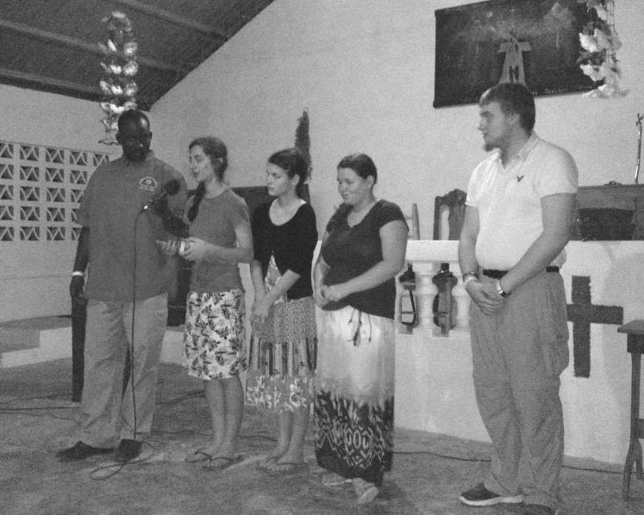******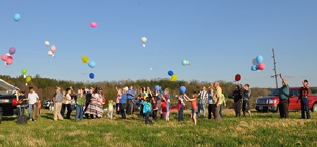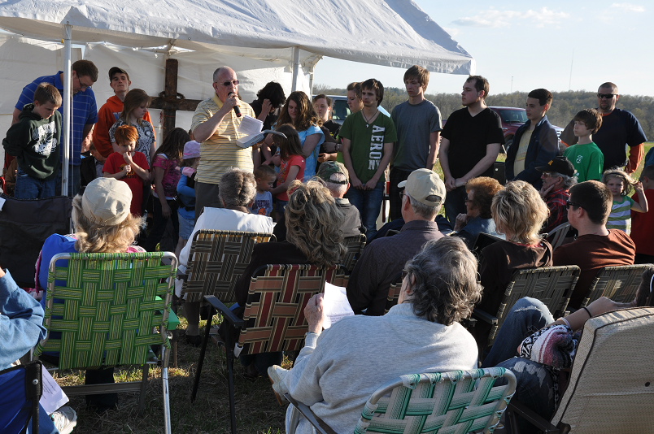**

**IBSA Mother Daughter Weekend**

**Friday, May 17, 5:00pm – Saturday, May 18, 3:00pm**

**Lake Sallateeska Baptist Camp, Pinckneyville, IL**

**Cost: $35/person (includes t-shirt & overnight accommodations)**

**For more information, email or call Barb Troeger at barbtroeger@ibsa.org or 217-391-3138**

The cost of the weekend is $35 per person which includes an event T-shirt, overnight accommodations and the use of the beautiful facilities of Lake Sallateeska Baptist Camp.  
For more information please contact BarbTroeger@IBSA.org or (217) 391-3138.

**LAND DEDICATION!**

**UBA APRIL MISSION PROJECT:**

**Shawnee Community College Witnessing Bags-** **Please deliver bags to the Metro Center by May 3rd!** One hundred bags are needed, so we need each church to please donate up to 10 bags, if possible.

**UBA MAY MISSION PROJECTS:**

**GUARDIAN FAMILY SERVICES COLLECTION:** Each church is responsible for collecting non-perishables or monetary donations. Please deliver to GFS.

**HOPE UNLIMITED BABY BOTTLES:** Please contact Hope Unlimited if your church has not participated in this ministry in the past, but would like to start. It begins on Mother’s Day and ends on Father’s Day and consists of filling baby bottles with change/bills.

Team Leader: Pat Agee

**Two groups from Metropolis 1st traveled to Haiti in March. The first group worked on construction and the second led Bible Clubs.**

**Below: Metropolis 1st youth explaining the Evangicube**

**Looking for a Mission Trip for your church, mission group, Sunday School class, etc.? Contact the UBA Office. We have connections with some 20 different mission projects in connection with the IBSA. These trips are within the state, national, as well as international. Contact us early in the new year as many of these mission projects have deadlines for reservations.**

The New Beginnings Clothes Closet is open the 2nd and 4th Saturdays of each month, 9:00 a.m.-noon. If you know of anyone who is in need of clothing, please send them to this great ministry. The location is 720 E. 12th in Metropolis (2 doors down from UBA).

The UBA Bowling League is looking for

bowlers. This is a couples or co-ed league. The league has been going on for four years and takes place at Bob’s Bowl in Metropolis on Friday nights. League begins in August. If interested in participating, please call Ed Hollis at 618-771-0442 by August 1st.

Bro. Joe Buchanan, the pastor of Metropolis First, has just completed and published his first book, entitled “Cultivating a Gospel-Shaped Attitude.” The official release of the book will be May 5th, but he is taking orders for it now. His goal is to sell 5,000 copies between now and the end of May and all of the proceeds raised will go toward mission work in Haiti. After May, 25% of the profits will continue going to the Haiti Mission Fund of Metropolis First. If you are interested in purchasing his new book, you can contact Metropolis First Baptist to pre-order or find it on Amazon or CrossBooks.

**WORLDCRAFTS:** Ms. Nelda Smothers recently went on a mission trip to India. The trip was designed to help the group get a heart for the WorldCraft artisans and an appreciation for their crafts. Their Indian travel guide led them to places where he had never been and he was touched by their plan to tour the slums, spending time working with those who are hidden from other tourists. The group came home with plans to encourage the growth of WorldCrafts ministries in the 30 countries where we support artisans, with hopes to reach even more.

If your church is interested in hearing of Nelda’s trip or in holding a WorldCraft party, contact Nelda at 638-5054. We also have catalogs available at the UBA Office.

Please let our Office know of your VBS dates so that they can be listed in our newsletter.

Karen Faulkner, Association VBS Director

UBA Men’s Ministry Rally!

Tuesday, May 14th

New Hope Baptist

Meal at 6:00 p.m. and program to follow.

**Next Scheduled Executive Board Meeting:**

**Monday, June 3rd, 7:00 p.m.**

**Oak Grove Baptist**

**PASTORS’ BREAKFAST**

**Tuesday, May 7th, 7:00-8:30 a.m., Jumbo’s in Vienna**

Drop by for breakfast or maybe just a cup of coffee and enjoy the fellowship.

***July 14, 2013***

***First Baptist Church of Karnak will be celebrating their 100th Anniversary with an all day service! An exciting day is planned! Sons of the Father will be singing and there will also be preaching.***

***Sunday School – 10:00 a.m.***

***Worship – 11:00 a.m.***

***Lunch and afternoon services – 1:15 p.m.***

***Everyone is invited to come and join in the celebration!***

**Saturday, October 5, 2013**

**Fort Massac Park in Metropolis**

All proceeds from the 5k run will be split amongst the top 3 groups to register and will be divided as follows:

Group 1 – 50% of proceeds to the charity of their choice

Group 2 - 30% of proceeds to the charity of their choice

Group 3 – 20% of proceeds to the charity of their choice

The run will be sponsored by Waldo Baptist Church and, in conjunction with the 5K, Waldo will be starting a 12 week training program called “Run for God”. This program will start June 26 and run through October 5th. The class will be on Wednesday nights from 6:30-8:00. The Run for God program offers a practical guide to running and a 12-week training plan aimed at completing a 5K while maintaining a Christian focus. All ages and fitness levels are welcome… there will even be classes for children!

If your church feels led to start a Run for God challenge class of your own, all of the info and instruction manuals can be found at www.runforgod.com. For more information, please contact Miranda Campbell at 618-564-9089, Greta Anderson at 618-638-6368, or Holly Turner at 618-645-0179.

***Run for God 5k/Fun Run-“This Little Light of Mine”***

**VIENNA 1ST BALLOON LAUNCH**

On April 14, 2013, I had the privilege of attending the Vienna 1st Baptist Land Dedication Service. They have purchased 11 acres next to Interstate 24 on the hill behind Jumbo’s Restaurant. It’s a beautiful location and is visible to everyone’s sight. Plans are, in the near future, to relocate the church to this lot. Plans have been drawn up and they are now in the process of paying off the land. The dedication was well attended by young and old alike. There was singing and testimonies along with a challenge from Pastor Ed Hollis, after which a balloon release took place. They are excited about what is happening in their church. I was very thankful to be a part of this historical event.

Terry Mathis

**VIENNA 1ST LAND DEDICATION SERVICE**

***Please pray for our travelling missionaries:***

***Haiti, June 7th-14th: Metropolis 1st will be taking a large group for a medical mission trip.***

***Mexico, July 20th-27th: Life Church Eastland will be sending a group to work with church planters and hold VBS.***

***Please let us know if you have an event that you would like to have promoted in our newsletter, on our website, or on our facebook page!***

**UPDATE FROM MEXICO:**