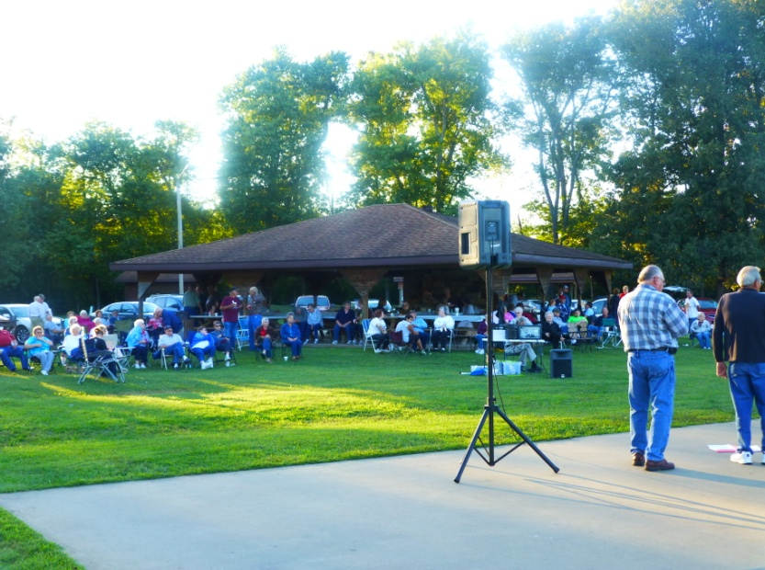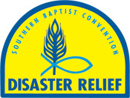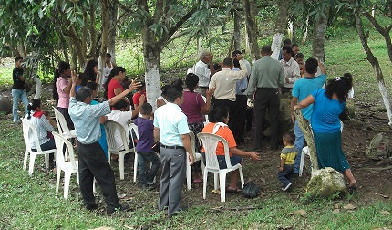

**October: Operation Christmas Child**

**One Day Mission Trip to Eagles Nest**

**Once again, we have shoe boxes for Operation Christmas Child. If you would like to purchase some, please call or drop by our office. There is a charge of 25 cents per box. Immanuel Baptist will be the drop off location again this year. Dates and times are:**

**Nov. 18-23: 2:00-6:00 p.m.**

**Nov. 24: Noon-2:00 p.m.**

**Please drop off literature for Eagles Nest no later than October 23rd. The trip to Eagles Nest will be on Thursday, October 24th. We will leave the UBA Office at 6:00 a.m. and return around 9:00 p.m. Please call the UBA Office to reserve a seat on the van. We have a twelve person limit.**

***Please pray for our traveling missionaries:***

***Sept. 30 – Oct. 7 – Haiti – Terry & Linda Mathis, Ben & Eren Hottel, Jackie & Emma Lange, Terry & Tam Foster, along with Bob Elmore from the IBSA, will be working with church planters.***

***Nov. 9 – 16 –Haiti – Amy Land, from Brookport Firs, will be traveling with a church group from Paducah.***

**DISASTER RELIEF TRAINING**

**October 11-12**

**Lake Sallateeska Baptist Camp**

**(By Pinckneyville)**

Several of you who have been trained in the past have expired badges. It is necessary to have the new hologram on your badge for security purposes. There is a $10 fee to renew. If interested in getting involved for the first time, there is a $30 fee and an Introduction Course to take. You can register online at ibsa.org/dr

I will be taking a van up on Saturday, October 12. We will leave the UBA Office at 6:00 a.m. and will return around 5:00 p.m. A schedule for the day is listed below. Please call the UBA office if you would like a ride.

7:30 a.m. – Registration & Welcome

8:30-noon – Choose a track from the following: food preparation, chainsaw, child care, flood recovery/mud out, shower unit, communications unit, and assessments

1:00-3:30 - Introduction to Disaster Relief and continuing of tracks

If you are interested in Chaplaincy Training, you will need to be there at 1:00 p.m. on **Friday**.

***Coming Events!***

**SEVEN MILE BAPTIST CHURCH HOMECOMING**

**October 6th**

**10:00 a.m.**

The service will begin with Bro. John Larrison speaking and “Cross Harmony” providing the music. There will be a noon potluck meal. All are invited!

**GOOD NEWS!** On Saturday, September 21, we had our Associational Fish Fry at Vienna City Park. A great time was had by the hundred or so who came. We had plenty of fish and hushpuppies, along with good singing by Divine Intervention of County Line Baptist. But, the greatest thing of all was that as everyone was leaving, Bro. David Wright spoke with a lady there and she accepted the Lord as Savior! It was one of the best Fish Fries ever!

**Praising God in Honduras**

**HONDURAS MEDICAL MISSION TRIP**

God’s plan is always best! In the four days of clinic in Honduras, the hands and heart of Jesus reached out to over 1,200 people at 2 different locations. In the little mountain community of San Antonio, God was busy building His Kingdom. With many new converts at this location and no evangelical church established there, what would happen to these new babes in Christ? They held their first service, 2 weeks after we left, in a home across from the medical team site. Fourteen adults and eight children were in attendance. God’s plan is always best! – Kevin Miller

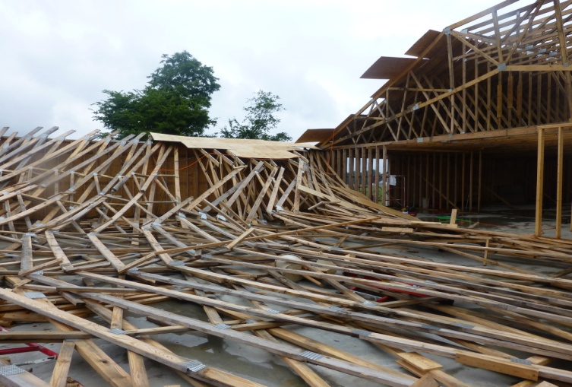

**2013 FISH FRY**

**IBSA Annual Meeting**

**November 13-14 at the Hilton Hotel in Springfield**

Kevin Ezell, North American Mission Board President, and Gary Frost, NAMB Midwest Region Vice President, will be Wednesday evenings featured speakers.

**IS YOUR CHURCH ON MISSION?**

We would love to hear about your church’s mission trip or mission work you are doing. We want to share what God is doing through Union Baptist Association churches. Just call, email (bevturner@metrouba.com), or drop by with the information so that we can print it in future issues of our newsletter.

**IBSA PASTORS’ CONFERENCE**

**November 12-13 at the Hilton Hotel in Springfield**

The IBSA Pastors' Conference is November 12-13 at the Hilton Hotel in Springfield, IL. The theme is “The Pastor as Servant Leader” based on Acts 20:28.

Featured speakers include:

- **Chuck Kelley**, president of New Orleans Baptist Theological Seminary  
- **Micah Fries**, Vice President of LifeWay Research in Nashville, TN  
- **Bobby Boyles**, Church Planting Consultant for the Baptist General Convention of Oklahoma  
- **Jerry Cain**, President Emeritus of Judson University in Elgin, IL  
- **Jay Strother**, Campus and Teaching Pastor of The Church at Station Hill, regional campus of Brentwood Baptist, TN

For more information, please visit ibsa.org/meeting2013 or call the IBSA at 217-786-2600.

**Oct. 13 is World Hunger Sunday**

Everyday people across the globe suffer from hunger. Not just the growling stomachs that we sometimes experience during the late afternoon, but real hunger.

Each year a Sunday is set aside to focus on the issue of World Hunger to educate and encourage followers of Christ to take steps to address this worldwide problem. This year the suggested date is Sunday, Oct 13. You can find resources for World Hunger Day at [WMU.com](http://wmu.com/index.php?q=blog/missions-leader/missions-involvement/world-hunger-what-you-can-do), [NAMB.net](http://www.namb.net/nambblog1.aspx?id=8590123092&blogid=8589939695)or by calling (800) 968-7301.

Everyone in your church will experience and become more aware of world hunger in age-appropriate ways. People will exit with a strategy to do their part in fighting world hunger.

**COLORADO FLOODING DISASTER RELIEF**

There are currently 2 teams from Southern Illinois that are responding to Disaster Relief in Colorado. They will be returning on October 2nd. There will be future mud out teams needed. If you are interested, contact the UBA Office. Disaster Relief Training is being offered in October. You can find more information in this newsletter.

**We have a new church plant in our area. “Revelation Road Baptist Church” is located in West Vienna. They are in need of a pianist/song leader. If you would like to volunteer on a temporary basis, please call Charles Duckworth at 618-697-4405.**

**Work progressing at Weaver Creek**

**North Carolina Mission Team**

Back in August, a mission team of twenty-four people from Canton, North Carolina came to our association to do construction and other mission projects in our area. We were able to send some of the group to work at Weaver Creek Baptist Church. If you remember, they were building a new church in June when a windstorm blew down the walls and rafters. In August, this team helped reset the walls. They felt a commitment to return September 18-21 to help the church reset the rafters and deck the roof in order to prepare it for metal roofing. On this trip, fourteen men came and, each day, a group from Thompsonville, IL came to help.

Things were going up and the work was progressing when yet another stumbling block came on Friday morning. Some thirty of the rafters they had set that morning suddenly came falling down and, unfortunately, one of the team members from NC was under them. He had to be taken to Baptist Health where he spent the night. He had 3 broken ribs and a fractured right wrist. We praise God that his injuries were not any worse. This put a damper on the work for a while, but on Saturday, there seemed to be a new vision. We don’t understand why things happen, but we leave it in God’s hands to work good out of this. The North Carolina Mission Team said they would be back in the near future to continue their partnership with Weaver Creek Baptist.