****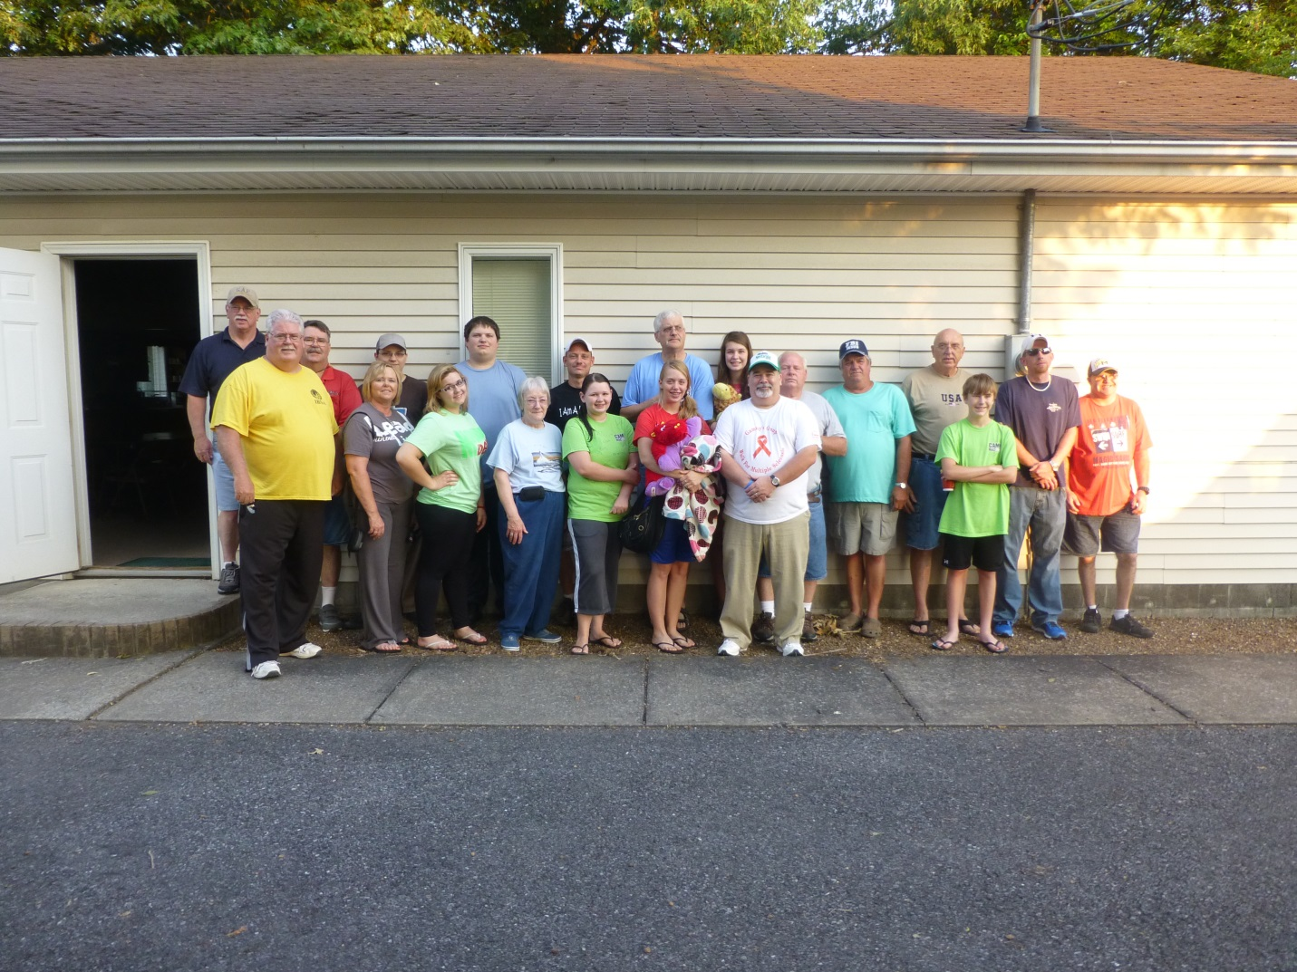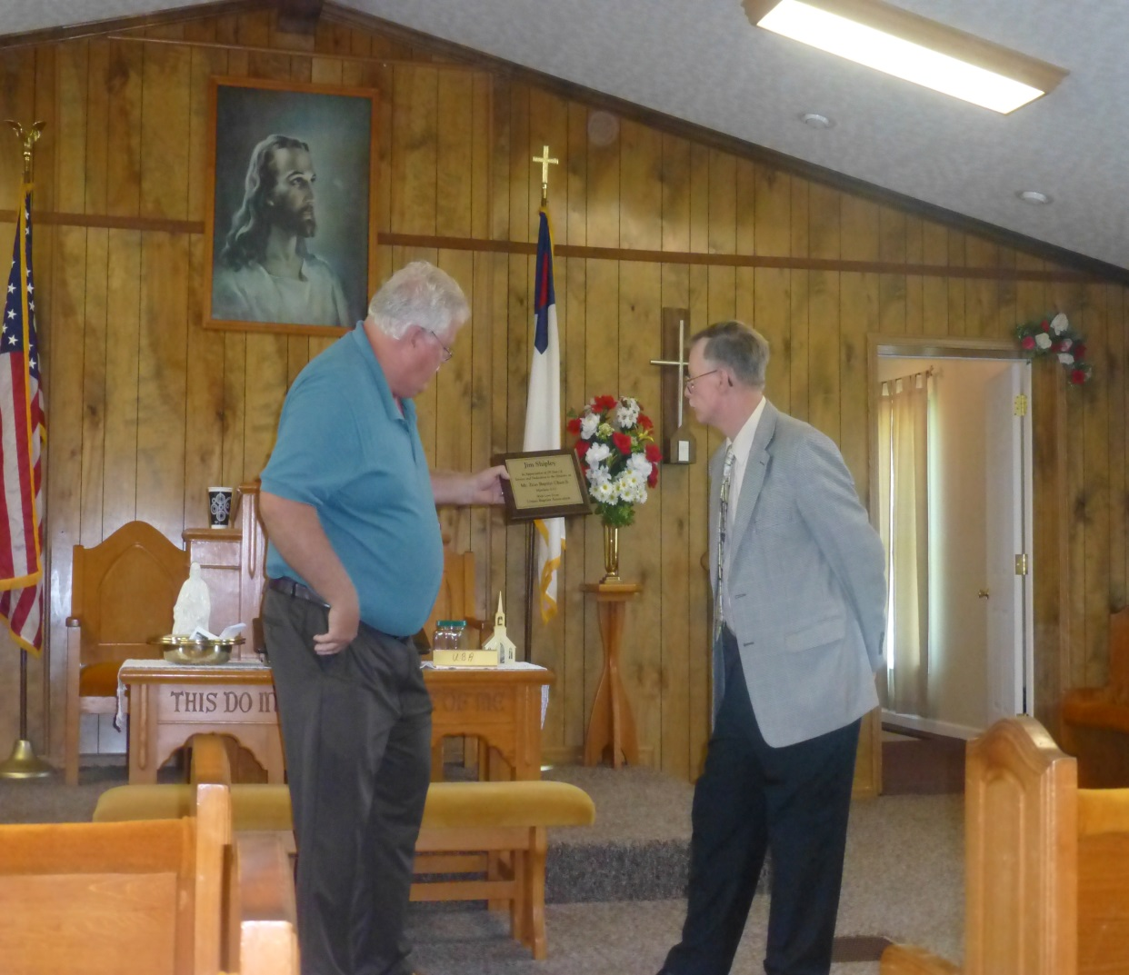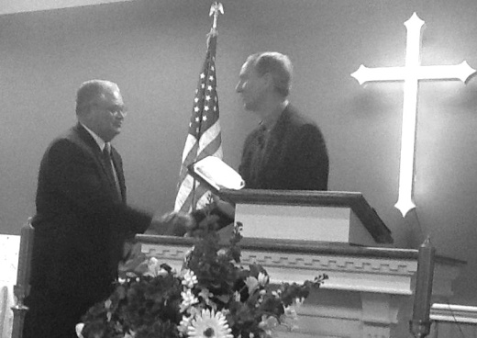

**COMING MEETINGS!**

**Bro. Terry Mathis presented a plaque, from the UBA, to Jim Shipley on behalf of his 28 years of serving the Lord as Pastor of Mt. Zion Baptist. Due to health issues, Bro. Jim retired on July 7th.**

**IMPORTANT LOCAL MISSION PROJECT!**

**AUGUST IS CRISIS INTERVENTION MONTH!**

During the month of August, we would like our churches to recognize our Law Enforcement, EMT’s and Emergency Responders, Fire Fighters, and other services that help in our communities.

**ASSOCIATION NOMINATING COMMITTEE**

Tuesday, August 6th, 7:00 p.m. UBA Office

**ASSOCIATION COUNCIL STRATEGY MEETING**

Monday, August 19th, 6:00 p.m. UBA Office

This is the strategy meeting to make plans for the 2014 calendar.

**ASSOCIATION BUDGET COMMITTEE**

Tuesday, August 20th, 7:00 p.m., UBA Office

**ASSOCIATION EXECUTIVE BOARD MEETING**

Monday, August 26th, 7:00 p.m., County Line Baptist

All Pastors, church E-Board Members, and Council Members are encouraged to attend.

**COMING VBS DATES:**

**July 29-Aug. 2: Dixon Springs**

**July 29-Aug. 2: Immanuel**

**August 3: Cypress**

**August 5-9: Brookport**

**PLEASE REMEMBER TO FILL OUT YOUR VBS SURVEYS AND SEND THEM TO OUR OFFICE.**

**Weaver Creek Baptist**

**HOMECOMING CELEBRATION!**

**Sunday, July 28th**

**10:45 a.m. service followed by lunch.**

**6:00 p.m. Gospel Singing**

**MEETING AND DINNER FOR UBA CHURCH CLERKS**

**THURSDAY, AUGUST 22, 6:00 P.M.**

**AT THE UBA OFFICE**

The Annual Church Profile will be given out that night to the Church Clerks. We will be going over it so that everyone will understand how the Church Profile is to be filled out, plus we’ll be informing you of additional information that is valuable to the association.

We invite all of our Church Clerks to register by August 20th by calling the UBA Office!

CHURCH

CLERK

MEETING!

**“CAMP MAC” REPORT**

We had a great week of camp: 160 in attendance, 15 Salvation Decisions, 8 Rededications, 11 Prayer Concerns

“My favorite things about “Camp Mac” are swimming and the organized chaos game because it is fun and funny. The next thing I liked about Camp Mac is the staff and the band. The staff is really nice and kind and the band is really good.” – Zach W., 8th grader from Joppa Missionary

“I love worshiping the Lord and having a blast with my friends.” – Peyton L., 8th grader from Life Church Eastland

We would like to thank everyone who works to keep our camp a fun and safe place where kids can learn about Jesus!

**The American Heritage Girls Troop IL 1230 will be holding an open enrollment event on Wednesday, August 14th at the Metropolis Community Center (900 W. 10th St.)**

**AHG is a Christ-centered character development program for girls ages 5-18. For more information, call Amy Land (618-638-6742) or visit ahgonline.org**.

**Sunday School Training**

**for Directors and Teachers of Grades 1-6**

**Saturday, August 10th**

**10:00 a.m. – noon**

**Union Baptist Association Office**

**The leader for this meeting will be Bryan Phelps, the Children’s Worship Leader at Heartland Worship Center. Please call our office by August 7th to register! A light lunch will be provided.**

**UBA Music Leaders Appreciation Banquet**

**Saturday, August 17, 2013**

**6:00 p.m. at the UBA Office**

**Please register by calling the office at 524-9738 by August 13th.**

***Please pray for our travelling missionaries:***

***Sept. 30 – Oct. 7 – Haiti – Terry & Linda Mathis, Ben & Eren Hottel, Jackie & Emma Lang, and Tam Foster will be teaching Church Planters and their spouses.***

***Nov. 9 – 16 –Haiti – Amy Land and others will be visiting the orphanages.***

**World Changers, Joplin, MO Report:**

**Total of 20 went from the UBA**

**Total of 233 workers were in Joplin**

**Total of 21 homes were worked on**

**Total of 27 salvation decisions!**

**Karnak 1st Baptist 100th Anniversary Celebration!**

From Pastor Dean West: Our church celebrated its 100th anniversary on July 14th.  It was a great day.  Sons of the Father gave two concerts, Nate Adams, Executive Director for Illinois Baptists, brought a great message during the morning service.  Our Director of Missions, Terry Mathis, brought a great challenge during the afternoon service.   One of our deacons counted 175  present for the morning service.  It was a special day for our church!

**Nate Adams presenting a**

**plaque to Pastor**

**Dean West**

**SCHOLARSHIP – DEADLINE AUGUST 5TH!**

Has God called you into a ministry that requires you to attend college in order to prepare for it? The Union Baptist Association will be taking applications for its first ever scholarship. Applications are for the fall semester and can be picked up at the UBA Office. This is for any person that is a member of one of our association churches. The scholarship is being made available by the UBA Men’s Ministry.

**PLEASE CONTACT US WITH YOUR PRAYER REQUESTS AND PRAISE REPORTS! WE WILL SHARE ON OUR FACEBOOK PAGE OR IN OUR NEWSLETTER.**

**FEEL FREE TO POST ANY URGENT PRAYER REQUESTS ON OUR FACEBOOK WALL. YOU WILL IMMEDIATELY HAVE A NUMBER OF PEOPLE PRAYING!**

***PRAYER REQUEST: Please remember Simpson Baptist and Mt. Zion Baptist in your prayers as they search for a pastor.***

***PRAISE REPORTS:***

***A group from Metropolis 1st, along with Pastor Manuel Orosco, went to the Migrant Camp in Cobden, IL on July 17th. There were 5 salvations that evening!***

***There were 15 salvations at Camp Mac this year. The camp continues to grow each year. Thanks for your prayers!***

.

**UBA August Mission Project:**

**Ice Cream for 9-Day Trail Ride – We need 20 gallons of homemade ice cream. Please call our office if you will donate a gallon. The ice cream needs to be frozen hard in a disposable container. Please bring to our office by 4:30pm on July 30th.**

**UBA July Mission Projects:**

**Collecting back to school supplies for Christian Activity Center in E. St. Louis. Please bring your supplies to the UBA Office by July 31st.**

**Leader: Vienna 1st**

**The jail ministry in Metropolis is looking for Bible Study/Sunday School books for young men. They enjoy the Explore the Bible series. If your church missed the collection we had last month and have any of these books that you would like to donate, please contact our office.**