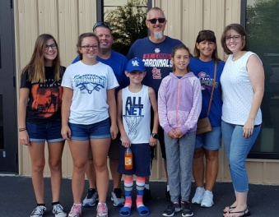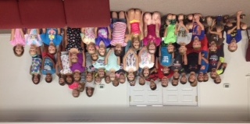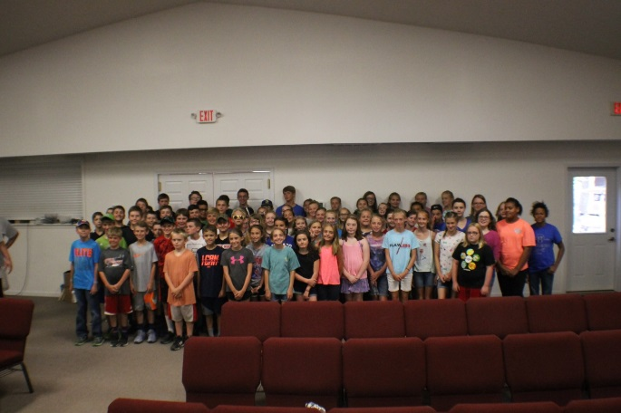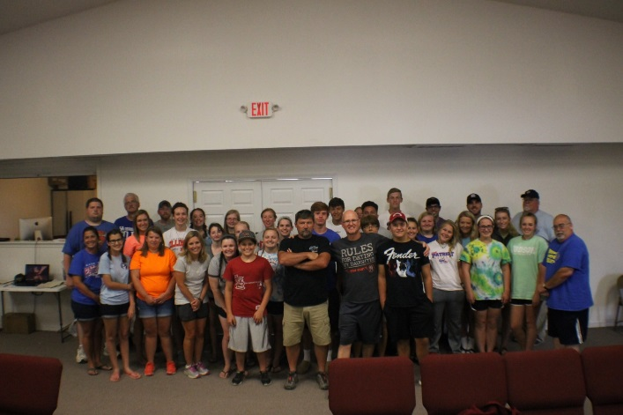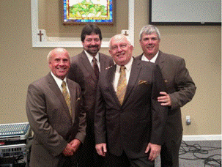

**Recent Mission Trip:**

**Eastland Life Church**

**Mexico Mission Group 1**

**The 2nd group leaves August 5th**

**Camp Mac Kids!**

**5th & 6th Grades**

**Camp Workers (minus the kitchen crew)**

**Camp Mac Update!**

We would like to thank all who contributed to Camp Mac this year! Whether you worked at the camp, contributed food or money, or prayed, we appreciate you very much! We had a total of 186 kids with 8 salvations, 2 rededications, and 64 prayer concerns. It really was a “Priceless” week!

**All proceeds will go directly to BCHFS!**

**14th Annual Singing**

**for the Baptist Children’s Home**

**Saturday, August 19th, 7pm, at Dixon Springs Baptist Church**

**(East of Vienna on State Route 146)**

**Featuring:**

**The Victory Boys**

the

UBAconnection

**Volume 1, #69**

**MONTHLY MISSION PROJECTS**

**AUGUST -** Local Crisis Intervention.Each church is asked to pick a crisis center in their community to serve in some way.

Also in August – Annual Benefit Singing for the Baptist Children’s Home. Leadership – Dixon Springs

**SEPTEMBER** – Baptist Children’s Home Fall Festival, Carmi, IL, on Sept. 16th, 10am-2pm. We’re asking for items for the silent auction. More information will be in our next newsletter.

**Union Baptist Association Terry Mathis, Director of Missions**

**P.O. Box 29 email:mathisterry2009@hotmail.com**

**Metropolis, IL 62960 Beverly Turner, Admin. Asst.**

**618-524-9738 bevturneruba@gmail.com**

**UBA theme for 2017: “For we cannot keep from**

**speaking about what we have seen and heard” Acts 4:20**

**AUGUST, 2017 NEWSLETTER**

**Non-Profit Organization**

**U.S. Postage Paid**

**Permit #137**

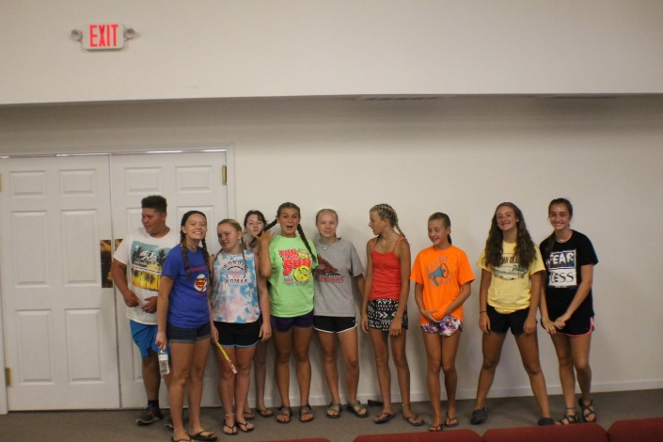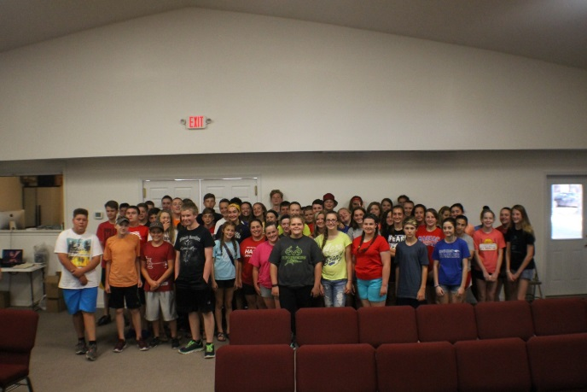

**Union Baptist Association**

**P.O. Box 29**

**Metropolis, IL 62960**

***Return Service Requested***

**Future Camp Workers**

**(Camp Brats)**

**7th & 8th Grades**

**3rd & 4th Grades**