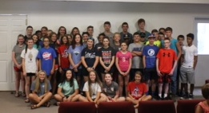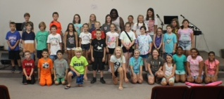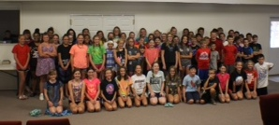

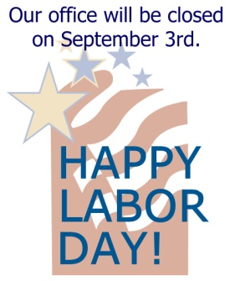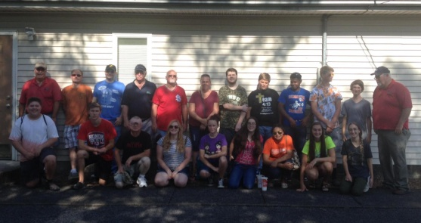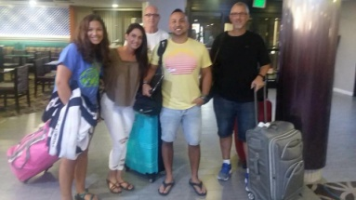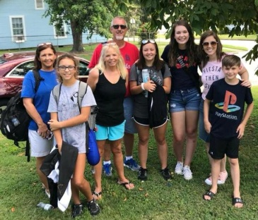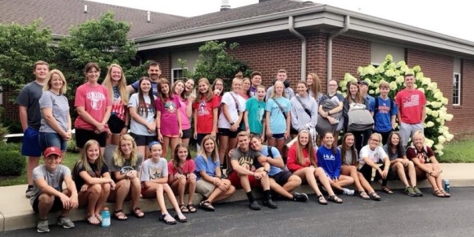

**CAMP MAC 2018: We would like to thank all the churches that gave special offerings for camp! Along with the food brought to our office, we also received $6,210.00 in monetary donations! This helped to offset many of our expenses! Also, thank you to all the adult and Jr. counselors and all the volunteers who worked so hard! This year, we had 154 kids and 43 workers in attendance, 2 salvations, 1 rededication, 1 answer to the call of ministry, and 23 prayer concerns addressed! What a wonderful week the Lord gave us!**

**15th Annual Singing**

**for the Baptist Children’s Home**

**Saturday, August 18th, 7pm, at Dixon Springs Baptist Church**

**(East of Vienna on State Route 146)**

**An offering will be taken for the children’s home.**

**Entertainment by The Victory Boys!**

**WORLD CHANGERS 2018**

**Volume 1, #78**

**The**

**UBA Connection**

**This newsletter has information for August and September! The next newsletter will be mailed out the end of September.**

**2 groups from Life Church Eastland who travelled to Mexico**

**Group from Metropolis First and Joppa Baptist headed to Chicago to do mission work.**

**Union Baptist Association**

**P.O. Box 29**

**Metropolis, IL 62960**

***Return Service Requested***

**UBA MONTHLY MISSION PROJECTS**

**Please don’t forget to bring your outdated literature to our office. It will be taken to Eagle’s Nest, in Butler, IL where they will sort and deliver it to overseas missionaries.**

**AUGUST - Local Crisis Intervention –** We’re asking each church to assist or show appreciation for their local first responders (police, firefighters, EMT’s, etc.

Also, in August, the Baptist Children’s Home Annual Singing will be held at Dixon Springs Baptist Church on August 18th. Please promote this in your church.

**SEPTEMBER 15th, 10:00am-2:00pm - Baptist Children’s Home Fall Festival.** We’re asking our churches to donate new or home-made items to be auctioned at the quilt or silent auctions. You could also set up a booth or game. Bring items to our office no later than September 4th. Please promote this.

**Union Baptist Association Terry Mathis, Director of Missions**

**P.O. Box 29 email:mathisterry2009@hotmail.com**

**Metropolis, IL 62960 Beverly Turner, Admin. Asst.**

**618-524-9738 bevturneruba@gmail.com**

**UBA theme for 2018: Assisting Churches - Advancing the Gospel**

**AUGUST & SEPTEMBER, 2018 NEWSLETTER**

**Non-Profit Organization**

**U.S. Postage Paid**

**Permit #137**