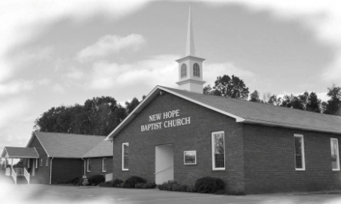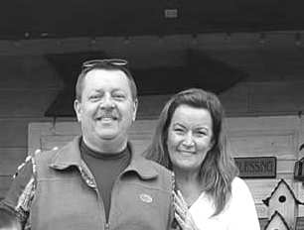

**IBSA Sunday School Director Training**

**Saturday, September 8th, Springfield, IL**

**Total cost: $60 (includes double-occupancy room, registration fee, lunch, and training materials)**

We will be taking a group to this. We will leave the UBA Office on Friday, September 7, at 3:00 p.m., for an overnight stay and training at the IBSA Office. Half of the cost will be paid by the UBA. Openings are limited, so please register by calling the UBA Office no later than August 30th. This is for Sunday School Directors only.

**Association Music Leaders’ Banquet**

**Saturday, August 25th at the UBA Office**

**Catered Meal: 6:00pm, Program: 6:45pm**

**For reservations, call the UBA by August 20th.**

**UBA Council & Executive Board Meeting –**

**August 27th, 7:00 pm at Hillerman Missionary Baptist**

**All pastors and board members are encouraged to attend!**

**Replenish 2018 - September 27, 10:00am-5:00pm**

**Heartland Church in Paducah**

Replenish is a one day event aimed at strengthening and encouraging pastors, and other Christian leaders in their callings. To find more information or to register, visit kybaptist.org/replenish/

**Pastor Church Anniversary**

**August:**

**Joe Buchanan – Metropolis 1st, 2007**

**Gary O’Neal – Cypress 1st, 1998**

**Jim Wilson – Oak Grove, 2011**

**Stephen Williams – Simpson, 2014**

**September:**

**Cliff Easter – Metropolis 1st, 2002**

**Ben Hottel – Hillerman Missionary, 2011**

New Hope Baptist Church was organized in 1860 and held its first services in the “Old Walker School” until a log cabin type structure was built. Later, in 1879, a new frame building was built. The frame building burned on March 3, 1935, so services were held across the road in the Odd Fellows Lodge while a new church was built on the original site. The new building was dedicated at the Homecoming service on May 30, 1936.

New Hope has always been a mission giving, going and praying church. In July of 1942, they held their first VBS and members have been going on mission, both locally and around the world, since then. One of the church’s ongoing mission works is a yearly trip to Jamaica, led by Duane McGinnis.

Today, the church is continuing to grow in membership. They have built a beautiful Activities Center and have remodeled the church. Bro. Frank Forthman, Jr. has been their pastor since 2005 and he, as well as the church, is very involved in the Union Baptist Association. We are proud to be in partnership with the great folks of New Hope Baptist.

**This month’s featured church is:**

**New Hope Missionary Baptist Church**

**ATTENTION VBS DIRECTORS:** Please remember to send us your LifeWay VBS report. Many thanks to the churches who have already sent theirs!

**Refocus: Evangelistic Preaching & Invitation**

**August 20, 2018, 6-8:30pm**

**West Union Baptist Association in Paducah**

**Leader: Joel Sutherland, NAMB Exec. Dir. of Evangelism**

You can find more information, as well as registration, at kybaptist.org

At 7:00 a.m. local time, all around the globe, students will be gathering at their flagpoles, praying for their school, friends, families, churches and communities.

**PASTOR/WIFE/CHURCH STAFF BIRTHDAYS**

**August 2 – Jack Hill, New Salem**

**August 10 – Gary O’Neal, Cypress 1st**

**August 17 – David Wright, Joppa Missionary**

**August 18 – Marvin Ballard, Seven Mile**

**August 19 – Kamie York, Waldo Missionary**

**August 22 – Carol Siere, Brookport 1st**

**September 5 – Glenn Coram, Immanuel**

**September 11 – Charles Duckworth, Revelation Road**

**September 12 – David Atwell, Waldo Missionary**

**September 15 – Linda Mathis, UBA**

**September 17 – Jim Wilson, Oak Grove**

**September 27 – Katrina Snell, Dixon Springs**

**PASTOR & WIFE ANNIVERSARIES**

**August 6 – Dean & Donna West, Karnak First**

**August 24 – David & Karen Faulkner, County Line**

**Frank and Sara Forthman**

***Church Contributions for Budget***

***(rec’d & deposited in May & June, 2018)***

Brookport First $ 1,178.20

County Line $ 600.00

Cypress First $ 122.00

Dixon Springs $ 427.00

Eastland Life Church $ 400.00

Grace Church $ 100.00

Hillerman Missionary $ 1,327.62

Immanuel $ 621.22

Joppa Missionary $ 2,119.50

Karnak First $ 1,183.51

Metropolis First $ 4,483.30

Mt. Zion $ 699.28

New Beginnings $ 565.53

New Hope $ 0.00

New Salem $ 50.00

Oak Grove $ 75.88

Revelation Road $ 25.00

Seven Mile $ 0.00

Simpson $ 200.00

Vienna First $ 866.66

Waldo $ 933.34

Weaver Creek $ 25.00