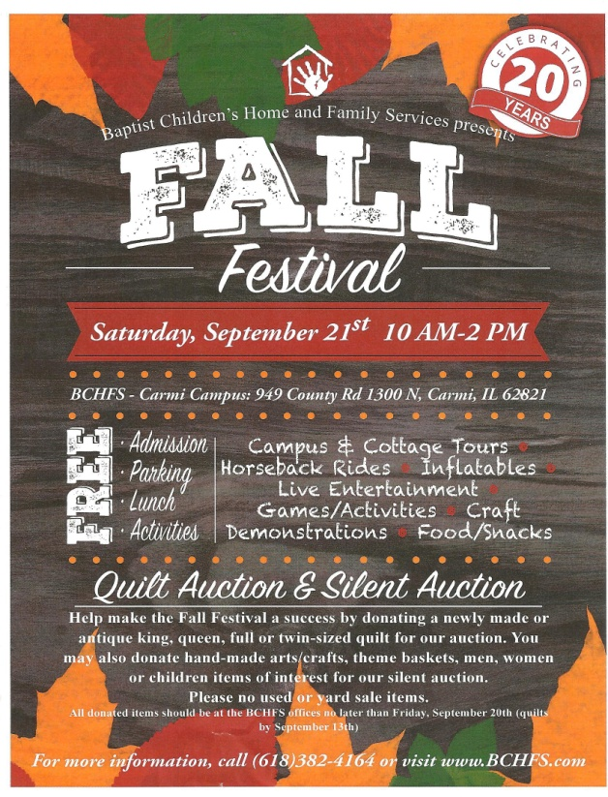******

***This newsletter contains information for August, September and October! The next newsletter will be mailed out the end of October.***

**The UBA Connection**

**Union Baptist Association**

**P.O. Box 29**

**Metropolis, IL 62960**

***Return Service Requested***

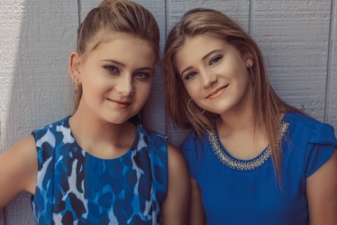

**PLEASE PROMOTE THIS IN YOUR CHURCH! This is a wonderful opportunity for children in our area with special needs! There is no charge for the camp, but children need to be registered through the website or through the Rolling in Faith facebook page.**

**Camp Mac!**

**141 campers! - 7 Salvations! – 3 answers to the call of missions or ministry! – 7 re-dedications! – Many prayer requests! We would like to thank our camp volunteers and the churches who donate each year to make this possible!**

**Annual Singing for the Baptist Children’s Home!**

**When: August 10th @ 7:00 PM**

**Featuring: The Peyton Sisters**

**Location:  Dixon Springs Baptist Church**

**UBA MONTHLY MISSION PROJECTS**

**JULY- Christian Activity Center in E. St. Louis**- bring items to the UBA Office by August 20th. Leadership: Vienna 1st

**AUGUST** – Local Crisis Interventions. Each church is asked to show appreciation to their local police, firefighters, EMTs, etc.

Also in August is the Annual Singing for the Baptist Children’s Home. Leadership: Danny Carter

**SEPTEMBER** – Baptist Children’s Home Fall Festival. Please donate new items for the silent auction. Leadership: Faye Bowman

**OCTOBER** – Operation Christmas Child Shoebox Collection Leadership: Immanuel. Also, Eagles Nest Trip – October 7, Seating on the bus is limited, so please call to reserve your seat.

**Union Baptist Association Terry Mathis, Director of Missions**

**P.O. Box 29 (716 E. 12th) email:terrymathis2019@outlook.com**

**Metropolis, IL 62960 Beverly Turner, Admin. Asst.**

**618-524-9738 bevturneruba@gmail.com**

**UBA theme for 2019: Together, everyone achieves more – 1 Cor. 3:9**

**August, September & October, 2019 NEWSLETTER**

**Non-Profit Organization**

**U.S. Postage Paid**

**Permit #137**