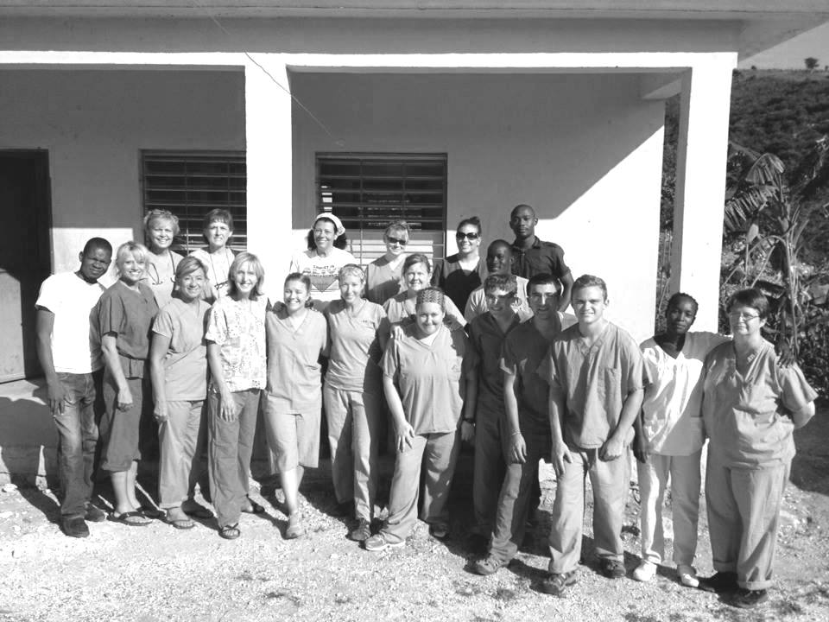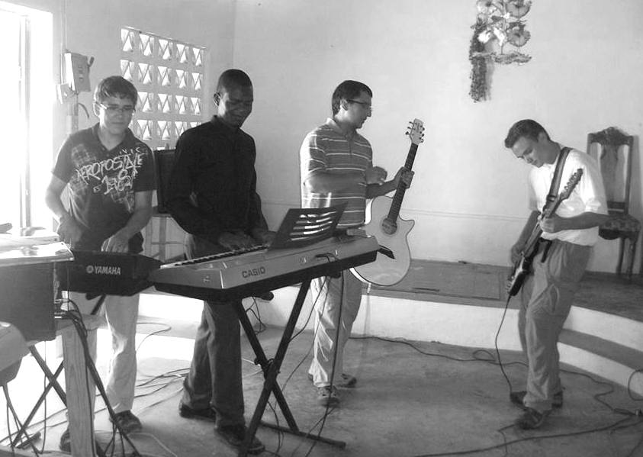

**Metropolis 1st, along with others, ready to open the clinic**

**We would like to share a few pictures from the Metropolis 1st Haiti Medical Missions Trip last month!**

**Youth Band**

**PLEASE CONTACT US WITH YOUR PRAYER REQUESTS AND PRAISE REPORTS! WE WILL SHARE ON OUR FACEBOOK PAGE OR IN OUR NEWSLETTER.**

**FEEL FREE TO POST ANY URGENT PRAYER REQUESTS ON OUR FACEBOOK WALL. YOU WILL IMMEDIATELY HAVE A NUMBER OF PEOPLE PRAYING!**

***PRAYER REQUEST: Please remember Simpson Baptist and Mt. Zion Baptist in your prayers as they search for a pastor.***

***PRAISE REPORT: County Line Baptist held a one day VBS with a good turnout. They had 25 kids and 17 workers!***

.

**BCHFS Representatives Meeting**

**July 1, 7:00 p.m. at Immanuel Baptist**

All reps are asked to attend. It’s time to work on craft items and quilts for the Fall Festival in September. Also, cottages are in need of paper towels, laundry detergent, cereal, canned fruit and vegetables, and toilet paper. Contact Faye Bowman at 618-771-7637 if you collect items to send.

**Sunday School Training for Teachers of**

**Grades K-6**

**Saturday, August 10th**

**10:00 a.m. – noon**

**Union Baptist Association Office**

**Please call our office to register!**

***July 14, 2013***

***An exciting day is planned! Sons of the Father will be singing at both services!***

***Sunday School – 10:00 a.m.***

***11:00 a.m. Morning Servicer – Nate Adams, IBSA Executive Director***

***Lunch***

***1:00 p.m. Afternoon Service – Terry Mathis, UBA Director of Missions***

***Everyone is invited to come and join in the celebration!***

**UBA Music Leaders Appreciation Banquet**

**Saturday, August 17, 2013**

**6:00 p.m. at the UBA Office**

**Please register by calling the office by August 9th**

**COMING VBS DATES:**

**July 21-26: Karnak 1st**

**July 29-August 2: Dixon Springs**

**August 3: Cypress**

**August 5-9: Immanuel**

**Brookport**

**YOUR HELP IS NEEDED:** Brookport First Baptist has built a new Family Life Center and the interior needs to be completed. Their first work day is Saturday, July 20th starting at 8:00 a.m. If you, as an individual, or your church group would like to go and help for a day, call the UBA Office by July 18th.

***Due to health concerns, Bro. Jim Shipley has announced his retirement as pastor of Mt. Zion Baptist after 28 years of service. Sunday, July 7th will be his final day. In his honor, there will be a lunch to follow the morning services. Please keep Bro. Jim and Debbie, along with Mt. Zion, in your prayers.***

Sunday, July 7th, as we load up the first group of kids to go to “Camp Mac”, we hope that your church will be celebrating Union Baptist Association Sunday. This Sunday, or any Sunday in July, we ask your church to take up a “Love Offering” that is given above your regular church support to our association. This ‘Love Offering” goes to help us do additional mission work beyond the normal budgeted items. Each church has been given bulletin inserts and “Love Offering” envelopes for each individual to use. Last year, because of your generous giving, we were able to help support some fourteen missions projects that we normally would not have been able to help with. Plus, we were able to hire a college student as a summer intern to help in the association this summer.

I pray that you give as the Lord leads you and I want you to know that it will be used to further God’s Kingdom. I have listed the projects it has helped with this past year so that you can see where your donation will be used.

“2012 Love Offering” went to help with the following:

Durango, Mexico – Church Planter, Bro. Pepe Flores Mission Spectacular – Local Mission Project

Mackenzie Easter – DeKalb, Chicago, IL church Plant trip Phil Davis – Durango, Mexico trip

Kevin Miller – Honduras trip Operation Christmas

Caleb Blankenbaker – Haiti trip Terry Mathis – Durango, Mexico trip

Ministry Under the Bridge – Nashville, TN trip David Wright – Jamaica trip

Kevin Miller – Jamaica trip Nelda Smothers – India trip

World Changers – Joplin, MO trip Cliff Easter – Haiti trip

Charles Harner – UBA Summer Intern

God bless you as you give to help others go and do mission work.

Terry Mathis, Director of Missions

**Saturday, August 10th, 7:00 p.m.**

**Dixon Springs Baptist Church**

**Featuring: Sons of the Father & Cross Harmony**

**A love offering will be taken for the BCH**

**Baptist Children’s Home**

**SCHOLARSHIP**

Has God called you into a ministry that requires you to attend college in order to prepare for it? The Union Baptist Association will be taking applications for its first ever scholarship. Applications are for the fall semester and can be picked up at the UBA Office. Deadline to have it filled out and returned to the office is August 5th. This is for any person that is a member of one of our association churches. The scholarship is being made available by the UBA Men’s Ministry.

**UBA July Mission Projects:**

**Collecting back to school supplies for Christian Activity Center in E. St. Louis. Please bring your supplies to the UBA Office by July 31st.**

**Leader: Vienna 1st**

**Ice Cream for 9-Day Trail Ride – We need 20 gallons of homemade ice cream. Please call our office if you will donate a gallon. The ice cream needs to be frozen hard in a disposable container. Please bring to our office by 4:30pm on July 30th.**

**The jail ministry in Metropolis is looking for Bible Study/Sunday School books for young men. They enjoy the Explore the Bible series. If your church missed the collection we had last month and have any of these books that you would like to donate, please contact our office.**

***Please pray for our travelling missionaries:***

***Mexico, July 20th-27th: Life Church Eastland will be sending a group to work with church planters and hold VBS.***