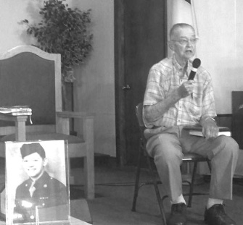[](http://www.google.com/url?sa=i&rct=j&q=&esrc=s&source=images&cd=&cad=rja&uact=8&docid=9oqpb63rLAzfAM&tbnid=P90_clQe6q2_HM:&ved=0CAUQjRw&url=http://localchurchbiblepublishers.com/product/lcbp-love-offering-gift/&ei=8AWjU7XPFZWPqAbciYGgCw&bvm=bv.69411363,d.b2k&psig=AFQjCNGTvP-bLa9F_SFqgZ3Q6uZRiHBz_Q&ust=1403279075875451)

**Please pray for the following:**

**June 21-28 – Indianapolis – Please pray for those attending World Changers.**

**Mexico - July 26-August 1 - Life Church Eastland will be traveling to two areas.**

**for the**

**Baptist Children’s Home**

**Saturday, August 9th, 7:00 p.m.**

**Dixon Springs Baptist Church**

**Featured guests: “Cross Harmony” and “One Voice”**

**A collection will be taken up for the children’s home.**

[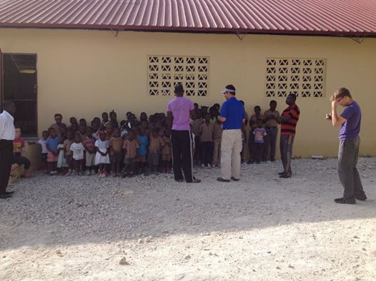](https://www.facebook.com/photo.php?fbid=10154217382785468&set=a.10150769262385468.727724.731905467&type=1&relevant_count=1)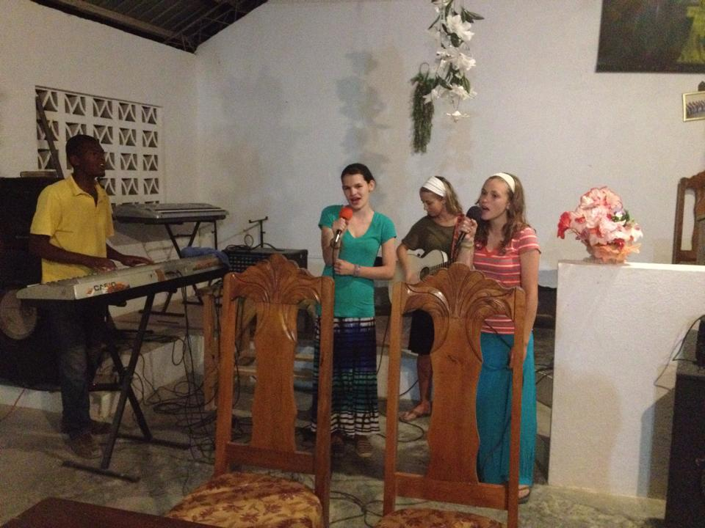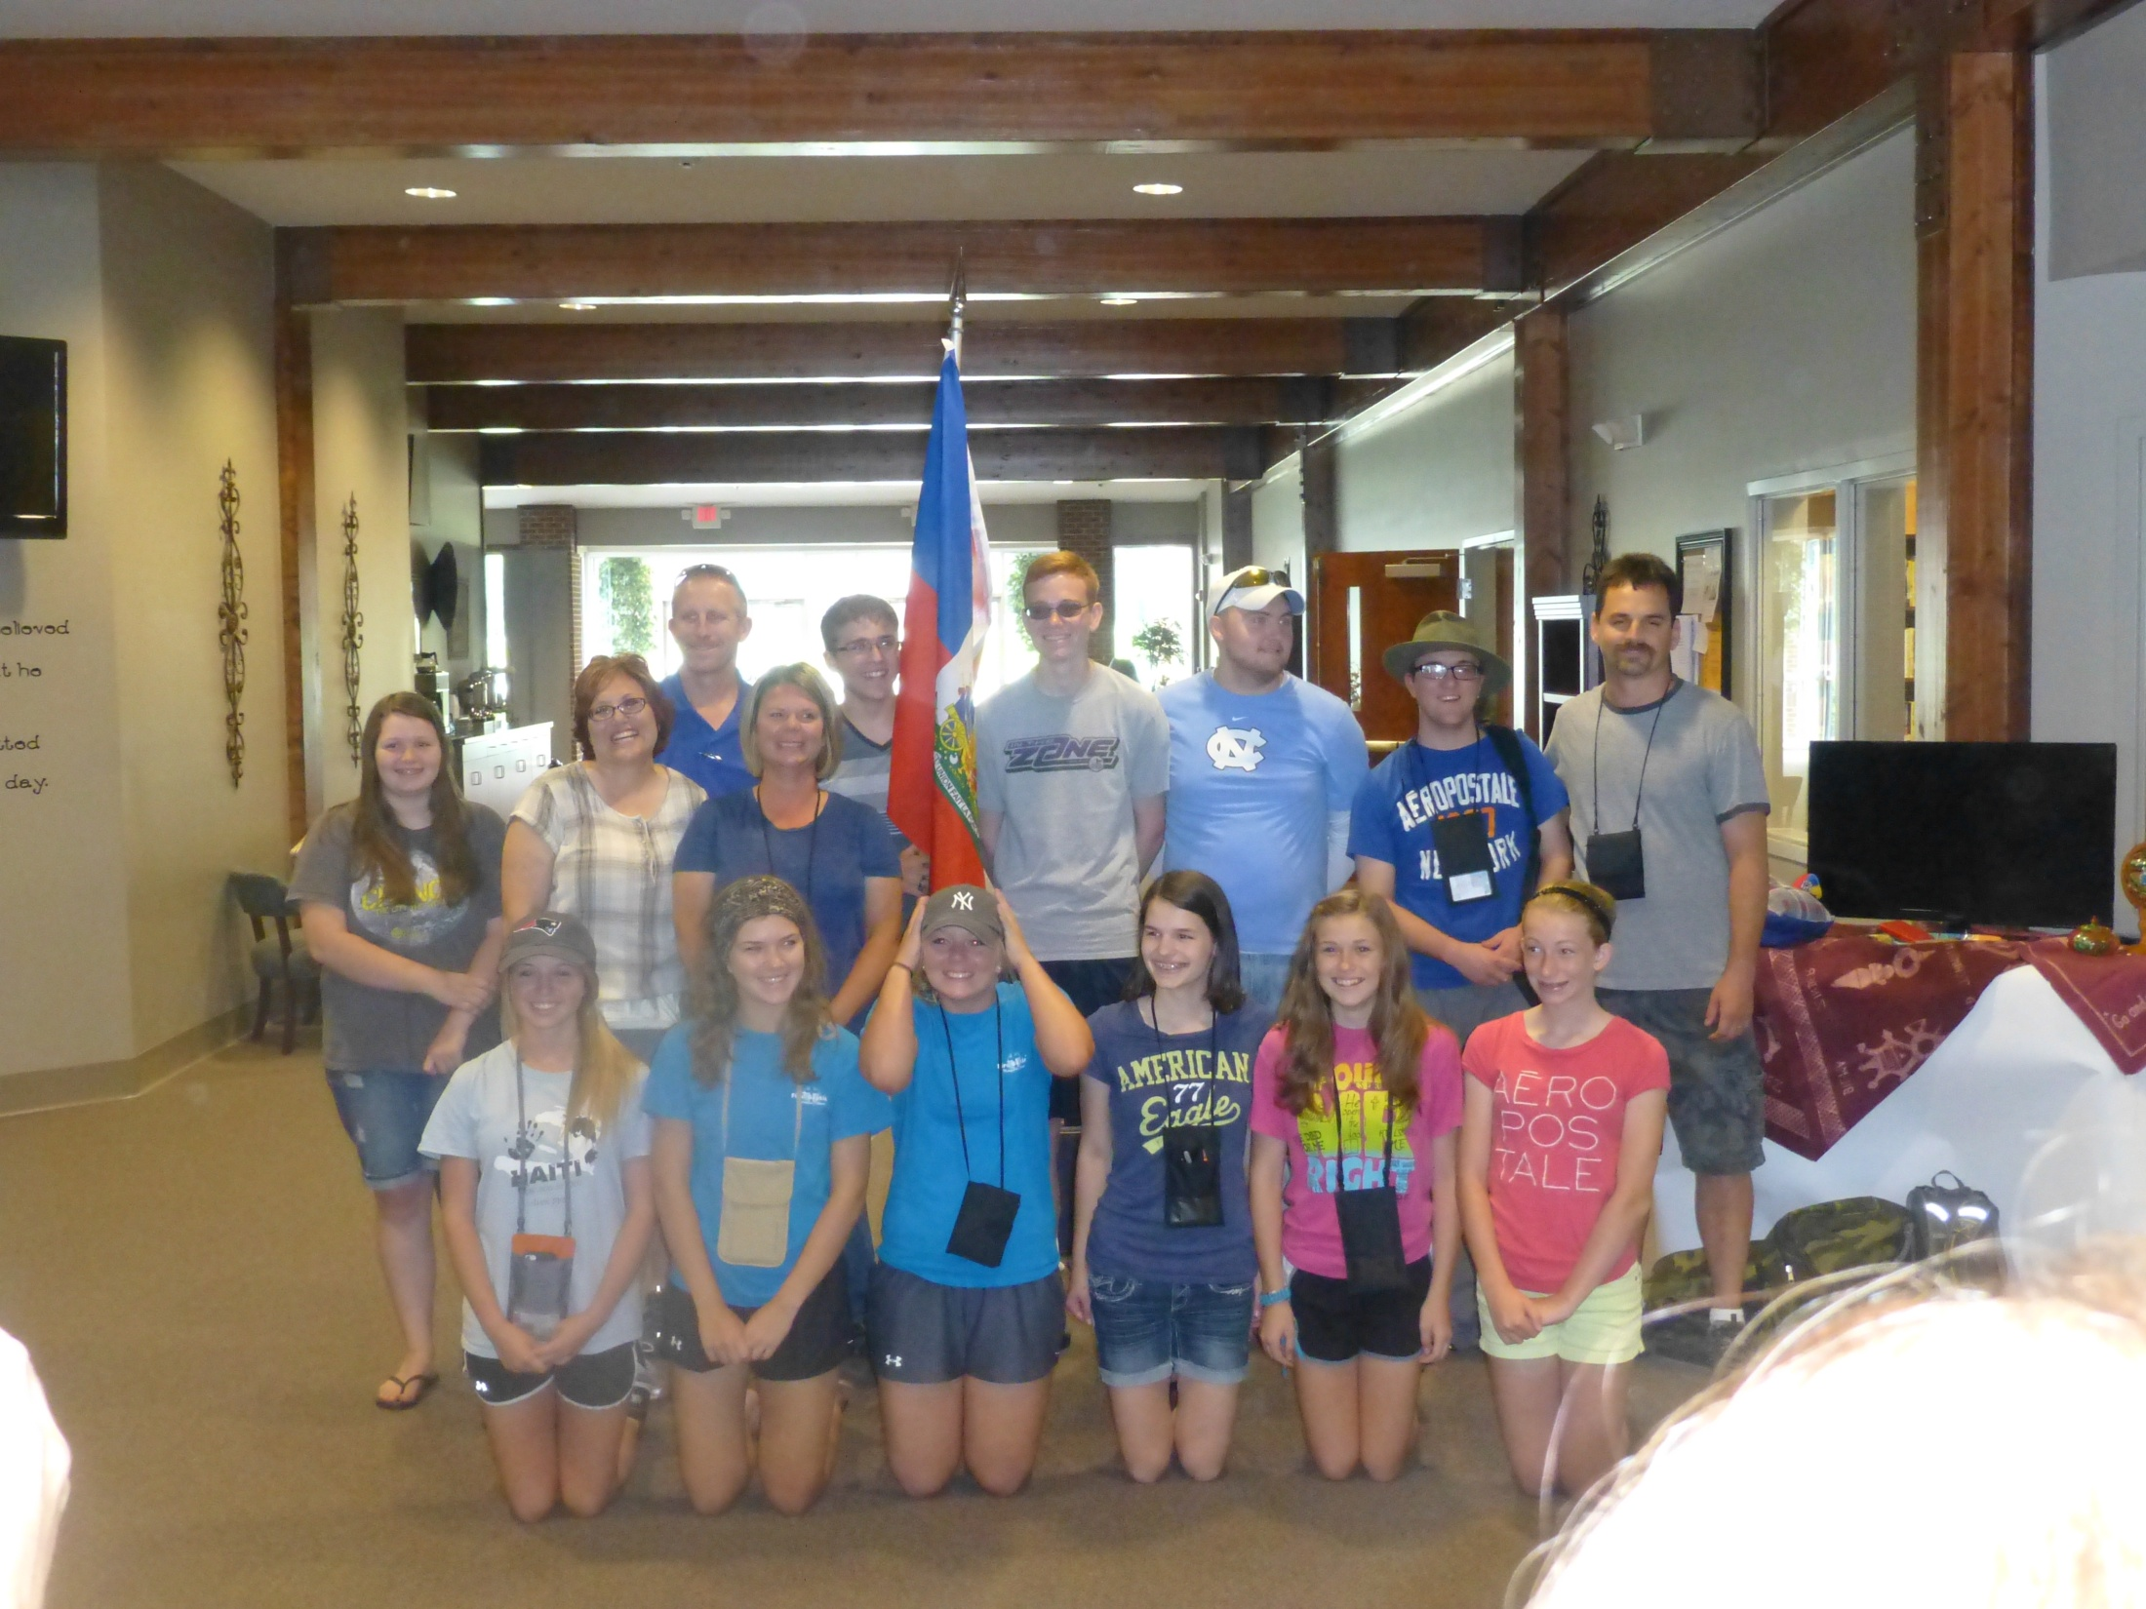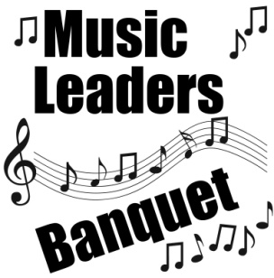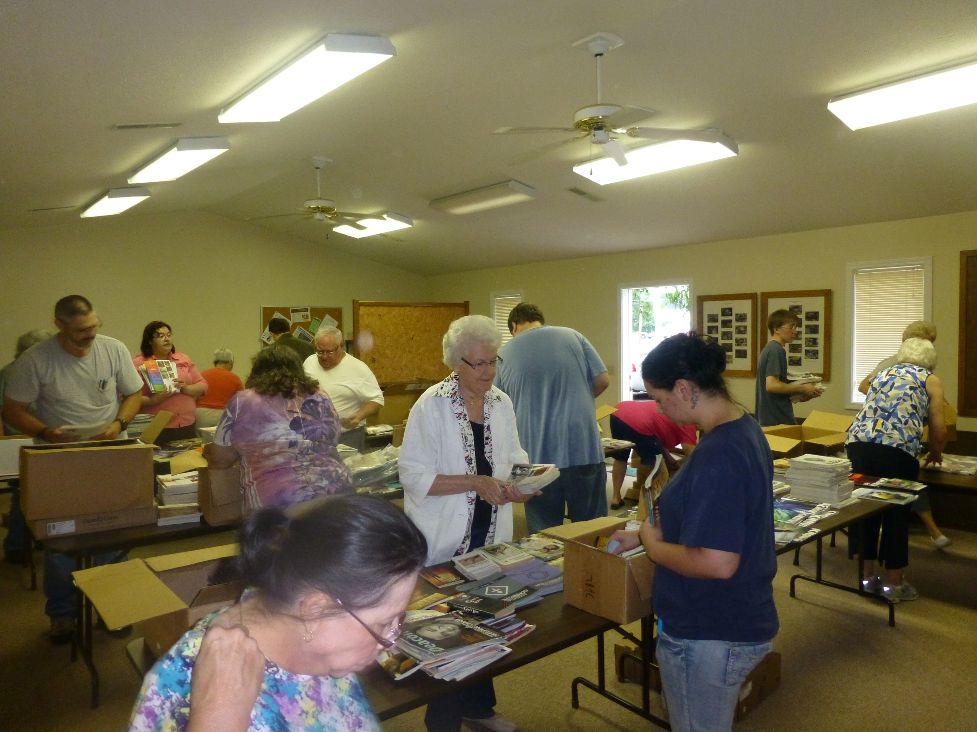

**Haiti Mission Trip**

**June 10-17**

**Metropolis 1st Youth**

**and Leaders. Your 2013 Love Offering helped sponsor some of the members of this team!**

**Leading Worship!**

**JULY MISSION ACTION:**

**Christian Activity Center in E. St. Louis – collection of school supplies. A letter has been mailed to WMU leaders and churches. Please bring collected items to the UBA Office by July 29th.**

**Items needed:**

**1 Subject Notebooks**

**Loose Leaf Paper**

**Pencil sharpeners**

**Copy paper**

**Science project boards (tri-fold boards)**

**Leadership: Vienna 1st**

**AUGUST MISSION ACTION:**

**Local Crisis Intervention – Serve our police, firefighters, EMT’s, ministries, etc.**

**Each church chooses what their ministry will be.**

Sunday School Training

For Directors and all Teachers

Saturday, August 9, 10:00 a.m.-Noon

To be held at the UBA Office

Please call our office, by August 7th, to register.

**Saturday, Aug.16th,**

**6:00 p.m.**

**at the UBA Office**

**If you plan on attending, please call our office by**

**August 12th.**

**Ed Hollis, Pastor of Vienna 1st, is beginning the process of organizing the fall and winter league. The organizational night is Friday, August 22nd at 7:00 p.m. at the newly renovated Super Bowl in Metropolis (formerly Bob’s Bowl). It has been completely remodeled and will be more family friendly.**

**On the night of the organizational meeting, you will bowl to set up your scratch score for the league. We would love to have 10 to 15 teams or more! If interested, please contact Ed Hollis at 618-771-0442 before August 22nd.**

**Association Co-ed**

**Bowling League**

**Presenting last years’ VBS offering to the school children!**

**This money will ensure that the teachers are paid and the school stays open for at least 4 months!**

**VBS Dates!**

**We’re asking the churches in our association to pray for the kids and leaders during the following VBS dates:**

**June 28 (all day) – County Line**

**July 7-11 – Metropolis 1st**

**July 9-13 – Karnak First**

**July 13-18 – Mt. Zion**

**July 20-24 – Hillerman Missionary**

**July 21-25 + 27 – Dixon Springs**

**Once you are finished with your VBS, please fill out your report and mail it to our office.**

**On June 9th, volunteers came to the UBA Office to sort literature for the Eagles Nest Ministry in Butler, IL**

**Brookport 1st was the leadership team for this project.**

**UNION BAPTIST ASSOCIATION**

**ANNUAL LOVE OFFERING**

**FOR ADDITIONAL MISSION WORK**

**SUNDAY, JULY 27, 2014**

**Last year, the churches of the UBA were able to help spread the gospel by donating a total of $3,243 to missionaries. These funds all came from our 2013 Love Offering.**

**Through your giving, we helped send missionaries to Mexico, Haiti, Peru, Jamaica and Uganda, as well as helping ministries close to home.**

**We will be mailing offering envelopes, as well as bulletin inserts to all of our churches. Please pray about taking up a special offering in your church. If July 27th isn’t convenient for you, any Sunday in July would be appreciated.**

**“It’s America”, a Patriotic Cantata, will be performed by the Adult Choir at Metropolis First Baptist. The Cantata will be followed by an All American Hot Dog and Watermelon Fellowship. A freewill offering will be taken up to benefit the music ministry at First Baptist.**

**Sunday, June 29th, 6:00 p.m.**

**Metropolis First Baptist Church**

On June 8th, Joppa Missionary Baptist held a recognition service honoring WWII Veteran, Clarence Cox. Pastor David Wright presented Mr. Cox with a plaque recognizing the 70th anniversary of Cox’s participation in the amphibious invasion of Omaha Beach. On behalf of the church brotherhood organization, Phil McHaney presented to Mr. Cox a recently written book about the 1st Infantry Division entitled “The Big Red One.”

Mr. Cox, who will soon turn 90 years old, spoke about his experiences on D-Day, June 6, 1944. Mr. Cox wants to share his recognition with all of the veterans who have honorably served their country.

**WWII Veteran**

**Clarence Cox**