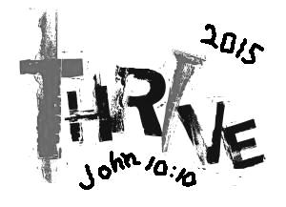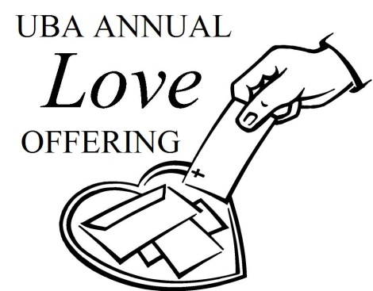****

**Please pray for the following church that is currently without a pastor: New Beginnings**

Happy Independence Day!

**CAMP MAC KID’S CAMP!**

**Registration and information packets have been mailed to the UBA churches.**

**The deadline for registering is July 6th!**

**Date: July 12-18, 2015**

**Cost: $55.00 per child**

**Location: Camp Hope in Ewing, Illinois**

**Grades: Completed Grades 3-8**

**Grades 3&4: July 12-14**

**Grades 5&6: July 14-16**

**Grades 7&8: July 16-18**

**Registration Forms can now be picked up from your church office or at the UBA Office. They can also be downloaded from our website, metrouba.com.**

**JULY 12TH!**

In 2014, a total of $3,034.00 was given toward helping 14 individuals, along with 5 groups, to work on mission trips and projects, both local and international. You helped to reach people in the United States, Mexico, Haiti, Honduras and Jamaica!

We are asking our churches to set aside **July 12, 2015**, or any Sunday in July, as “Love Offering Sunday”. Envelopes and bulletin inserts have been sent to each church. Please let us know if your church did not receive them.

**THE POWER OF ‘AND’ – It’s you AND me, working together to bear witness to the power of Jesus Christ in Jerusalem, AND in all Judea AND Samaria, AND to the ends of the earth**

**Pastor & Wife Birthdays**

**July 19 – Frank Forthman, Jr., New Hope**

**Wedding Anniversaries**

**July 24 – Dustin and Sarah Womack,**

**Youth Minister, Joppa Missionary**

**July 31 – Brian and Robin Anderson, Life Church Eastland**

**Secretary’s office hours: Monday-Thursday, 9:00 a.m. – 2:00 p.m.**

***Church Contributions for Budget***

***(rec’d & deposited in May)***

Brookport First $ 0.00

County Line $ 0.00

Cypress First $ 145.24

Dixon Springs $ 168.00

Hillerman Missionary $ 636.98

Immanuel $ 227.22

Joppa Missionary $ 887.76

Karnak First $ 857.09

Life Church Eastland $ 200.00

Metropolis First $ 1,934.76

Mt. Zion $ 312.88

New Beginnings $ 0.00

New Hope $ 0.00

New Salem $ 60.00

Oak Grove $ 38.43

Seven Mile $ 0.00

Simpson $ 208.00

Vienna First $ 433.34

Waldo $ 466.67

Weaver Creek $ 0.00

UBA theme for 2015: THE POWER OF ‘AND’ -

It’s you AND me working TOGETHER to bear witness to the POWER OF JESUS CHRIST in Jerusalem, AND in all Judea AND Samaria, AND to the ends of the Earth

***If you have information that you would like to have included in our monthly newsletter, please call or email the UBA office by the 20th of the month. We would be happy to promote any special events (revival, singing group, special programs/ministries, etc.)***

**CONTACT INFORMATION:**

**Phone: 524-9738**

**Email: Terry Mathis - mathisterry2009@hotmail.com, Beverly Turner - bevturneruba@gmail.com**

**Website – www.metrouba.com Facebook – UBA (Metro)**

**Volume 1, #49**

**Union Baptist Association**

**P.O. Box 29**

**Metropolis, IL 62960**

*Return Service Requested*

**JULY 2015 NEWSLETTER**

**Non-Profit Organization**

**U.S. Postage Paid**

**Permit #137**