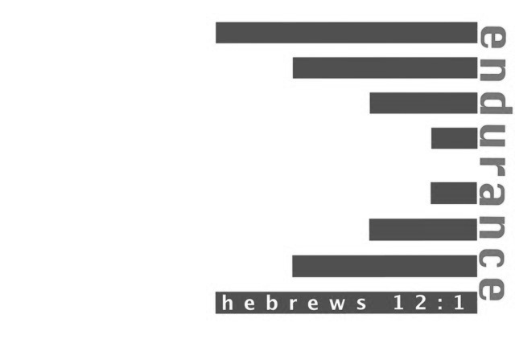

**Camp Mac Kid’s Camp 2014!**

**July 27-August 1**

**Camp Hope in Ewing, IL**

**Please pray for the following:**

**Haiti Trip – June 10-17 – Metropolis 1st Youth Group & Adults holding VBS**

**Mexico - July 26-August 1 - Life Church Eastland**

*We would like to welcome Jake and Leetta Ervin to the Union Baptist Association! Beginning in May, Jake became the new pastor of Weaver Creek Baptist. They currently live in the Dongola area and came from Bethany Baptist Church.*



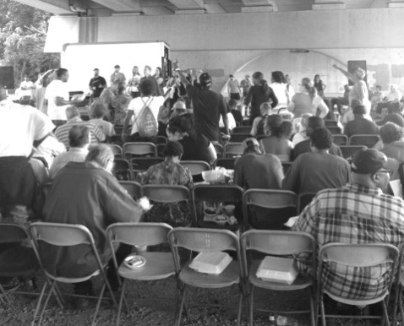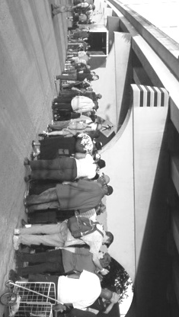

**VBS Dates!**

**We’re asking the churches in our association to pray for the kids and leaders during the following VBS dates:**

**June 5, 6 & 7 - Weaver Creek**

**June 8-12 – Brookport 1st**

**June 9-13 – Seven Mile**

**June 16-20 – New Hope**

**June 22-27 – Joppa Missionary**

**June 23-27 – Immanuel**

**June 23-27 – Life Church Eastland**

**June 28 (all day) – County Line**

**July 7-11 – Metropolis 1st**

**July 13-18 – Mt. Zion**

**July 20-24 – Hillerman Missionary**

**July 21-25 + 27 – Dixon Springs**

**Once you are finished with your VBS, please fill out your report and mail it to our office.**

**Association Co-ed**

**Bowling League**

**17th Annual UBA Golf Scramble Results**

**1st Place – Metropolis 1st, Team #1, Leader: Terry Foster**

**2nd Place – Metropolis 1st, Team #2, Leader: Jimmy Martin**

**3rd Place – Life Church Eastland, Leader: Ralph Steel**

**4th Place – Immanuel, Leader: Toby Davis**

**Trip to Israel**

Brent Cloyd, pastor of North Side Baptist Church Fairfield, will be serving as tour host of a Biblical tour of Israel December 1-10, 2014. Tour arrangements are being made by Imagine Tours and Travel. The cost of the trip is $2,995 per person. This price includes air travel, first class hotels, two meals a day, the cost of a tour guide and tour bus, as well as all taxes and gratuities. That is a good price, but yes it does cost something to travel to Israel. Going to Israel and walking in the footsteps of Jesus will change your life. Cloyd says it is the best thing he has done, educationally and spiritually, in thirty-two years of ministry. For more information, contact Brent Cloyd at 618-599-5059 or email him at c.brentcloyd@gmail.com

This year, we have nineteen individuals who have completed their studies and preparations in order to work in the inner-city area of Indianapolis. They will be sharing their testimonies and the gospel while working on houses there. Please keep this group in your prayers!

Terry Mathis, Director of Missions

Ralph Steel, Sharon Baptist in Mayfield

Billy Burkhead, Life Church Eastland

Kelsey Strong, Life Church Eastland

Miranda Hartline, Life Church Eastland

Karen Bunch, Metropolis 1st

Mackenzie Easter, Metropolis 1st

Jeff Windhorst, Brookport 1st

Eli Windhorst, Brookport 1st

Gary Moore, Brookport 1st

Jeremy Clark, Brookport 1st

Shawn Stafford, Vienna 1st

Jessica Cook, Vienna 1st

Isaac Vaughn, Vienna 1st

Hondo Ragsdale, Hillerman Missionary

Adam Ragsdale, Hillerman Missionary

Zachary Walquist, Joppa Missionary

Vivian Burton, New Hope

Shelby Wilson, Oak Grove

***We would like to thank all of the churches who attended our VBS Workshop and ordered their materials through the UBA Office! We had the largest VBS order to date!***

**Association Executive Board meeting**

**Monday, June 2, 2014, 7:00 p.m.**

**Dixon Springs Baptist**

**The Association Council meets at 6:00 p.m.**

**Bro. David Wright will bring the message “Focus on Fruitfulness”**

**JUNE MISSION ACTIONS:**

**Hope Unlimited Baby Bottles (Mother’s Day-Father’s Day)**

**Take filled bottles to Hope Unlimited.**

**Leadership: Pat Agee**

**Eagles Nest – Recycle Literature – Please bring your used literature to the UBA Office by June 6th. It will be sorted on June 9th. If you would like to help with the sorting, please be at our office around 9:00 a.m. The materials will then will be taken to Eagle’s Nest at a later date.**

**Leadership: Brookport 1st**

**JULY MISSION ACTION:**

**Christian Activity Center in E. St. Louis – collection of school supplies. A letter will be mailed to the churches.**

**Southern Baptist Convention**

**June 9-11, 2014, Baltimore, Maryland**

***Please keep the process and outcome of this meeting in your prayers!***

**Under the Bridge Ministry in Nashville**

Serving in this ministry is a great opportunity for churches to participate in helping feed and distribute food to the homeless of Nashville, TN. The dinner takes place every Tuesday night from 5:00-8:00. For details, contact Terry Mathis at the UBA Office. The pictures below were taken on 5/20/14.

**Also, don’t forget our own local ministry, At the River, which takes place on the 4th Monday of every month from 5:00-7:00 p.m.** Weather permitting, it is held at Dorothy Miller Park on Front St. In the case of inclement weather, it is held at Life Church Eastland. The evening begins with a meal and worship music. After the meal, there is a short message, prayer time and the distribution of gifts. Area churches are needed to help feed and provide speakers there. Contact Dan Haun at 618-638-6901 or Jackie Lange at 618-521-7880 if you are interested in helping out. The next At the River Dinner and Service will be held on Monday, June 23rd.

**Ed Hollis, Pastor of Vienna 1st, is beginning the process of organizing the fall and winter league. The organizational night is Friday, August 22nd at 7:00 p.m. at the newly renovated Super Bowl in Metropolis (formerly Bob’s Bowl). It has been completely remodeled and will be more family friendly.**

**The night of the organizational meeting, you will bowl to set up your scratch score for the league. We would love to have 10 to 15 teams or more! If interested, please contact Ed Hollis at 618-771-0442 before August 22nd.**

**WORLD CHANGERS MISSION TRIP**

**June 23-27, 2014**

**Indianapolis, Indiana**

**Grades 3 & 4: July 27-29**

**Grades 5 & 6: July 29-31**

**Grades 7 & 8: July 31- August 2**

**Grades listed are the grades the students are coming out of. You may now pick up registration packets at your church office or at the UBA Office.** **They will also be available on our website, metrouba.com. *The last day for registration will be July 23rd.***