

**JUNE MISSION ACTION:**

Eagle’s Nest – collect literature for recycling. Please bring new or used literature to the UBA Office by June 12th. It will be taken to Eagle’s Nest in Butler, IL where they will ship it to missionaries around the world.

Leadership: Brookport 1st

**JULY MISSION ACTION:**

Christian Activity Center in E. St. Louis. Each church is asked to collect school supplies for the children at the center. Collected items can be dropped off at the UBA Office no later than July 27th. They will be picked up on the 28th.

Leadership: Vienna 1st

Please pray for the following teams:

Brazil: June 8-14 – Dr. Randy Oliver will be traveling on a medical mission trip.

Haiti: July 12-19 - Metropolis 1st Youth will be holding VBS and Backyard Bible Clubs. A medical team will also be going.

Mexico: July 11-17 – Life Church Eastland – Eighteen people will be going to 2 cities and holding VBS during the day and a marriage conference in the evening.

**Southern Baptist Convention**

**Annual Meeting**

**June 15-17, 2015 in Columbus, OH**

**Theme:**

**Great Awakening**

**CLEAR AGREEMENT**

**VISIBLE UNION**

**EXTRAORDINARY PRAYER**

**For more information and to register for the convention and hotel, please visit sbcannualmeeting.org**

Seven Mile: Sundays, May 17–June 14, 9:30 a.m.-noon

New Hope: June 15-19, 6:00-8:30 p.m.

Life Church: June 15-19, 9:00 a.m-12:30 p.m.

Immanuel: June 22-26, 8:30 a.m.-11:40 a.m.

Hillerman: June 28-July 2, 6:00-8:30 p.m.

Metropolis 1st: July 6-10, 9:00 a.m.-noon

Mt. Zion: July 6-10, 6:00-8:00 p.m.

Vienna 1st: July 13-17, 5:30-8:30 p.m.

Dixon Springs: July 20-24, 6:00-8:30 p.m.

Brookport: July 26-30, 6:00-8:00 p.m.

Karnak: July 26-30, 6:30-8:00 p.m.

Simpson: July 26-30, 6:40-8:30 p.m.

County Line: August 1, 9:00 a.m.-3:00 p.m. (One Day)

**CONFERENCE**

**March 15-18**

**Metropolis 1st Baptist**

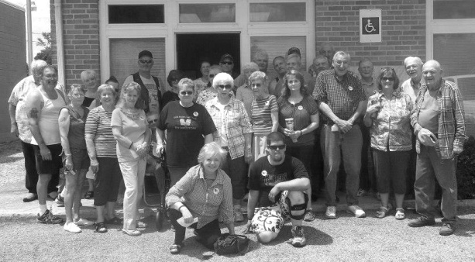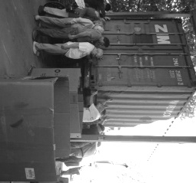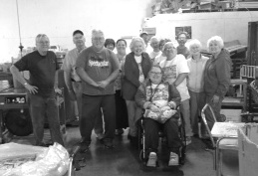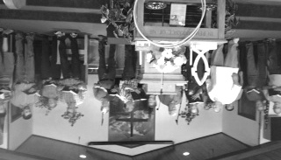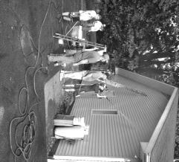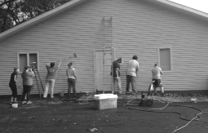

**APRIL MISSION PROJECT:** On April 30th, a group of individuals went to Eagles Nest Sunday School Recycling Center to help sort literature. The top picture is of a cargo container that was packed and leaving for Africa that morning. Those attending were from Metropolis First, Hillerman, Immanuel, and Seven Mile.

**Association Executive Board Meeting**

**Monday, June 1, 2015 at Simpson Baptist**

**Council Meeting – 6:00 p.m.**

**Board Meeting – 7:00 p.m.**

**Books for Sale**

Bro. Ed Hollis, the pastor of Vienna 1st Baptist, wishes to sell the books of his personal library. If interested, please contact him at 618-771-0442.

**April Mission Project**

Two churches in our association were listed in the “Top 50 Illinois Supporting Churches

to Baptist Children’s Home and Family Services”

New Hope Baptist - #44

Dixon Springs Baptist - #47

Three churches in our association were listed in the “Top 100 Illinois Churches in Cooperative Program Giving 1st Quarter”

Metropolis First - #15

New Hope - #85

Karnak 1st - #92

BFI, Baptist Foundation of Illinois, is now offering defined maturity bonds as a method for Illinois Baptist Churches and individuals to save while investing in the construction or purchase of more Baptist Churches in Illinois.

The table below shows the maturity and interest for each bond type. Unlike CD’s, BFI bonds pay interest every six months.

* 1 year – 1.25%
* 2 year – 2.25%
* 3 year – 3.0%
* 4 year – 3.6%
* 5 year – 4.25%

Purchase of these bonds keeps God’s resources in God’s Kingdom and links Illinois Baptist savers with Illinois Baptist Churches. If you, as an individual or church, wish to purchase these bonds, or would like more information, you can visit BaptistFoundationIl.org and you will be able to view an update of available bonds and their maturity. You can also call BFI in springfield at 217-391-3116 and ask for Sheila or Doug.

Pictured below is the group that met at the Joppa Village Center for the National Day of Prayer on May 7, 2015. Other places that had special services were Metropolis Court House, Brookport Community Center and Vienna Court House.

**June 22-27, 2015**

**West Memphis, AR**

The World Changers group will be working on homes for the underprivileged and the handicapped. They will be building ramps, painting, installing vinyl siding and new windows, and also will be doing some roofing. At the same time, they will be going door to door throughout the community and sharing their faith with others.

Those attending this year are:

Terry Mathis, MacKenzie Easter, Emma Lange, Elizabeth Rottmann, and Heather Rottmann from Metropolis First.

Gary Moore, Eli Windhorst, Jeff Windhorst and Brandon Land from Brookport First.

Bill Burkhead, Miranda Hartline and Madalyn LaDue from Life Church Eastland

Hondo Ragsdale and Adam Ragsdale from Hillerman Missionary

Vivian Burton from New Hope

Jessica Cook and Shawn Stafford from Vienna 1st

Ralph Steel from Sharon Baptist in Mayfield

Calissa Glass from County Line

Zach Walquist from Joppa Missionary

This group of guys and gals have already attended three study sessions in preparation for them to share the gospel. They have also had a local workday here in the association. Please pray for the WC Group as we go on this mission trip to serve the Lord.

Joppa Missionary Baptist Revival - Group of men singing a special during revival Services at Joppa in April.

**World Changers Local Project Work Day**

**The group power washed the UBA Office and the New beginnings Parsonage next door. Workdays are a part of the requirements that need to be fulfilled in order to go to World Changers.** 