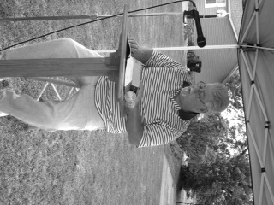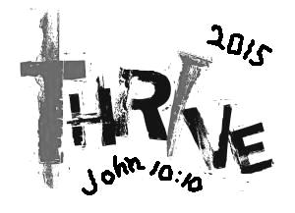****

**Please pray for the following church that is currently without a pastor:**

**New Beginnings**

Bro. Terry Mathis reading the Scriptures during the all day Public Reading of the Scriptures

**SCRIPTURE READING FOR NATIONAL DAY OF PRAYER, MAY 7TH**

The Massac Ministerial Alliance held a public reading of the scriptures from 6:00 a.m. through 6:00 p.m. in Brookport and Metropolis. The UBA was responsible for providing people to read for many of these hours. Several churches from our association were involved! We would like to thank those who showed up to help out!

**CAMP MAC KID’S CAMP!**

**Registration and information packets have been mailed to the UBA churches. We will also have them available on our website soon.**

**Date: July 12-19, 2015**

**Cost: $55.00 per child**

**Location: Camp Hope in Ewing, Illinois**

**Grades: Completed Grades 3-8**

**Grades 3&4: July 12-14**

**Grades 5&6: July 14-16**

**Grades 7&8: July 16-18**

**Registration Forms can now be picked up from your church office or at the UBA Office.**

**Pastor & Wife Birthdays**

**June 19 – Leetta Ervin, Pastor’s Wife, Weaver Creek**

**June 22 – David Faulkner, County Line**

**June 23 – Jill Ballard, Pastor’s Wife, Seven Mile**

**June 23 – Jerry Jackson, Mt. Zion**

**Wedding Anniversaries**

**June 4 – Ed & Sandy Hollis, Vienna First**

**June 5 – Stephen & Janice Williams, Simpson**

**June 6 – Jim & Penny Wilson, Oak Grove**

**June 13 – Cliff & Michele Easter, Metropolis 1st**

**June 14 – David & Anita Wright, Joppa Missionary**

**June 26 – Matt & Katrina Snell, Dixon Springs**

**June 26 – Ben & Eren Hottel, Hillerman Missionary**

**June 30 – Jake & Leeta Ervin, Weaver Creek**

**June 30 – Glenn & Kim Coram, Immanuel**

**Pastor/Staff Church Anniversaries**

**David Faulkner, County Line, 2005**

**Dean West, Karnak 1st, 2008**

**Bill Gholson, New Salem, 2011**

**John Windings, Metropolis 1st, 2013**

UBA theme for 2015: THE POWER OF ‘AND’ -

It’s you AND me working TOGETHER to bear witness to the POWER OF JESUS CHRIST in Jerusalem, AND in all Judea AND Samaria, AND to the ends of the Earth

**Secretary’s office hours: Monday-Thursday, 9:00 a.m. – 2:00 p.m.**

***If you have information that you would like to have included in our monthly newsletter, please call or email the UBA office by the 20th of the month. We would be happy to promote any special events (revival, singing group, special programs/ministries, etc.)***

**CONTACT INFORMATION:**

**Phone: 524-9738**

**Email: Terry Mathis - mathisterry2009@hotmail.com, Beverly Turner - bevturneruba@gmail.com**

**Website – www.metrouba.com Facebook – UBA (Metro)**

**Volume 1, #48**

***Church Contributions for Budget***

***(rec’d & deposited in April)***

Brookport First $ 570.05

County Line $ 200.00

Cypress First $ 40.36

Dixon Springs $ 207.00

Hillerman Missionary $ 762.00

Immanuel $ 342.50

Joppa Missionary $ 970.44

Karnak First $ 816.31

Life Church Eastland $ 200.00

Metropolis First $ 3,205.46

Mt. Zion $ 371.36

New Beginnings $ 95.46

New Hope $ 2,363.45

New Salem $ 0.00

Oak Grove $ 65.17

Seven Mile $ 0.00

Simpson $ 208.00

Vienna First $ 433.34

Waldo $ 466.67

Weaver Creek $ 0.00

**Union Baptist Association**

**P.O. Box 29**

**Metropolis, IL 62960**

*Return Service Requested*

**JUNE 2015 NEWSLETTER**

**Non-Profit Organization**

**U.S. Postage Paid**

**Permit #137**