***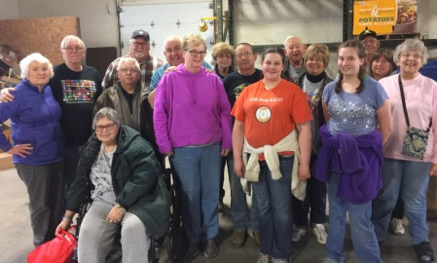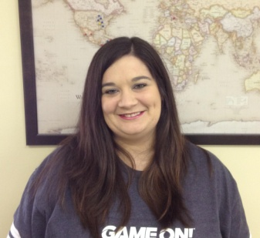*********

***Union Baptist Association***

***Annual Love Offering***

***for Missions***

***July 8th***

**UBA 2018 Fall Semester**

**Scholarship Recipient**

**Amy Land, a member of Brookport 1st Baptist, recently graduated from Shawnee Community College with an Associate of Arts. Amy now plans to attend Murray State University, majoring in Non-profit Leadership Studies. Amy has already been working with our association in this area of study, and we wish her well in her continued studies.**

**Eagle’s Nest Trip April 2018 –**

**The UBA had a large group of volunteers who went to sort literature.**

***God made him who had no sin to be sin for us, so that in him we might become the righteousness of God.***

***– 2 Corinthians 5:21***

**CAMP MAC KIDS’ CAMP 2018**

**July 8-14 at Camp Hope in Ewing, IL**

**This year’s theme:**

This offering goes to help individuals, within our association, who go on mission trips and it also helps fund special mission training events throughout the year. Without your love offering, we would not be able to help these individuals do the Lord’s work. The UBA Annual Love Offering will take place on July 8th. If your church is unable to hold the offering on that Sunday, just do it any Sunday in July.

**COST $55.00 per child**

**\*3 & 4 Graders**

**Sunday, July 8, 1:30 p.m. till Tuesday, July 10, Noon**

**\*5 & 6 Graders**

**Tuesday, July 10, 1:30 p.m. till Thursday, July 12, Noon**

**\*7 & 8 Graders**

**Thursday, July 12, 1:30 p.m. till Saturday, July 14, Noon**

***\*Must have completed these grades***

**Registration Deadline: Friday, June 29, 2018**

**Pick up your Registration Form from your Church Office or your Pastor. Camp may fill up before the deadline!**

**The**

**UBA Connection**

**This newsletter has information for June and July! The next newsletter will be mailed out the end of July.**

**Union Baptist Association**

**P.O. Box 29**

**Metropolis, IL 62960**

***Return Service Requested***

**Volume 1, #77**

**UBA MONTHLY MISSION PROJECTS**

**JUNE –** **Camp Mac Kids’ Camp** – Collection of assigned items from each church for camp. Our office will be mailing out a list of items to our churches. Our funds for Camp Mac are very low this year. If a church or individual would like to give financial help for expenses, it would be greatly appreciated. Leadership: Terry Mathis

**Eagle’s Nest Collection** of used Sunday School materials. Bring your outdated literature to the UBA Office. We will take it to Eagles Nest where it will be sent to missionaries overseas. Leadership: Brookport 1st

**JULY – Christian Activity Center in E. St. Louis**. Each church is asked to bring school supplies to the UBA Office. We will be sending out a letter to each WOM Director or church office with a list of needed items. Leadership: Vienna 1st

**Union Baptist Association Terry Mathis, Director of Missions**

**P.O. Box 29 email:mathisterry2009@hotmail.com**

**Metropolis, IL 62960 Beverly Turner, Admin. Asst.**

**618-524-9738 bevturneruba@gmail.com**

**UBA theme for 2018: Assisting Churches - Advancing the Gospel**

**June & July, 2018 NEWSLETTER**

**Non-Profit Organization**

**U.S. Postage Paid**

**Permit #137**