

**WORSHIP LEADERS RETREAT**

**Saturday, May 3, 8:30 a.m. – 4:30 p.m.**

**IBSA Building, Springfield**

**Cost: $15 per person**

**Leader: Craig Adams –**

**Creative Director of LifeWay Worship**

**There will be ten break-out sessions to choose from.**

**Register by sending email to DebbieMuller@IBSA.org or by calling Debbie at 217-391-3126.**

**More information is available at IBSA.org**

***A NOTE OF THANKS: We would like to thank the churches who have contributed to our recent collections for the food pantries, Hope Lodge, Eagles Nest and also items for the migrant workers! We are able to make a huge impact when we all work together!***

Tee times will be set. The first tee time will be at 7:30 a.m.

The deadline to register is May 13th. We will be signing the contract with the course, so all fees must be turned in by the deadline. If you have a team and do not receive registration forms in the mail, you can pick them up at the UBA Office or call 270-559-3717.

**17th Annual UBA**

**4 Person Golf Scramble**

**Saturday, May 17th at Gambit in Vienna**

**Cost: $45/person (includes green fee, cart, noon meal and prizes)**

**Please pray for the following:**

**Haiti Trip – June 10-17 – Metropolis 1st Youth Group**

**Mexico - July 26-August 1 - Life Church Eastland**

**MAY MISSION ACTIONS:**

**Collection for Guardian Family Services. Needed items: toilet paper (most needed), laundry detergent, fabric softener sheets, garbage bags, aluminum foil, koolaid, tea bags, sugar, coffee.**

**Leadership: Alma Harris**

**Hope Unlimited Baby Bottles (Mother’s Day-Father’s Day)**

**It’s that time of year when Hope Unlimited distributes baby bottles to those churches whose members would like to collect their loose change and then donate it to this great ministry. You can pick up the bottles through your church office. If your church is not currently receiving the bottles, but would like to participate, please call Hope Unlimited in Metropolis.**

**Leadership: Pat Agee**

**JUNE MISSION ACTION:**

**Eagles Nest – Recycle Literature**

**Leadership: Brookport 1st**

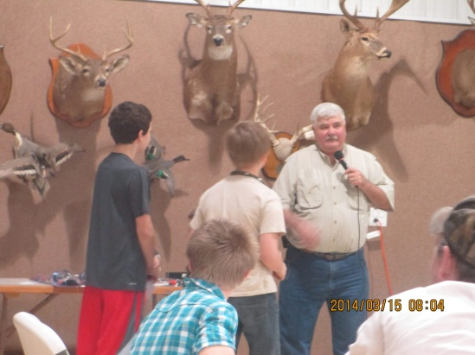[](http://www.churchart.com/Subscriber/ViewImages.aspx?keywords=&entry_date=1/1/0001&image_type=,cl,ca,ph,ea,pp,bc&topic_id=427&image_source_id=&page=1#no)

MAY 6TH, 7:00-8:30 A.M.

JUMBO’S IN VIENNA

We’re inviting all ministers to attend this fellowship!

**The 2nd Annual Beast Feast 2014, held at Joppa Missionary Baptist, was a huge success!**

**Southern Baptist Convention**

**June 9-11, 2014**

**Baltimore, Maryland**

More information is available at sbcannualmeeting.net

**Please continue to pray for the following churches as they search for a pastor:**

**Dixon Springs (Interim, Matt Snell)**

**Seven Mile**

**Simpson (Interim, Ken Wilson)**

**Weaver Creek**

**Association Executive Board meeting**

**Monday, June 2, 2014**

**Dixon Springs Baptist**

**7:00 p.m.**

**The Association Council meets at 6:00 p.m.**

**PRAY FOR OUR NATION!**

**NATIONAL DAY OF PRAYER**

**Thursday, May 1, 2014**

**The Massac Ministerial Alliance has scheduled times for scripture reading and prayer in 15-30 minute intervals, at 2 locations:**

**Metropolis: Vacant corner across from First United Methodist Church 11:00 a.m.-Noon**

**Brookport: by the soldier statue on Hwy 45, 7:00-8:30 p.m. If you would like to be scheduled to read or pray at the Brookport location, please contact the UBA Office at 524-9738. Three people are still needed.**

***Locations: Decatur, Collinsville, Dongola, Cobden, Cairo***

More than 40 projects in 4 locations across the state are posted at IBSA.org/Missions. Please locate the project that interests you or your group and register online for that project. There is no registration deadline, however the project will close when the maximum number of participants has been reached.

For more information, contact BarbTroeger@IBSA.org or 217-391-3138. The cost is $25 ($7.50 for children under 12). This includes T-shirt, lunch, dinner and some ministry supplies.

**Please remember to take your “Survival Kits” to the Shawnee Metro Center Office by May 5th.**

**NEEDS FOR THE MIGRANT WORKERS**

The migrant workers are in need of used, long sleeve work shirts in medium to large sizes.

There is also a need for work socks. Collecting socks would be a great opportunity to get your children’s or youth Sunday School classes or other groups involved. Please bring your personal donations and church’s collections to the UBA Office during the month of May.

**NEW HOPE BAPTIST’S ANNUAL BARBECUE!**

**May 3rd, 6:00 p.m.**

**Serving chicken and country ribs!**

**Meat is provided. You are only asked to please bring a side dish.**

**Everyone is invited!**

**2014 Women’s Missions Celebration**

**May 1-3**

**1st Baptist Church, in Marion, Illinois**

**Cost: $20 (includes conference cost and lunch on Friday)**

**This year’s theme:**

**Chaplain Kenneth DeWitt, Prison to Purpose Ministry, will lead the Bible study.**

**The Thursday evening reception with missionaries begins at 6:30. The Women's Meeting starts at 8:30 a.m. Friday and includes afternoon and evening sessions. The final session begins at 8 a.m. Saturday and ends at noon.**

**What a great opportunity for our local ladies missions groups to attend since it is so close to home this year! Make plans to go and experience the excitement of what God is doing through the work of missions!**

**SHORT-TERM MEDICAL MISSION TRIP**

If you have medical experience in your background and are looking for a way to allow God to use your gift, please consider a trip to Bolivia. A team is forming to travel in June. This is a region where floods have hit the villages very hard.

Julie Dalechek, an RN, is the Team Leader. If interested in joining the group, contact the UBA Office for contact information.

**Please pray for the following churches as they search for a Pastor:**

**Dixon Springs Baptist**

**Simpson Baptist (has interim)**

**Seven Mile Baptist**

**Weaver Creek Baptist**