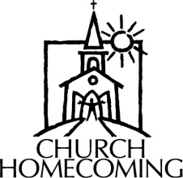

**Oak Grove Baptist Church**

**May 17th**

**Sunday School: 10:00 a.m.**

**Worship: 11:00 a.m.**

**A potluck meal will be held at noon.**

**Entertainment: 1:30 p.m. – singing featuring “The Glory Road Travelers” (no evening service)**

**Everyone is invited!**

**“35 CHALLENGE” - UPDATE FROM THE D.O.M.**

Many of our churches that are participating in the “35 Challenge” are in the contact stage of inviting people to their church. The following report is from the pastor of Revelation Road Baptist Church in West Vienna. Pastor Charles Duckworth is using the challenge at this new church plant and is seeing great results! He wrote this article for me to share with all of you and to let you know what is happening as they work the “35 Challenge”.

“When Terry spoke to me about the “35 Challenge”, I felt a peace come over me and that let me know that this was something our church could commit to and do. We had been talking about how we would like to minister in a way that would help us to introduce ourselves to the community.

We spent the six weeks prior to our visitation in prayer for our community as well as for our own members. Some of our members were unsure if they could knock on a stranger’s door. PRAYER was the key through this whole process and it eased the hearts of everyone.

On Saturday, March 21st, we went door to door making people aware of the church and where it was located. We told them of our intention to be ministers to the community. We knew GOD was working before our people visited because we found about 70% of the people home on a Saturday morning. GOD was also working on the members as they felt good about the visits they made.

On Saturday, April 18th, we held our community fish fry fellowship and had eighteen guests to show up. Some of the guests attended other churches, but others did not attend anywhere. One of the most exciting things to happen is to see GOD working through the words and actions of the members. Everyone had a good time and was able to sit and visit with each other. No one was in a hurry to leave.

This has been a gigantic building block for Revelation Road Baptist Church as we head into the future. I want to thank you, Terry, for sharing this vision with us.”

**Your Love Offering at work!**

From Duane McGinnis:

We had a great time ministering in Jamaica in the name of the Lord. With 5 team members, we were blessed to all stay in the same home and be able to fellowship with our hosts and each other. We were again allowed to present devotions in 10 different schools, sharing the good news of Jesus with the children and staff. We also worshiped and served with the Balaclava Circuit of Churches. Our construction projects also went very well and we were blessed by being able to show the love of God in this effort as well. I really want to stress that God and bringing praise to His name is the only reason for this trip. This year’s scriptures are Isaiah 55:8 and 55:11."For my thoughts are not your thoughts and my ways are not your ways" and "So shall my word be that goeth out of my mouth it shall not return to me void, but it shall accomplish what I please, and it shall prosper in the thing whereto I send it."   
Thanks for your prayers and continued support.

**MAY MISSION ACTIONS:**

Collection for Guardian Family Services –

Their director tells us that our collections are a big help to them. Please take your donated items to GFS.

Their most needed items are:

Diapers-size 5

Baby wipes

Deodorant

Pillows

Toilet paper

Laundry detergent

Dryer sheets

Bleach

Garbage bags-13 gallon

Cleaning solutions

Leadership: Alma Harris

Hope Unlimited Baby Bottles-

This takes place Mother’s Day - Father’s Day. Church members take bottles home and fill them with change or cash. If your church doesn’t currently receive the baby bottles, you can call Hope Unlimited at 524-5730.

Leadership: Pat Agee

**JUNE MISSION ACTION:**

Eagle’s Nest – collect literature for recycling

Leadership: Brookport 1st

**CONFERENCE**

**March 15-18**

**Metropolis 1st Baptist**

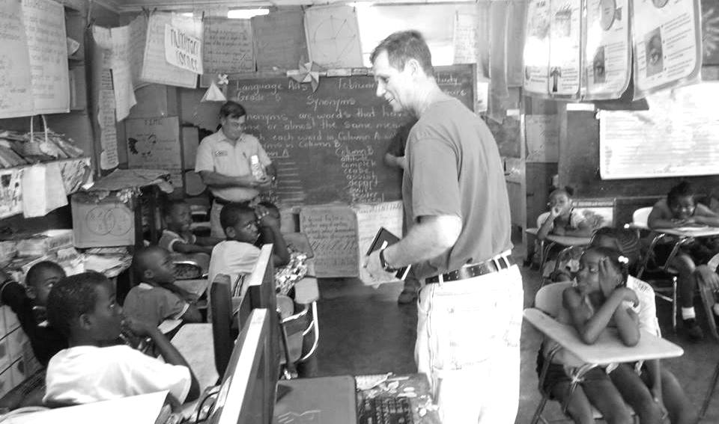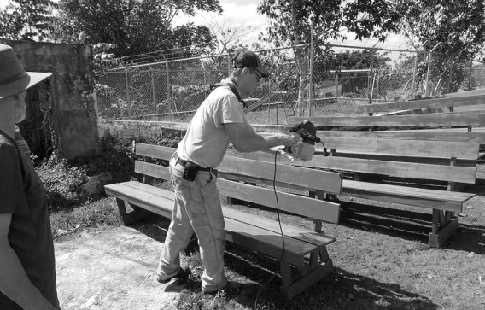

**Hillman Ferry Campground Ministry**

I have an open date at Hillman Ferry Campground that needs to be filled by someone to serve as a chaplain on June 15-21, 2015. The camper is. We ask you to conduct Sunday Morning Worship Service at 9:00 a.m. If interested, please contact Terry Mathis at 270-559-0717.

**Association Pastors’ Breakfast**

**Tuesday, May 5th, 7:00-8:30 a.m.**

**Jumbo’s in Vienna**

**This is for all pastors, staff and retired pastors.**

**MISSIONS SPECTACULAR – JUNE 6, 2015 – 6 LOCATIONS**

Missions Spectacular is a one‐day, hands‐on missions opportunity designed specifically for families, youth groups, and adult groups. It can be used by the local church to help members move beyond the walls of the church and to engage one of their Acts 1:8 mission fields right here in Illinois.

Families and groups can choose from a variety of mission projects at several locations in our state. Choose your location, decide on the project, and connect your people to our vast mission field in Illinois.

**SCHEDULE (May vary by location):**

9:00 a.m. – Orientation at host location

9:30 a.m. – Leave for projects

4:30 p.m. – Projects are completed

**COST:**

$15 ($10 for children under 12) includes t-shirt, lunch, and some ministry supplies.

**THIS YEAR’S LOCATIONS:**

Granite City, 12 projects available

Metropolis, 6 projects available

Streator Baptist Camp, 10 projects available

Decatur, 9 projects available

East St. Louis, 5 projects available

Elkville, 11 projects available

**Registration and more information are available at IBSA.org/missions. For further information, please contact** [**AlexisDumire@IBSA.org**](mailto:AlexisDumire@IBSA.org) **or call (217) 391-3142.**

**Eddyville First Baptist Church**

**(Big Saline Association)**

**May 11-15 at 7:00 p.m. each night**

**Bro. Terry Mathis will be the speaker**

**VBS Dates for May & June**

Seven Mile: Sundays, May 17–June 14, 9:30 a.m.-noon

Immanuel: June 22-26, 8:30 a.m.-11:40 a.m.

Hillerman: June 28-July 2, 6:00-8:30 p.m.

**Southern Baptist Convention**

**Annual Meeting**

**June 15-17, 2015 in Columbus, OH**

**Theme:**

**Great Awakening**

**CLEAR AGREEMENT**

**VISIBLE UNION**

**EXTRAORDINARY PRAYER**

**For more information and to register for the convention and hotel, please visit sbcannualmeeting.org**

Happy Mother’s Day!

May 10th

**Association Executive Board Meeting**

**Monday, June 1, 2015 at Simpson Baptist**

**Council Meeting – 6:00 p.m.**

**Board Meeting – 7:00 p.m.**

*We have a group of twenty going, from various churches within our association. Pray for them as they prepare to go and to serve others.*

**June 22-27, 2015**

**West Memphis, AR**