

**UPCOMING MISSION TRIPS:**

**Haiti – June 6-12 – Metropolis 1st youth**

**Italy – June 8-18 – Mackenzie Easter**

**West Memphis, AR – June 20-25 – World Changers Group**

**Asia – June 13-July 21 – Chloe Quint**

**Mexico – July 23-30 – Life Church Eastland Group**

**Please keep our missionaries in your prayers.**

**CHILDREN’S MISSION DAY!**

Thank you to all who helped with our first Kids’ Mission Day. Thanks to Nelda Smothers for sharing about missions and Alma Harris for working with the kids in music. They sang at Misty Meadows Assisted Living. Also, many thanks to all the other leaders who helped the kids with the cards and appreciation bags that they handed out at Hope Unlimited and the Metropolis Fire Dept.

We hope to do this again in the near future. We want to help teach our children about missions and mission work.

**ANNUAL**

**WORLD CHANGERS TRIP**

**West Memphis, Arkansas**

**June 20-25**

**Volume 1, #57**

**MONTHLY MISSION PROJECTS**

**MAY:** Collection for Guardian Family Services- Most needed items are: Toilet paper, 13 gallon Trash bags, laundry detergent, assortment of cleaning supplies, and hair brushes. Please drop items off at the shelter.

Hope Unlimited Baby Bottles – Mother’s Day – Father’s Day

**JUNE:** collection of literature for Eagle’s Nest (love packages)

Leadership: Brookport 1st

**Union Baptist Association Terry Mathis, Director of Missions**

**P.O. Box 29 email:mathisterry2009@hotmail.com**

**Metropolis, IL 62960 Beverly Turner, Admin. Asst.**

**618-524-9738 bevturneruba@gmail.com**

**UBA theme for 2016: “Disciple- Be One/Make One”**

**MAY 2016 NEWSLETTER**

**Union Baptist Association**

**P.O. Box 29**

**Metropolis, IL 62960**

***Return Service Requested***

**Non-Profit Organization**

**U.S. Postage Paid**

**Permit #137**

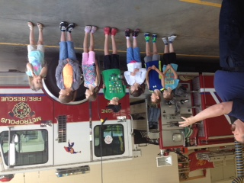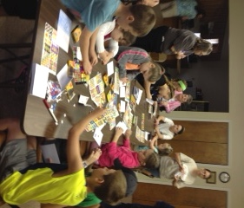

*Also, please remember the Henrietta Wemhoener family. This is Betty Jackson’s mother. Ron and Betty have pastored in our association in the past.*

*Our deepest sympathy goes out to the Anita Wright family. Please remember Pastor David and family, along with the congregation of Joppa Missionary Baptist Church during this difficult time of healing.*

Those attending this year from our association are:

Billy Burkhead–Life Church Terry Mathis-Metropolis 1st

Charles Duckworth-Revelation Rd. Eli Wright-Joppa Missionary

Mackenzie Easter-Metropolis 1st Jason Wright-Joppa

Adam Ragsdale-Hillerman Brandon Land-Brookport 1st

Jeremy Clark-Brookport 1st Alexia Land-Brookport 1st

Gary Moore-Brookport 1st Charity Land-Brookport 1st

Owen Westbrook-Metropolis 1st Ethan King-Metropolis1st

Jeff Windhorst-Brookport 1st Aaron King-Metropolis 1st

Eli Windhorst-Brookport 1st J.R. Conkle-Metropolis 1st

Heather Rottmann-Metropolis 1st Lily Conkle-Metropolis 1st

Elizabeth Rottmann-Metropolis 1st Jessica Cook-Vienna 1st

Ralph Steel-Sharon Bapt., Mayfield Shawn Stafford-Vienna 1st