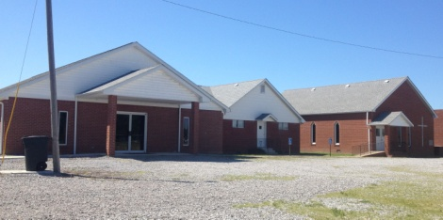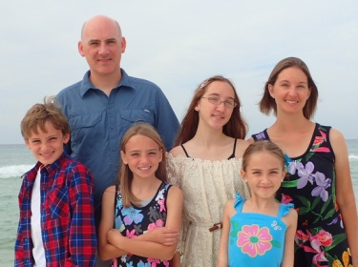

**M.S. BENEFIT YARDSALE – May 27th, 7:00am-3:00pm**

**Brookport 1st Ministry Building**

**Proceeds go to the local Multiple Sclerosis Society**

**MAY PASTOR/WIFE BIRTHDAYS**

May 8 – Brian Anderson, Eastland Life

**MAY WEDDING ANNIVERSARIES**

May 22 – Gary & Vickie O’Neal, Cypress 1st

May 23 – Joe & Grace Buchanan, Metropolis 1st

**JUNE PASTOR/WIFE BIRTHDAYS**

June 19 – Leeta Ervin, Weaver Creek

June 22 – David Faulkner, County Line

June 23 – Jill Ballard, Seven Mile

June 23 – Jerry Jackson, Mt. Zion

**JUNE WEDDING ANNIVERSARIES**

June 4 – Ed & Sandy Hollis, Vienna 1st

June 5 – Stephen & Janine Williams, Simpson

June 6 – Jim & Penny Wilson, Oak Grove

June 13 – Cliff & Michele Easter, Metropolis 1st

June 14 – Jack & Mary Hill, New Salem

June 26 – Ben & Eren Hottel, Hillerman

June 26 – Matt & Katrina Snell, Dixon Springs

June 30 – Jake & Leeta Ervin, Weaver Creek

June 30 – Glenn & Kim Coram, Immanuel

**JUNE PASTOR CHURCH ANNIVERSARY**

David Faulkner, County Line, 2005

Dean West, Karnak 1st, 2008

John Windings, Metropolis 1st, 2013

**Birthdays & Anniversaries**

**June 19-23 in Owensboro, KY**

**Please pray for the crew of twenty-three from various churches within our association.**

**Pastor Breakfast**

**Monday, May 8th, 7:00-8:30am at the Vienna Diner**

All pastors, staff and retired pastors are invited to come join us for fellowship and a time of prayer.

**Southern Baptist Convention and Pastor Conference**

**“Pray for Such a Time as This”**

**June 11-14 in Phoenix, AZ**

**For more information and to register, visit**

**www.sbcannualmeeting.net/sbc17**

**Association Council and Executive Board Meetings**

**Monday, June 5th at Seven Mile Baptist Church**

**Council meets at 6:00pm**

**Executive Board meets at 7:00pm**

All E-board members, Council members, Pastors, as well as guests, are invited to attend.

Hillerman Missionary Baptist Church was organized in 1886 with the name “Nineveh Baptist Church”. The church was also known as “Buzzard Roost” because of the crude way in which the seats were made from saw mill slabs. The original building was a two-story structure built on the Wm. R. House Farm. The Modern Woodsmen used the upper story for their meeting place.

In 1927, the building was destroyed by a tornado. The church was rebuilt and renamed “Hillerman Missionary Baptist Church”. In 1959, six classrooms were added and ten years later, more classrooms, a pastor study and a kitchen were added. Just in the past few years, a beautiful Fellowship Hall was built and the parsonage was remodeled. Today, along with its generous support of the association, Hillerman Baptist is in the Top 100 in the state for per capita giving to the Cooperative Program.

Bro. David Keyes was a long-time pastor there for twenty-seven years and retired in 2010. Ben Hottel has been the pastor there since 2011. We are so proud to be a part of the mission outreach of Hillerman Missionary Baptist Church.

**Pastor Ben Hottel & family**

**This month’s featured church is:**

**Hillerman Missionary Baptist Church**

***Church Contributions for Budget***

***(rec’d & deposited in March, 2017)***

Brookport First $ 1,152.46

County Line $ 200.00

Cypress First $ 135.00

Dixon Springs $ 462.00

Eastland Life Church $ 200.00

Hillerman Missionary $ 702.93

Immanuel $ 225.80

Joppa Missionary $ 899.87

Karnak First $ 704.64

Metropolis First $ 2,307.91

Mt. Zion $ 295.68

New Beginnings $ 0.00

New Hope $ 0.00

New Salem $ 35.00

Oak Grove $ 32.62

Revelation Road $ 37.00

Seven Mile $ 0.00

Simpson $ 100.00

Vienna First $ 433.33

Waldo $ 466.67

Weaver Creek $ 0.00