

**NOVEMBER MISSION ACTION:**

Christian Activity Center in E. St. Louis – “ADOPT A CHILD FOR CHRISTMAS” - If you or your church would like to provide Christmas gifts for one or more of the kids, please call the center to get a list. The number there is 618-874-5615. You can also provide Christmas for a child by making $100.00 gift to the center and they will do the shopping for you.

Gifts need to be dropped off at the UBA Office by December 1st.

**DECEMBER MISSION ACTION:**

Meeting needs for local ministries or families. Each church is asked to meet needs in their own community.

**JANUARY MISSION ACTION:**

Local food pantries. The pantries are always low on food following the holidays.

**Association Executive Board**

**Christmas Dinner and Meeting!**

**Date: Monday, December 7, 2015**

**Location: Brookport First Baptist Church**

**Times: 6:00 p.m. Meal in their new Life Center**

**7:00 p.m. Business Meeting**

**7:30 p.m. Entertainment- “By Grace” from Mayfield**

**All pastors, board members, council members, including their spouses, are invited to attend.**

**Please RSVP by contacting the UBA Office by December 3rd.**

**Local Drop-off week is November 16-22**

**Times:**

**November 16th-21st – 2:00-6:00 p.m.**

**November 22nd – 12:00-2:00 p.m.**

**Location:**

**Immanuel Baptist, 1119 Market St., Metropolis**

**The UBA Office is out of shoeboxes for this year. We will purchase more next year.**

**Please note that we will not be mailing a newsletter out the end of November. We have included information for November, December and January in this newsletter.**

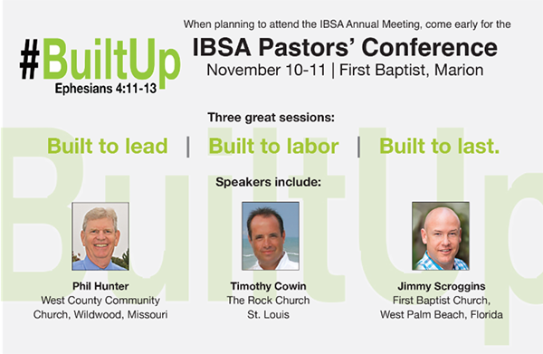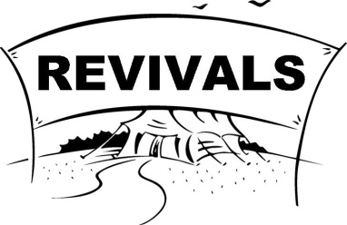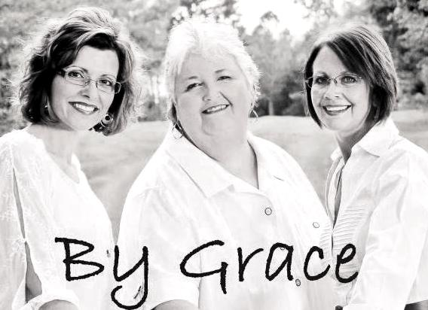

**WINTER BIBLE STUDY 2016**

**II Corinthians – “The Church’s Ministry Handbook”**

**Bro. Terry Mathis, our Director of Missions, has a few openings left to teach these 4 sessions.**

**Call him at 270-559-3717 if you are interested in him leading this study at your church.**

**UBA Co-ed Volleyball League**

**Beginning January 9, 2016**

All games will be played on Saturdays with a total of 8 games, plus tournaments.

Be forming your church teams! Information and sign-ups will be mailed out to the churches in December.

**IBSA Annual Meeting–November 12-13 First Baptist Marion**

**Hillerman Missionary Baptist**

**November 1-4, 2015, 6:00 p.m. nightly**

**Speakers:**

**Sunday a.m./p.m.: Terry Mathis, UBA D.O.M.**

**Monday: Ed Hollis, Vienna 1st**

**Tuesday: David “Buck” Siere, Brookport 1st**

**Wednesday: Tommy Mathis, Former Church Interim**

**Metropolis First Baptist**

**November 8-11, 2015, 6:00 p.m. nightly**

**Speaker: Allen Speer**

**A potluck meal will be served at 11:00 a.m. with the chicken strips and desserts provided by the association WOM. We are asking those who attend to provide the side dishes. Following the meal, Jeanette Cloyd, who has been involved with Women on Mission at the IBSA level, will be sharing about International Missions experiences. She will also be leading in a time of prayer.**

**Gather up a group of ladies from your church and plan on attending this event. Please RSVP to the UBA office by November 2nd.**

**The UBA Office will be closed November 25 - 27, in observance of Thanksgiving.**

**In observance of Christmas and New Years, we will be closed December 23 - January 1.**

The COPE Food Pantry is in need of canned pumpkin and canned yams for holiday meals. If you can help out with these items, please drop them off at COPE, 1013 North Ave., Metropolis. The pantry is open 9:00am-3:00pm on Monday, Wednesday and Friday. If you would like to make a monetary donation towards the purchase of needed items, please mail a check to COPE, P.O. Box 761, Metropolis.

**Please continue to pray for the following church that is currently without a pastor: New Beginnings**

**Baptist Women’s World Day of Prayer**

**& International Mission Board Study**

**November 5, 2015**

**11:00 a.m. at the UBA Office**

**Guest Speaker Jeanette Cloyd**

**FALL BACK: Daylight-Saving Time ends November 1st. Don’t forget to set your clocks back an hour the night before.**

**We would like to thank all of those who took the time to fill out the Annual Church Profiles. We received ACP’s from all 21 churches in our association!**

**Illinois Leadership Summit**

**January 26-27, 2016**

**IBSA Building in Springfield, IL**

Leaders from our churches will learn how to expand their leadership skills and use them to help grow effective churches.

If interested in attending, call the UBA Office for further information.

Note: Discount hotel rates are available if we can register before 12/15/15. There is limited space for only 300 to attend.

**Monday, November 9th**

**7:00-8:30 a.m.**

**Jumbo’s in Vienna**

**All pastors, ministers and retired ministers are encouraged to attend.**

**Fall Festival Results from BCHFS**

The ministry received approximately $7,200 from the silent auction and $14,200 from the quilt auction. The day was a huge success with over 1,840 guests attending, several of which were first time visitors.

**7th and 8th Graders**