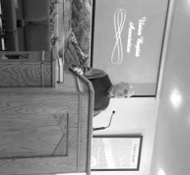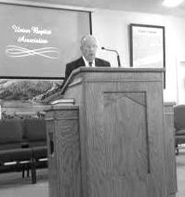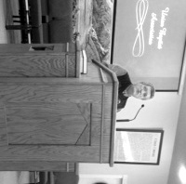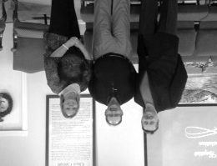****

Newly elected officers:

Frank Forthman, Jr., Moderator

Jerry Jackson, Vice-moderator

Linda Mathis, Clerk

Ben Hottel Annual Meeting Speakers:

Moderator Ed Hollis, Vienna 1st Stephen Williams, Simpson

**148TH ANNUAL MEETING SUMMARY:**

On Monday, October 19, 2015, the 148th Annual Meeting of the Union Baptist Association, was held at New Hope Baptist Church. There was a great turnout for both the morning and evening sessions. Bro. Ben Hottel, Pastor of Hillerman Missionary Baptist, was Moderator and did a wonderful job of conducting our program and business. Bro. Stephen Williams, Pastor of Simpson Missionary Baptist, as well as IBSA Zone Consultant for our area, lead in two great Bible Studies on Discipleship. Bro. Ed. Hollis, Pastor of Vienna 1st Baptist, preached a fantastic Annual Sermon on Discipleship. I, as the Director of Missions, preached the closing Mission Challenge message, also on Discipleship, concerning our Associational Theme for 2016: “Be One/Make One – Disciple.”

We heard from all the Department Directors, as each gave a report of what they accomplished this past year and what they hope to do in 2016. We also heard reports from the Baptist Children’s Home and the Illinois Baptist State Association. The Moderator appointed several people to serve on various committees through 2018. Also, a new Associational Trustee was elected to serve through 2018.

The highlight of the day was voting in a new church work as we welcomed Revelation Road Baptist Church, located in West Vienna, into our association. Their pastor, Charles Duckworth, along with several members, were present at the meeting. We now have twenty-one churches participating in our association!

Other business included voting in our annual budget, our new Department Directors, and also our new officers. Voted in were Bro. Frank Forthman, Jr. (New Hope) as Moderator, Bro. Jerry Jackson (Mt. Zion) as Vice-Moderator, and Linda Mathis (Metropolis 1st) as Associational Clerk.

What a privilege it is to serve the Lord alongside these churches and their leadership. I am truly blessed.

Serving the Lord together,

Terry Mathis, Director of Missions

**Pastor/Wife Birthdays**

**Nov. 24 - Karen Faulkner, Pastor’s Wife, County Line**

**Nov. 27 – Michele Easter, Pastor Family Ministry’s Wife, Metropolis 1st**

**Dec. 1 – Trad York, Pastor of Waldo Baptist**

**Dec. 12 – John Windings, Worship Leader, Metropolis 1st**

**Dec. 17 – Ben Hottel, Pastor, Hillerman Baptist**

**Dec. 24 – Sara Forthman, Pastor’s Wife, New Hope**

**Dec. 25 – Janine Williams, Pastor’s Wife, Simpson**

**Jan. 3 – Terry Mathis, DOM, Union Baptist Association**

**Jan. 19 – Pauline Gholson, Pastor’s Wife, New Salem**

**Jan. 19 – Vickie O’Neal, Pastor’s Wife, Cypress 1st**

**Jan. 26 – Matt Snell, Pastor, Dixon Springs**

**Pastor/Wife Anniversaries**

**Dec. 24 – Jerry & Elaine Jackson, Mt. Zion Baptist**

**Jan. 21 – Marvin & Jill Ballard, Seven Mile Baptist**

**Pastors’ Church Anniversaries**

**Ed Hollis - Vienna 1st, November 2006**

**David “Buck” Siere – Brookport 1st, December 2003**

**Frank Forthman, Jr. – New Hope, December 2005**

**Terry Mathis, Director of Missions, January 1997**

**David Wright, Joppa Missionary, January 2001**

**David Atwell, Waldo Baptist, January 2001**

**This Year’s Theme: “Making Disciples”**

UBA theme for 2016: “Disciple- Be One/Make One”

**NOVEMBER, DECEMBER 2015 & JANUARY 2016 NEWSLETTER**

**Volume 1, #53**

Gospel Messengers

**Secretary’s office hours: Monday-Thursday, 9:00 a.m. – 2:00 p.m.**

***Church Contributions for Budget***

***(rec’d & deposited in September)***

Brookport First $ 516.35

County Line $ 600.00

Cypress First $ 121.00

Dixon Springs $ 380.00

Hillerman Missionary $ 706.58

Immanuel $ 244.04

Joppa Missionary $ 1,029.70

Karnak First $ 648.88

Life Church Eastland $ 200.00

Metropolis First $ 2,505.41

Mt. Zion $ 1,000.76

New Beginnings $ 0.00

New Hope $ 65.00

New Salem $ 60.00

Oak Grove $ 39.27

Seven Mile $ 0.00

Simpson $ 208.00

Vienna First $ 866.67

Waldo $ 466.67

Weaver Creek $ 0.00

***If you have information that you would like to have included in our monthly newsletter, please call or email the UBA office by the 20th of the month. We would be happy to promote any special events (revival, singing group, special programs/ministries, etc.)***

**CONTACT INFORMATION:**

**Phone: 524-9738**

**Email: Terry Mathis - mathisterry2009@hotmail.com, Beverly Turner - bevturneruba@gmail.com**

**Website – www.metrouba.com Facebook – UBA (Metro)**

**Union Baptist Association**

**P.O. Box 29**

**Metropolis, IL 62960**

*Return Service Requested*

**Non-Profit Organization**

**U.S. Postage Paid**

**Permit #137**