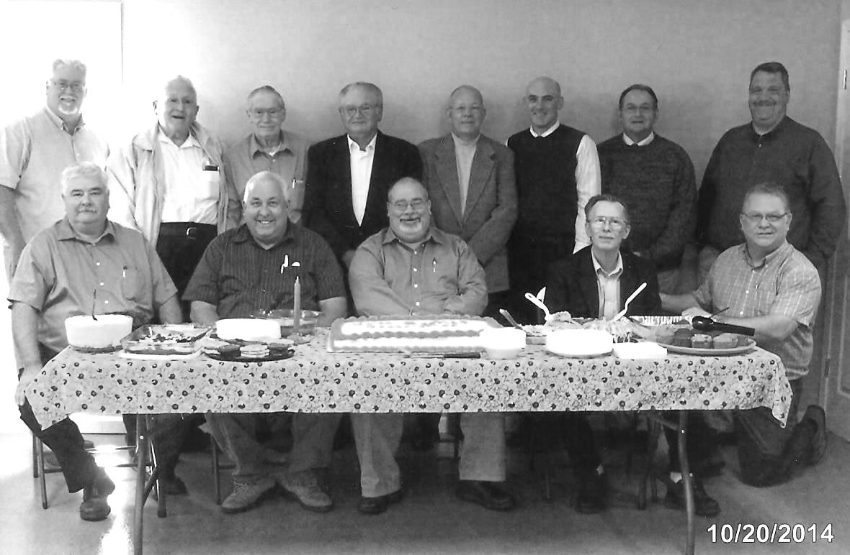

Shoeboxes are available at the UBA Office.

Immanuel Baptist will once again be the drop off location for shoeboxes.

Pastors Present

Back row, left to right: Terry Mathis-Director of Missions, Bill Gholson-Salem Baptist, Jim Wilson-Oak Grove, Dean West-Karnak 1st, Ed Hollis-Vienna 1st, Ben Hottel-Hillerman Missionary, Jerry Jackson-Mt. Zion, Joe Buchanan-Metropolis 1st.

Seated, left to right: David Wright-Joppa Missionary, David Faulkner-County Line, David Siere-Brookport 1st, Jim Shipley-retired from Mt. Zion, and Glenn Coram-Immanuel. Not pictured, but in attendance was Frank Forthman, Jr.-New Hope

**147th Annual Meeting of the Union Baptist Association**

**October 20, 2014**

**Hillerman Missionary Baptist Church**

**Drop off times:**

**Nov. 17 –22: 2:00-6:00pm**

**Nov. 23: Noon-4:00pm**

**NOVEMBER MISSION ACTIONS:**

**The Christian Activity Center in E. St. Louis – providing Christmas for kids. Leadership: Toby & Judy Davis**

**DECEMBER MISSION ACTIONS:**

**Local Ministries – Meeting needs for Christmas.**

**Leadership: all churches**

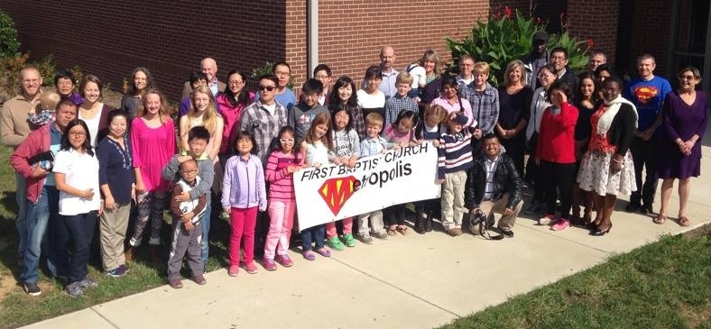

**UBA CONSTRUCTION VOLUNTEER WORKDAYS**

An association Volunteer Workday for Rebuild Brookport, has been scheduled for Friday and Saturday, November 7-8th. If interested in volunteering for one or both days, please call the UBA Office for the time and location to meet.

Also, another workday is scheduled for Saturday, December 6th to help hang sheetrock at Weaver Creek Baptist. Please call the UBA if you can volunteer for this day. We will work at the church from 8:00 a.m.-4:00 p.m.

**C.O.P.E. Volunteers Needed**

Volunteers are needed on Mondays, Wednesdays, and Fridays, 9:00-3:00, at C.O.P.E. If you would like to help out, please call Don Harper at 618-645-0110 to set up a day and time.

Paula McGinnis will be holding a charity devotional book signing and walk on her book. All of the proceeds will be going to the Myasthenia Gravis Foundation of America.

Date: Nov. 15, 9:00 a.m.-noon Location: Lillie’s Hallmark, 606 Market St., Metropolis

At the book signing, Paula will have available the paintings that she has completed of the sixty-seven churches in Massac County. She is asking that someone from each church pick theirs up.

The Community Myasthenia Gravis Walk will be held on the same day beginning at noon. Location: Starting at the Lois Lane Statue, on the corner of Market and 8th St. It will end at the Superman Square on Market St. For more information, contact Paula at 618-638-4576 or visit join.mgwalk.org/paulaburnettmcginnis

The New Beginnings Clothing Ministry is in need of casual men’s clothes (any size) and infant clothes (nb-24 mo.)

If you can help out, please leave donated items by the side door of the church. If it is raining you may leave them at the UBA office.

**IBSA Pastors’ Conference and Annual Meeting**

**November 4, 5, 6**

The 2014 IBSA Annual Meeting is Nov. 5-6 at the Springfield Crowne Plaza Hotel. The meeting, including Wednesday’s “concert of prayer,” will continue to unpack the Mission Illinois theme unveiled last year.

Messengers may register at the Annual Meeting with a signed messenger card from their church. Churches may e-mail CaroleDoom@IBSA.org or call (217) 391-3113 to request blank messenger cards or for registration assistance.

The IBSA Pastors’ Conference will precede the meeting, beginning at 1 p.m. on Tuesday, Nov. 4.

More information, plus downloads, are available at ibsa.org

**More information is available at ibsa.org**

**MEETING HIGHLIGHTS:**

There was an excellent turn out for the 147th Annual Meeting. We were presented with various reports from all of the Association Department Directors, on what was accomplished the past year. Bro. Jerry Day, our IBSA Zone Consultant gave our Bible Study from the passage of 2Timothy, Chapter 4.

Bro. David Wright from Joppa Missionary Baptist, brought a dynamic Annual Message from Acts 1:8. Terry Mathis brought the Mission Challenge Message for the evening, also from Acts 1:8. The 2015 Budget was adopted and various Committee Appointments were made by the Moderator. Bro. Ben Hottel, Moderator; Frank Forthman, Jr., Vice-Moderator; and Linda Mathis, Clerk, were all re-elected to their positions for another year.

During our Acts 1:8 Celebration Time, Bro. Clay Blankenbaker, association Camp Director, shared with us an emotional and challenging devotion about the great events happening at the association’s “Camp Mac”.

Bro. David Siere, Pastor of Brookport First, brought us a challenging devotion on the impact that missions can make on a church. The singing, led by Bro. Tim Henderson, was great as always.

Finally, let me say a word of gratitude to the members of Hillerman Missionary Baptist Church in helping host this event. The food was great and everyone was so friendly as they served.

Next year’s 148th Annual Meeting will take place on October 19, 2015 at New Hope Baptist Church.

Please pray for the following churches which are currently without pastors:

New Beginnings

Seven Mile

BAPTIST DAY OF PRAYER

NOVEMBER 3, 2014

10:00 a.m. – Noon

UBA Office

**All adults on mission are invited to attend.**

**A potluck luncheon will follow**.

**November 17, 2014**

**2:00 p.m.**

This event will be held at the Senior Citizen Building in Brookport.

This will be a time set aside to honor and remember the tornado victims of the 2013 tornado.

**International Students from SIU were hosted by members of Metropolis 1st October 18-19.The students were honored with a dinner at the church following the Sunday morning service.**

**Massac Ministerial Alliance**

**Community Thanksgiving Service**

**Tuesday November 25, 7:00 p.m.**

**First Christian Church in Metropolis**

**Everyone is welcome to attend!**

**SPECIAL RECOGNITIONS FOR 3RD QUARTER:**

Top 100 in giving to Cooperative Program

#15 Metropolis First Baptist

#97 New Hope Baptist

Top 100 in per capita in giving to the

Cooperative Program

#19 Hillerman Missionary

#68 Mt. Zion Baptist