

**Local Drop-off week is November 16-22**

**Times:**

**November 16th-21st – 2:00-6:00 p.m.**

**November 22nd – 12:00-2:00 p.m.**

**Location:**

**Immanuel Baptist, 1119 Market St., Metropolis**

**If you need shoeboxes, we have pre-printed ones at the UBA Office for 40¢/box**

**Disaster Relief Training**

Friday & Saturday, October 9-10

Lake Sallateeska

We will be taking a bus to the training on Saturday, October 10th. If you would like a ride, please call the UBA office to reserve a seat.

Metropolis First Baptist

Judgement House

October 22nd-25th

Thursday & Friday: 6:00-10:00 p.m.

Saturday: 5:00-11:00 p.m.

Sunday: 4:00-10:00 p.m.

Your help is needed! As Director of Missions, I have volunteered to present the gospel to the groups that go through the Judgement House. I will be presenting as they reach the end of their tour. I need volunteers to counsel with the individuals who make decisions. If interested, call me at 270-559-3717. There will be a required training session offered at 6:00 p.m. on October 6th and then again on the 13th. You will need to attend one of these 1 ½ hour sessions. Thanks, Terry Mathis.

**OCTOBER MISSION ACTION:**

**NOVEMBER MISSION ACTION:**

Providing Christmas gifts for kids at the Christian Activity Center in St. Louis. If you or your church would like to provide Christmas gifts for one or more of the kids, please call the center to get a list. The number there is 618-874-5615. Gifts can be dropped off at the UBA Office. We will have a deadline in next month’s newsletter.

**Annual Book of Reports**:

We are asking all Department Heads to please turn in their annual reports by September 28th.

At this time, the COPE food pantry is asking for donations of dry beans (1 lb.) and canned fruit (16-20 oz.) If you can help out with these items, please drop them off at COPE, 1013 North Ave., Metropolis. The pantry is open 9:00am-3:00pm on Monday, Wednesday and Friday. If you would like to make a monetary donation towards the purchase of needed items, please mail a check to COPE, P.O. Box 761, Metropolis.

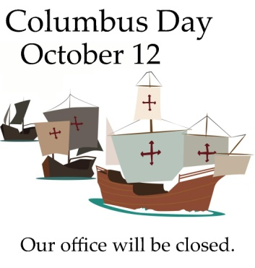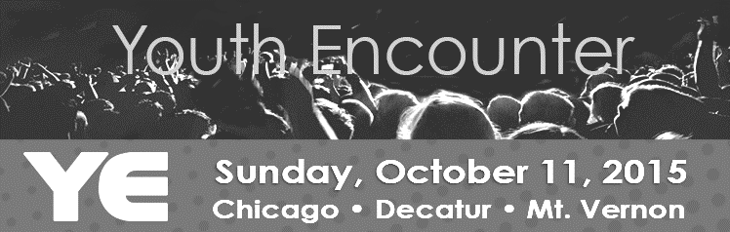

**One-Day Mission Trip to Eagles Nest, Butler, IL**

**Monday, October 5th**

**Leaving UBA Office at 6:00 a.m.**

**Returning around 8:00 p.m.**

We will be taking a group to sort literature. To reserve a seat on the van, please call our office. We only have 2 seats open at this time.

***SPECIAL THANKS!***

We would like to thank each individual and church that donated items for the Baptist Children’s Home Fall Festival auctions! Our collection was the best we have received to date and required the use of the Dixon Springs church van to hold all of the items for delivery to the children’s home! We would also like to thank Faye Bowman, from Dixon Springs, for organizing and delivering each year!

Youth Encounter is an evangelistic opportunity for hundreds of students to be led in worship by up and coming Christian artists, while being inspired and challenged by some of the top student ministry speakers in the country. Student leaders should seize this opportunity to attract students in need of Christ, but also being confident that the event will benefit their entire group. Featured this year are: 321 Improv, David Nasser, Jordan and Jessa Anderson, Shuree Rivera, The Great Romance.

The nearest location for Youth Encounter is Logan Street Baptist Church in Mt. Vernon, IL. It will be held on October 11, 2015 from 3:00pm to 10:00pm. The cost is $25 per person.

For more information, as well as registration, please visit the IBSA website at ibsa.org/students. The deadline is October 9th.

**IBSA Annual Meeting and Pastor’s Conference**

**Location: Marion First Baptist Church**

**Theme: “Build Your Kingdom Here”**

**Pastors’ Conference: November 10-11**

**Wives’ Luncheon: November 11**

**Annual Meeting: November 11-12**

There is a great opportunity to attend this year because it will be close to home. For more information and to register, please visit ibsa.org. All messengers attending will need a signed messenger card from their church.

**Daylight-Saving Time ends November 1st. Don’t forget to set your clocks back an hour the night before.**

**October 11, 2015, 10:00 a.m.**

**Seven Mile Baptist Church**

**Bible Preaching by: Bro. Shane Davenport**

**Special Singing By: For HIM**

**A potluck meal will be served following the service.**

**Everyone is welcome!**

**The Annual Church Profiles were mailed to all clerks or churches in our association. If you did not receive yours, please call our office. The ACP’s are due back to our office by October 6th or as soon as possible after that. If you get yours filled out before Oct. 6, we would appreciate your mailing it in early. We appreciate the time and effort that goes into providing this information!**

**148th UBA Annual Meeting Schedule:**

**8:30 a.m. - Fellowship Hour (coffee & donuts)**

**9:30 a.m. - Call to Order: Ben Hottel, Moderator**

**Welcome & Prayer**

**Adoption of Program**

**Joining of Revelation Road Baptist**

**Seating of Messengers**

**Congregation Song**

**Bible Study**

**Reports from Department Directors**

**Other Various Reports:**

**Baptist Children’s Home**

**Obituary**

**Congregation Song**

**Miscellaneous Business**

**Congregation Song**

**Annual Message: Dr. Ed Hollis**

**Benediction**

**12:00 p.m. - Potluck Meal**

**Afternoon Break**

**6:30 p.m. - Call to Order**

**Welcome & Prayer**

**Congregation Song**

**Bible Study: Dr. Stephen Williams,**

**Zone Consultant**

**Miscellaneous Business**

**Other Various Reports:**

**D.O.M.**

**IBSA**

**Special Recognitions**

**Congregation Song**

**Celebration:**

**Camp Mac**

**World Changers**

**35 Challenge**

**Congregation Song**

**Mission Message: Terry Mathis**

**7th and 8th Graders**