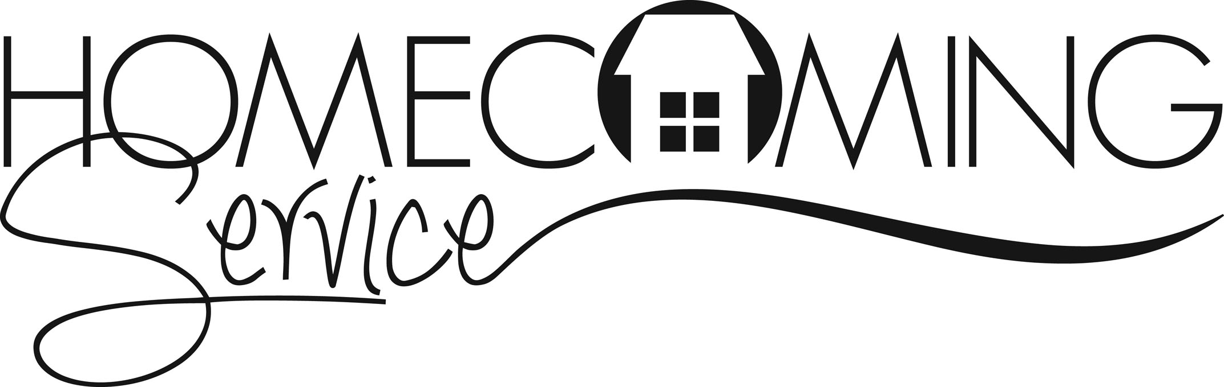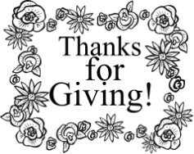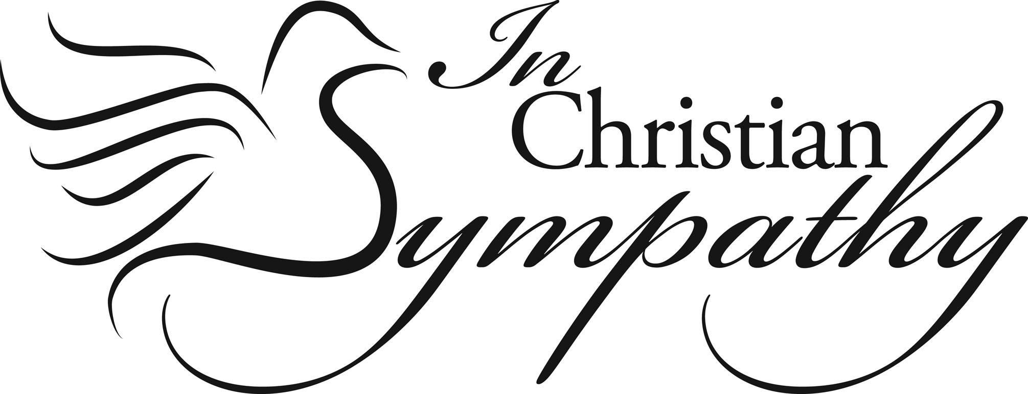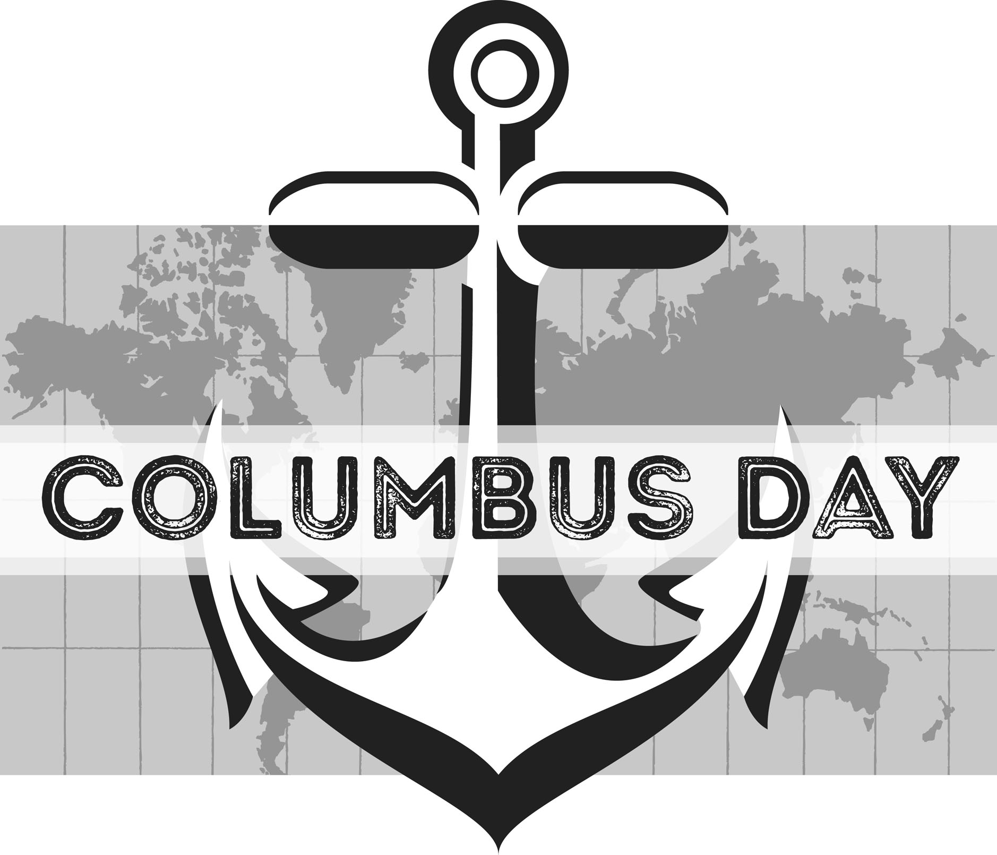

**JUDGEMENT HOUSE**

**Illinois Disaster Relief Opportunities to Serve**

**IBSA Region 2 to Southern Louisiana-**

Date: September 17-24, Need: Mudout/Flood Recovery and Chaplaincy, Contact: David Howard at (217) 303-4699 or [david@capcity.org](mailto:david@capcity.org)

Date: October 16-22, Need: Mud-out/Flood Recovery and Chaplaincy, Contact: Steve Ohl at [theohlfamily@hotmail.com](mailto:theohlfamily@hotmail.com) or (217) 503-0598

Date: November 5-12, Need: Mud-out/Flood Recovery and Chaplaincy, Contact: Andy Muller at drcapcity@gmail.com or (217) 415-9868

**Welcome New Pastor!**

*We would like to welcome Bro. Jack Hill to our association. He will be serving as pastor of New Salem Baptist Church.*

*We would like to express our deepest sympathy to the following families after the passing of loved ones:*

*The Raymond (Cub) Boner Family. Raymond was the father of Elaine Jackson, wife of Jerry Jackson, pastor of Mt. Zion.*

*The Mary Ellen Windings Family. She was the mother of John Windings, the Worship Leader at Metropolis First.*

*The Robert Turner Family. Robert was Beverly Turner’s father-in-law. Beverly is the Admin. Assistant at the UBA Office.*

***So far, we have received $5,041.41 for our Annual Love Offering! This is the most we have ever received!***

**In observance of Columbus Day, our office will be closed on Monday, October 10th.**

**DON’T FORGET TO VOTE!**

**Election Day is November 8th**

**IBSA Pastors’ Conference & Annual Meeting**

**November 1st-3rd**

**Broadview Baptist Church in Chicago**

If you plan on attending, you will need to make reservations asap. You can register online at ibsaannualmeeting.org/reservations/ If you need help with arrangements, call the UBA Office.

**PASTOR AND WIFE OUTING**

**Saturday, October 22nd**

**5:00 p.m. at Vienna City Park**

Please contact David Faulkner at 618-771-6532 if you plan to attend.

**Baptist Children’s Home Annual Singing**

The total of donations given to the children’s home this year was $2,639.05!

Thanks to all who attended and gave!

**Disaster Relief Training – October 14-15**

**Lake Sallateeska, Pinckneyville, IL,**

Register online at IBSA.org/DR or contact [AlexisDumire@IBSA.org](mailto:AlexisDumire@IBSA.org) or 217-391-3142

UBA will be taking a van up for the Saturday training. Please call our office if you would like to go. The van will be leaving at 6:30 a.m.

**Youth Encounter 2016**

**October 9th, 3-9pm at the Marion Cultural & Civic Center**

$25/person (includes dinner)

Featuring: Speaker-Tony Nolan, Artists-Sixteen Cities, & Comedy by 321 Improv

To register, visit IBSA.org/YE2016. For more information, contact [BarbTroeger@IBSA.org](mailto:BarbTroeger@IBSA.org) or 217-391-3138.

Seven Mile Baptist Church will be holding their Homecoming on October 9th, beginning at 10:00 a.m.

A potluck meal will follow the service.

Speaker: Bro. Ron Knapp, Jr.

Special Singing: The Moreheads

**October 26 – 30**

**Metropolis First Baptist**

**Call the church to reserve a time for your tour.**

***Church Contributions for Budget***

***(rec’d & deposited in August 2016)***

**August**

Brookport First $ 574.76

County Line $ 400.00

Cypress First $ 72.00

Dixon Springs $ 186.00

Eastland Life Church $ 200.00

Hillerman Missionary $ 678.06

Immanuel $ 245.53

Joppa Missionary $ 1,134.84

Karnak First $ 804.45

Metropolis First $ 2,746.19

Mt. Zion $ 530.15

New Beginnings $ 0.00

New Hope $ 0.00

New Salem $ 60.00

Oak Grove $ 47.81

Revelation Road $ 30.00

Seven Mile $ 0.00

Simpson $ 100.00

Vienna First $ 433.33

Waldo $ 466.67

Weaver Creek $ 0.00