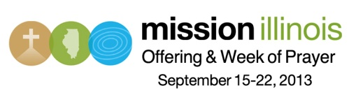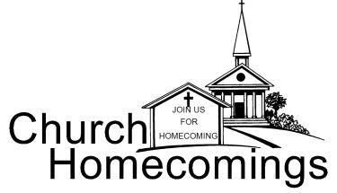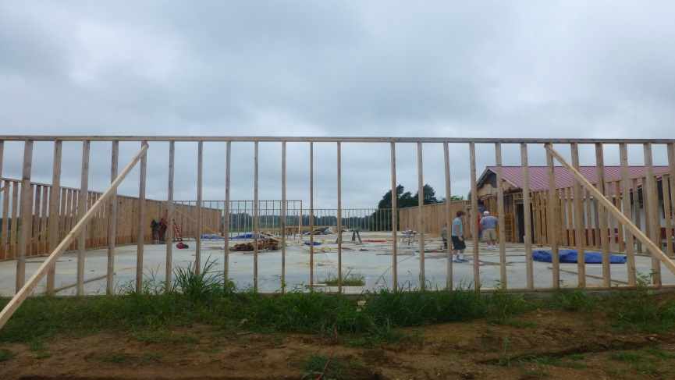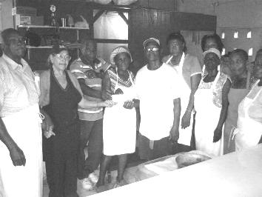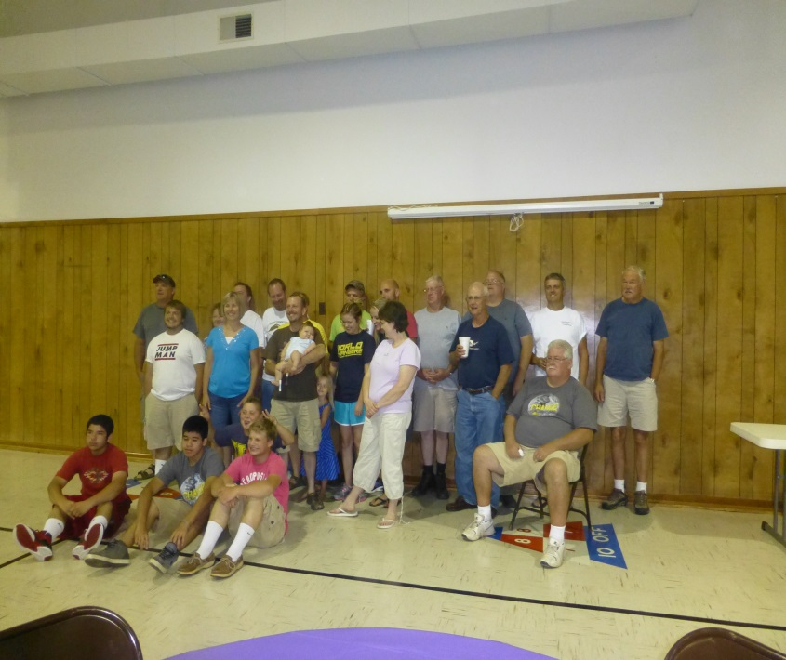

**IS YOUR CHURCH ON MISSION?**

We would love to hear about your church’s mission trip or mission work you are doing. We want to share what God is doing through Union Baptist Association churches. Just call, email (bevturner@metrouba.com), or drop by with the information so that we can print it in future issues of our newsletter.

A Note from Doug Devore, of the Baptist Children’s Home. It is in reference to the offering collected during the annual singing, held at Dixon Springs Baptist.

“The summer is almost over. It’s a time when our residents are getting ready to start a new school year. Your gift of $1,917.06 received on 8/12/13, tells us that, even at this time, you are still with us. You know that this ministry is open 24 hours a day, 365 days each year and that we depend on you to keep caring for children and families.”

**CYPRESS 1ST BAPTIST CHURCH HOMECOMING**

**September 8th**

Following the morning services, a Potluck Meal will be served at noon.

Beginning at 1:30 pm., entertainment will be provided by the “Glory Road Travelers”

Everyone is invited!

**DIXON SPRINGS BAPTIST CHURCH HOMECOMING**

**September 8th**

Sunday School times are 9:30-10:30 a.m.

The Homecoming will feature a new gospel band, “Good News”.

There will be a noontime fellowship and potluck meal with the meat and beverages furnished.

Everyone is welcome!

Nursery Provided!

If you need a ride, call 524-2024.

Nearly 1,000 churches and church plants comprise the Illinois Baptist State Association. We are churches together advancing the gospel across Illinois and around the world. Pray for leaders in the churches as they are trained and strengthened in IBSA-led conferences made possible, in part, by your gifts to the Illinois Mission Offering. You can find promotional videos for this offering, by visiting IBSA.org/mio.

**146th Annual Meeting**

**of The Union Baptist Association**

**Monday, October 21, 2013, Joppa Missionary Baptist**

**All Pastors, Executive Board Members, Association Council Members, plus 3 Elected Messengers from each church have voting privileges. Come and celebrate what God has done through the churches of the association, plus hear about plans for 2014!**

***We would like to thank all of the churches who brought school supplies for the Christian Activity Center in E. St. Louis!***

**Time to Elect Messengers for the Annual Meeting**

Each year, there seems to be some confusion about electing Messengers to represent your church at the Association Annual Meeting. Please do not elect your Association Executive Board Members as Messengers as they already have a part in the Annual Meeting, as well as voting privileges. Instead, elect 3 more people from your church to come and participate.

Messengers represent your church at the Annual Meeting and they have a one-time voting privilege at that meeting. The Association Executive Board Members have voting privileges at our Quarterly Meetings, along with the Annual Meeting. By electing 3 separate Messengers, along with your Association Executive Board Members and your Pastor, each church can have 6 voting members at the Annual Meeting. As you elect your Messengers, your Church Clerk will record their names in the Annual Church Profile which is turned in to us. Messengers from your church will attend the Association Annual Meeting on October 21, 2013 at Joppa Missionary Baptist Church. We have a morning session and an evening session on that day.

**DISASTER RELIEF TRAINING**

October 11-12, 2013 at Lake Sallateeska

Register online at IBSA.org under “Disaster Relief”

**PASTOR AND FAMILY PICNIC**

**Saturday, September 28th, 5:00 p.m.**

**Massac Park Pavilion by the campground**

Please bring a dish and a dessert to go with hotdogs and hamburgers.

Contact Bro. David Faulkner or our office by Thursday, September 26th if you plan on attending. We will need to know how much meat to grill.

**Adults on Mission Fish Fry**

Saturday, September 21st, 5:00 p.m., Vienna Park

Cost is $5 per person. For reservations, please call our office by Thursday, September 19th.

Please bring a covered dish to go with the meal. Drinks and desserts will be provided. Don’t forget to bring a lawn chair to sit in during the entertainment!

**SEVEN MILE BAPTIST CHURCH HOMECOMING**

**October 6th, 10:00 a.m.**

The service will begin with Bro. John Larrison speaking and “Cross Harmony” providing the music. There will be a noon potluck meal. All are invited!

**The Kitchen of Love Ministry**

For the past 6 months, Joppa Missionary Baptist has been taking up a love offering on the last Sunday evening of each month. The offering of $700 was recently taken to Jamaica by an IBSA Mission Team. It was given to “The Kitchen of Love”, which is located in Lucea. This ministry feeds over 700 people a meal of rice and beans every Tuesday. Pastor Crossman, far left in the picture below, said that the money came in the nick of time and that all saw it as an answer to prayer and a blessing from God!

**September: Crisis Intervention Ministries**

**Once again, we have shoe boxes for Operation Christmas Child. If you would like to purchase some, please call or drop by our office. There is a charge of 25 cents per box.**

**WORK AT WEAVER CREEK**

**NORTH CAROLINA TEAM**

A Mission Team from the Bethel Baptist Church in Waynesville, NC, came to our association to help a sister church. This started as a group of 6 or 7 people, but grew to twenty-four! They worked on 3 projects in the 2 days that they were here. They built a deck for a family, painted a house, and the majority of the group helped Weaver Creek Baptist on their new building. As you remember, back in the spring, their new building was under construction when a wind storm blew down the walls and rafters. The North Carolina Team helped them put up the walls of the church once again. This was a great encouragement to the members of Weaver Creek. Plans are being made for another team to come back in September to help them set the rafters once again.

**JOPPA MISSIONARY BAPTIST CHURCH**

**September 15th – 18th**

**Sunday- 11:00 a.m. & 6:00 p.m.**

**Monday-Wednesday-7:00 p.m.**

EVANGELISTS:

Sunday a.m.: Evangelist Matt Snell

Sunday p.m.: Rev. Ed Hollis

Monday: Rev. Joe Buchanan

Tuesday: Bro. Terry Mathis

Wednesday: Rev. Frank Forthman

***Please pray for our travelling missionaries:***

***Sept. 18 – 25 – Appalachia – a group of 8 ladies, from 3 churches in our association, will be traveling to Eastern Kentucky to work with local missionaries at their ministries.***

***Sept. 30 – Oct. 7 – Haiti – Terry & Linda Mathis, Ben & Eren Hottel, Jackie & Emma Lang, Terry & Tam Foste, along with Bob Elmore from the IBSA, will be working with church planters.***

***Nov. 9 – 16 –Haiti – Amy Land and others will be visiting the orphanages.***